Key Vocabulary and Definitions:

Muslim  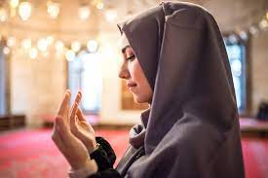 | The word 'Islam' in Arabic means submission to the will of God. Followers of Islam are called Muslims.
Qur’an  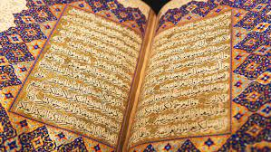 | Holy book – word of Allah, written in Arabic
Makkah  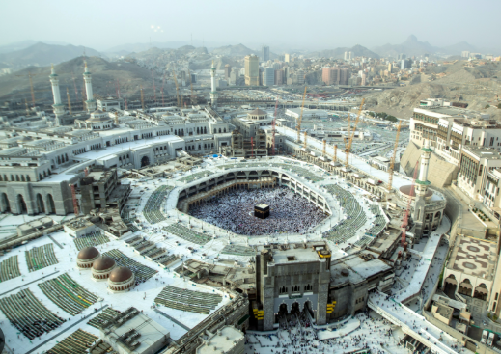 | city where Islam began.
Mosque  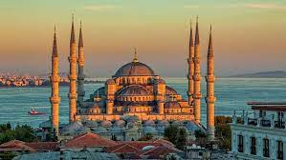 | Place of worship
Makkah  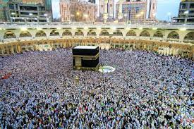 | Holy city in Saudi Arabia
Allah | Muslim name for God

What should I already know?

EYFS – Learning from religious stories (Islam)
EYFS – Looking at special religious places (Islam)

RE Skills:
Islam started in Makkah in Saudi Arabia when the prophet Muhammad was chosen by Allah to tell people to live their lives in a way that God would want.

This is the first enquiry on Islam. It looks at the importance of God/Allah and how nothing should be more important to a Muslim.

Teaching Sequence

- I can explain how to show respect
- I can consider some attributes that Muslims might believe that Allah has
- I can explain the meaning of some of the 99 names of Allah
- I can explain the ways a Muslim might show respect to Allah in their lives
- I can tell you how I might show respect for other people
- I can say what I do to show people who are special to me that I care
Blooms Taxonomy – Specific Verbs to Use in Lesson Aims
Knowledge: Describe, find, identify, list, locate, name, recognise, retrieve Comprehension: Classify, compare, explain, infer, interpret, paraphrase, summarise Application: Carry out, implement, use Analysis: Deconstruct, Organise, outline, structure Synthesis: Construct, design, devise, invent, make, plan, produce, Evaluation: Appraise, assess, choose,

Key Knowledge

There are different groups within Islam and practices concerning prayer differ- Sunni Muslims often pray 5 times a day whereas Shi’a Muslims can pray 3 times.
Many Muslims pray regularly ranging from early morning to last thing at night. Prayer is saying thanks to God. Muslims want to thank God for life and everything. Muslim life is built around worship of Allah (their name for God) through prayer.
The daily prayers (Salah) mean that Muslims pray as a community. It is a great symbol of equality as all pray side by side in rows, focused towards the holy city of Makkah together.
Prayer helps develop self-discipline; this is key to Muslims.
Praying regularly helps Muslims put Allah at the centre of their lives.

