Key Vocabulary and Definitions:

Dairy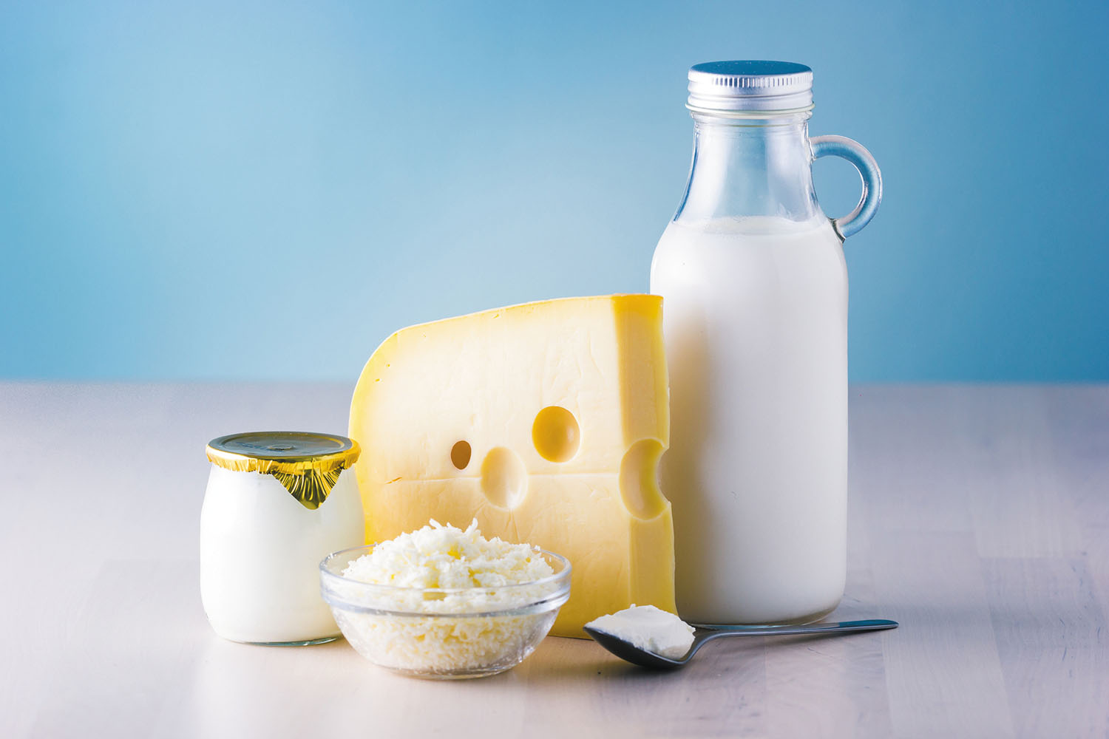 | Food and drinks made from cow’s milk.
Diet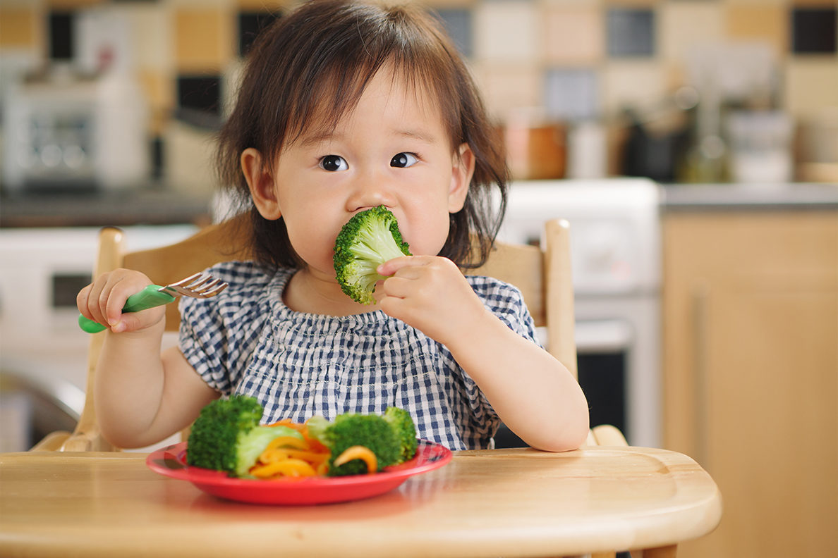 | What you eat.
Exercise | Moving your body to increase heart rate and strengthen muscles.
Healthy | Things that are good for your mind and body.
Heart rate | How quickly your heart is beating, to pump blood around your body.
Hygiene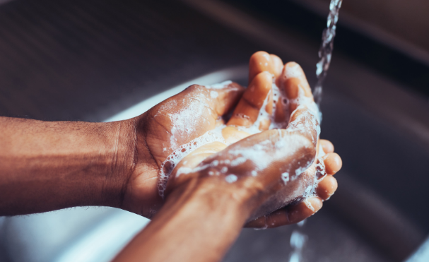 | Keeping your body and clothing clean and killing germs.
Overweight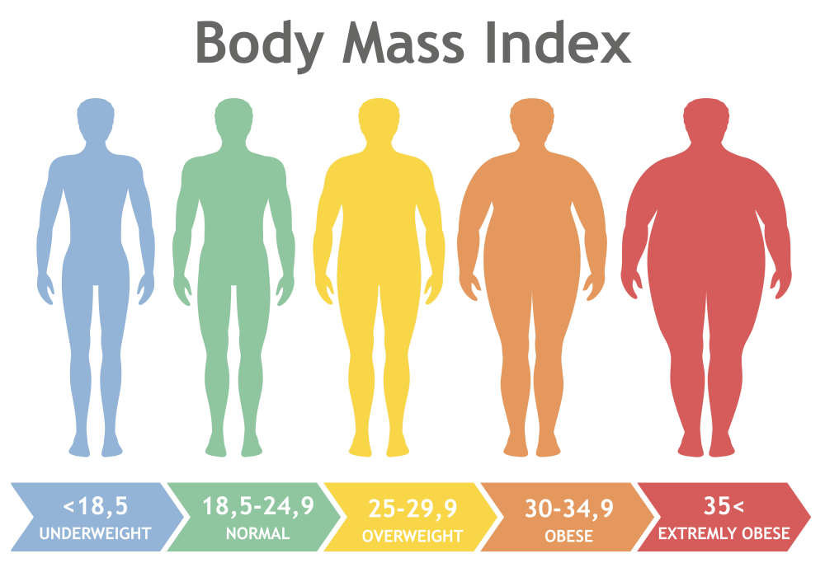 | Being heavier than a healthy weight for your height.
Portions | The size of different food types on your plate.
Proteins | A food group that can build and support muscle growth.
Starchy | A group that includes white foods such as potatoes and white bread.
Variety | A mixture of different things.

What should I already know?
- Identify and name a variety of common animals that are carnivores, herbivores and omnivores. (Y1 - Animals, including humans)
- Identify, name, draw and label the basic parts of the human body and say which part of the body is associated with each sense. (Y1 - Animals, including humans)

Scientific Knowledge:
- Notice that animals, including humans, have offspring which grow into adults.
- Find out about and describe the basic needs of animals, including humans, for survival (water, food and air).
- Describe the importance for humans of exercise, eating the right amounts of different types of food, and hygiene.

Blooms Taxonomy – Specific Verbs to Use in Lesson Aims
Knowledge: Describe, find, identify, list, locate, name, recognise, retrieve Comprehension: Classify, compare, explain, infer, interpret, paraphrase, summarise Application: Carry out, implement, use Analysis: Deconstruct, Organise, outline, structure Synthesis: Construct, design, devise, invent, make, plan, produce, Evaluation: Appraise, assess, choose,

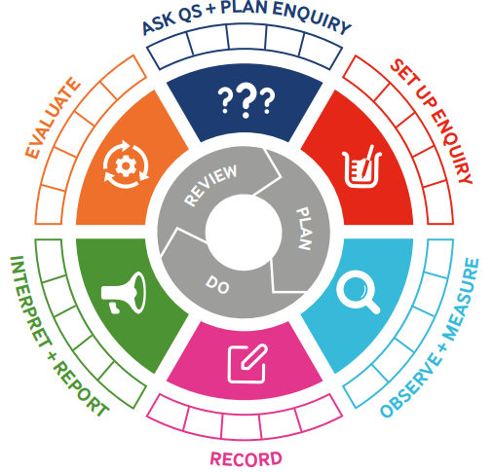
Teaching Sequence

- To understand that there are healthy and unhealthy foods
- To create a healthy plate and know that there are different food groups
- To ask questions and suggest answers (TAPs)
- To explain how and why we keep clean
- To understand the importance of washing our hands
- To know how to exercise and describe what it does to our bodies

Key Knowledge
Term 3 | Let’s Talk (Explorify) | Scientific Knowledge | Scientific skill
Lesson 1 | Odd One Out  Tropical Fruits  Https://explorify.uk/en/activities/odd-one-out/tropical-fruits/classroom | - Find out about and describe the basic needs of animals, including humans, for survival (water, food and air). | To Record
Lesson 2 | Big Question  Balanced Diet  https://explorify.uk/en/activities/the-big-question/what-is-a-balanced-diet-for-us-and-the-planet/classroom | - Describe the importance for humans of exercise, eating the right amounts of different types of food, and hygiene. | To Observe
Lesson 3 | Hygiene Experiment | - Describe the importance for humans of exercise, eating the right amounts of different types of food, and hygiene. | To Ask Questions and Plan Enquiry
Lesson 4 | Listen: What Can you hear?  Scrub-a-dub-dub  https://explorify.uk/en/activities/listen-what-can-you-hear/scrub-a-dub-dub | - Describe the importance for humans of exercise, eating the right amounts of different types of food, and hygiene. | To Record
Lesson 5 |  | - Describe the importance for humans of exercise, eating the right amounts of different types of food, and hygiene. | To Evaluate
Lesson 6 | Listen: What Can you hear?  Let’s get physical  https://explorify.uk/en/activities/listen-what-can-you-hear/lets-get-physical | - Describe the importance for humans of exercise, eating the right amounts of different types of food, and hygiene. | To Observe and Measure

