Overview
This unit explores the concept of sequencing in programming through Scratch. It begins with an introduction to the programming environment, which will be new to most learners. They will be introduced to a selection of motion, sound, and event blocks which they will use to create their own programs, featuring sequences.

National Curriculum
- Design programs that accomplish specific goals, including controlling or simulating physical systems.
- Use sequence in programs.
- Use logical reasoning to explain how some simple algorithms work.

Key Vocabulary and Definitions:

Algorithm  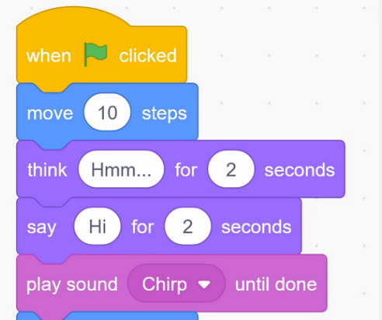 | A series of instructions, in the right order, designed to complete a task.
backdrops   | An image at the back of a stage or program.
commands   | An order that must be followed.
motions   | An action.
program | A set of instructions that are joined together.
Scratch  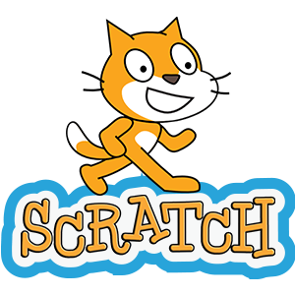 | A piece of software used to create a program.
sequence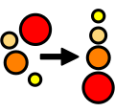 | A set of instructions that are in the correct order.
sprites  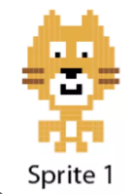 | A computer-made image which can be moved on-screen.

Teaching Sequence
- To explore a new programming environment.
- To identify that commands have an outcome.
- To explain that a program has a start.
- To recognise that a sequence of commands can have an order.
- To change the appearance of my project.
- To create a project from a task description.

Online Safety Teaching: Online Reputation
1. To explain how to search for information about others online.
2. To give examples of what anyone may or may not be willing to share about themselves online.
3. To explain the need to be careful before sharing anything personal.
4. To explain who someone can ask if they are unsure about putting something online.
5. Recap of all SMART rules with a focus on T-Tell.
Key Vocabulary and Definitions:

Algorithm | A series of instructions, in the right order, designed to complete a task.
backdrops | An image at the back of a stage or program.
commands | An order that must be followed.
motions | An action.
program | A set of instructions that are joined together.
Scratch | A piece of software used to create a program.
sequence | A set of instructions that are in the correct order.
sprites | A computer-made image which can be moved on-screen.

Overview
This unit explores the concept of sequencing in programming through Scratch. It begins with an introduction to the programming environment, which will be new to most learners. They will be introduced to a selection of motion, sound, and event blocks which they will use to create their own programs, featuring sequences.

National Curriculum
- Design programs that accomplish specific goals, including controlling or simulating physical systems.
- Use sequence in programs.
- Use logical reasoning to explain how some simple algorithms work.

Teaching Sequence
- To explore a new programming environment.
- To identify that commands have an outcome.
- To explain that a program has a start.
- To recognise that a sequence of commands can have an order.
- To change the appearance of my project.
- To create a project from a task description.

Online Safety Teaching: Online Reputation
1. To explain how to search for information about others online.
2. To give examples of what anyone may or may not be willing to share about themselves online.
3. To explain the need to be careful before sharing anything personal.
4. To explain who someone can ask if they are unsure about putting something online.
5. Recap of all SMART rules with a focus on T-Tell.
Blooms Taxonomy – Specific Verbs to Use in Lesson Aims
Knowledge: Describe, find, identify, list, locate, name, recognise, retrieve Comprehension: Classify, compare, explain, infer, interpret, paraphrase, summarise Application: Carry out, implement, use Analysis: Deconstruct, Organise, outline, structure Synthesis: Construct, design, devise, invent, make, plan, produce, Evaluation: Appraise, assess, choose,

Key Knowledge
