Key Vocabulary and Definitions:

Allah | The one and only God in Islam.
Makkah 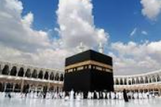 | Holy city Muslim’s face when they pray.
Ka’bah 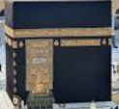 | Building in Makkah which Muslim’s face in prayer
Pilgrimage 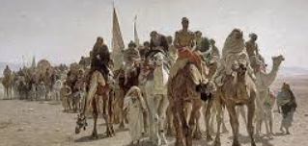 | A special or religious journey
Hajj 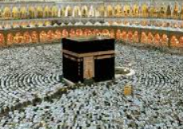 | Pilgrimage to Makkah – Muslims are expected to go once in a lifetime if possible
Muslim  | A follower of the religion of Islam.
Qur’an  | Holy book - word of Allah.

What should I already know?
How important is the prophet Muhammad to Muslims? (Year 2)
How important is the Qur'an to Muslims? (Year 2)

RE Skills:
To explain how commitment can be hard and can describe how it would feel to reach a goal.
To describe the Muslim prayer routine and where they might choose to pray and say why.
To explain how Muslims might be helped in their everyday lives by regular prayer.

Teaching Sequence

- To consider how making a regular commitment to something can increase its effectiveness
- To discuss some reasons why Muslims might pray
- To explain what parts of Muslim’s life might be helped by regular prayer
- To explain why Muslims might want to pray in a Mosque
- To explain how Muslims might be helped in their everyday lives by regular prayer
- To consider what regular actions are important to me and how I can remember them
Blooms Taxonomy – Specific Verbs to Use in Lesson Aims
Knowledge: Describe, find, identify, list, locate, name, recognise, retrieve Comprehension: Classify, compare, explain, infer, interpret, paraphrase, summarise Application: Carry out, implement, use Analysis: Deconstruct, Organise, outline, structure Synthesis: Construct, design, devise, invent, make, plan, produce, Evaluation: Appraise, assess, choose,

Key Knowledge

Islam Ages 7-9 Enquiry 1:

Does praying at regular intervals help Muslims in their everyday lives?
Muslims pray at least 5 times a day ranging from early morning to last thing at night.
Prayer is saying thanks to God. Muslims want to thank God for life and everything he has
done, is doing and will do in their lives.

Muslim life is built around the worship of Allah (God) through prayer. The prophet
Muhammad (the founder of Islam) set the prayer numbers as part of “The Night Journey”,
a journey Muhammad took from the Great Mosque in Makkah to the Temple Mount in
Jerusalem on a winged horse-like creature known as Buraq, which was then followed by
Muhammad's ascension into heaven. Briefly mentioned in the Qur’an (17:1) (the Muslim
Holy Book), this journey allowed Muhammad to meet Moses and other prophets who had
preceded him and discuss the times a day they needed to pray.

The five daily prayers (Salah) mean that Muslims pray as a community. It is a great
symbol of equality as all pray side by side in rows, focused on Allah, facing towards
Makkah together.

Before praying, Muslims wash exposed parts of their body and prepare their minds to be
in the presence of Allah – everyday worries should be pushed to one side during prayer
as Allah deserves total focus and respect.

Prayer helps develop self-discipline; this is key to Muslims. Praying regularly helps
Muslims put Allah at the centre of their lives. Prayer can take place anywhere as long as
you are in a clean place. For this reason, many Muslims have a prayer mat and a
compass. This means they can always find the direction of Makkah which they need to
face as this is the location of the Ka’bah (a building at the centre of Islam's most
important mosque, the Great Mosque in Makkah). It is a large black box-like structure
which is also the focus of the hajj, the Islamic pilgrimage to Makkah which Muslims are
expected to make once in their lives, finances permitting.

Praying regularly helps a Muslim structure their lives around Allah and never forget the
blessings that he has given them.

Optional Additional Texts which could be utilised:
Qur’an 62:9 ‘O you who have believed, when [the adhan] is called for the prayer on the
day of Jumu'ah [Friday], then proceed to the remembrance of Allah and leave trade. That
is better for you.’

This states that praying to Allah is more important than anything else.

