Key Vocabulary and Definitions:
Aerial view   | Sometimes called birds-eye view. It is an image from above, as if looking down on something.
Human features  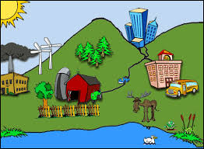 | Ways in which people have affected an area
Key  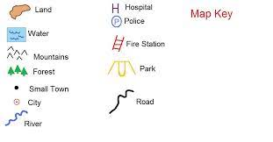 | Shows what the colours or symbols on a map mean.
Landmark   | An object or feature of a place that is easily seen and recognised from a distance.
Physical features  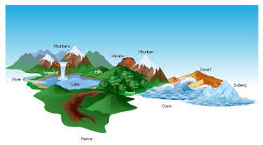 | The natural features of an area, such as mountains, deserts, rivers, and oceans.
Population   | The number of people living in a country, city, or area
Rural  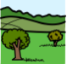 | An area of countryside
Scale | The size of things on a map compared to real life
Sketch map  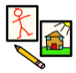 | A roughly drawn map that shows only basic details
Urban   | An area in and around a city or town

What should I already know?
- Understand geographical similarities and differences through studying the human and physical geography of a small area of the UK;
- Devise a simple map; and use and construct basic symbols in a key.

Geographical Skills:
- Describe and understand key aspects of physical geography including key topographical features and land use patterns;
- Understand geographical similarities and differences through studying the human and physical geography of a region of the UK.
- Use fieldwork to observe, measure and record the human and physical features in the local area using a range of methods, including sketch maps, plans and graphs.

Blooms Taxonomy – Specific Verbs to Use in Lesson Aims
Knowledge: Describe, find, identify, list, locate, name, recognise, retrieve Comprehension: Classify, compare, explain, infer, interpret, paraphrase, summarise Application: Carry out, implement, use Analysis: Deconstruct, Organise, outline, structure Synthesis: Construct, design, devise, invent, make, plan, produce, Evaluation: Appraise, assess, choose,

Teaching Sequence

- To create a simple sketch map and a key to show how land is used.

- To create a simple sketch map to show how land is used (Local Area Walk).

- To create a simple map to show how land is used.

- To describe land use in urban and rural areas in the UK

- To explain how land is used for different types of agriculture.

Key Knowledge

Sketch Map
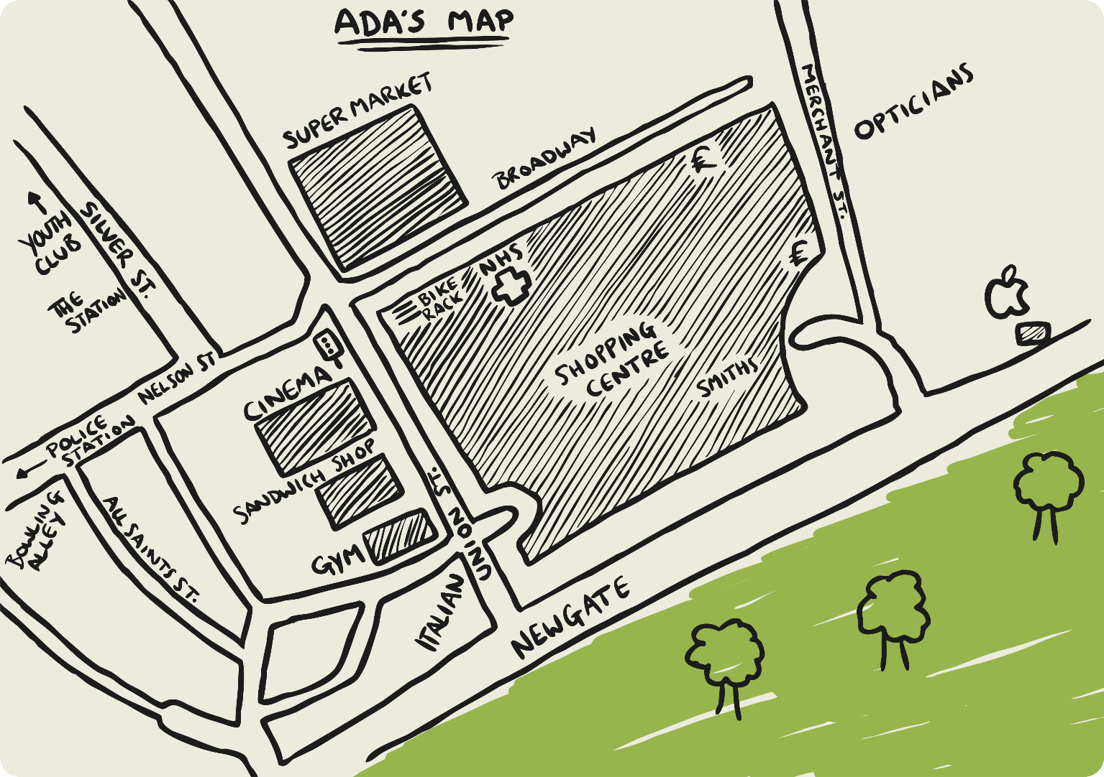
Aerial Map
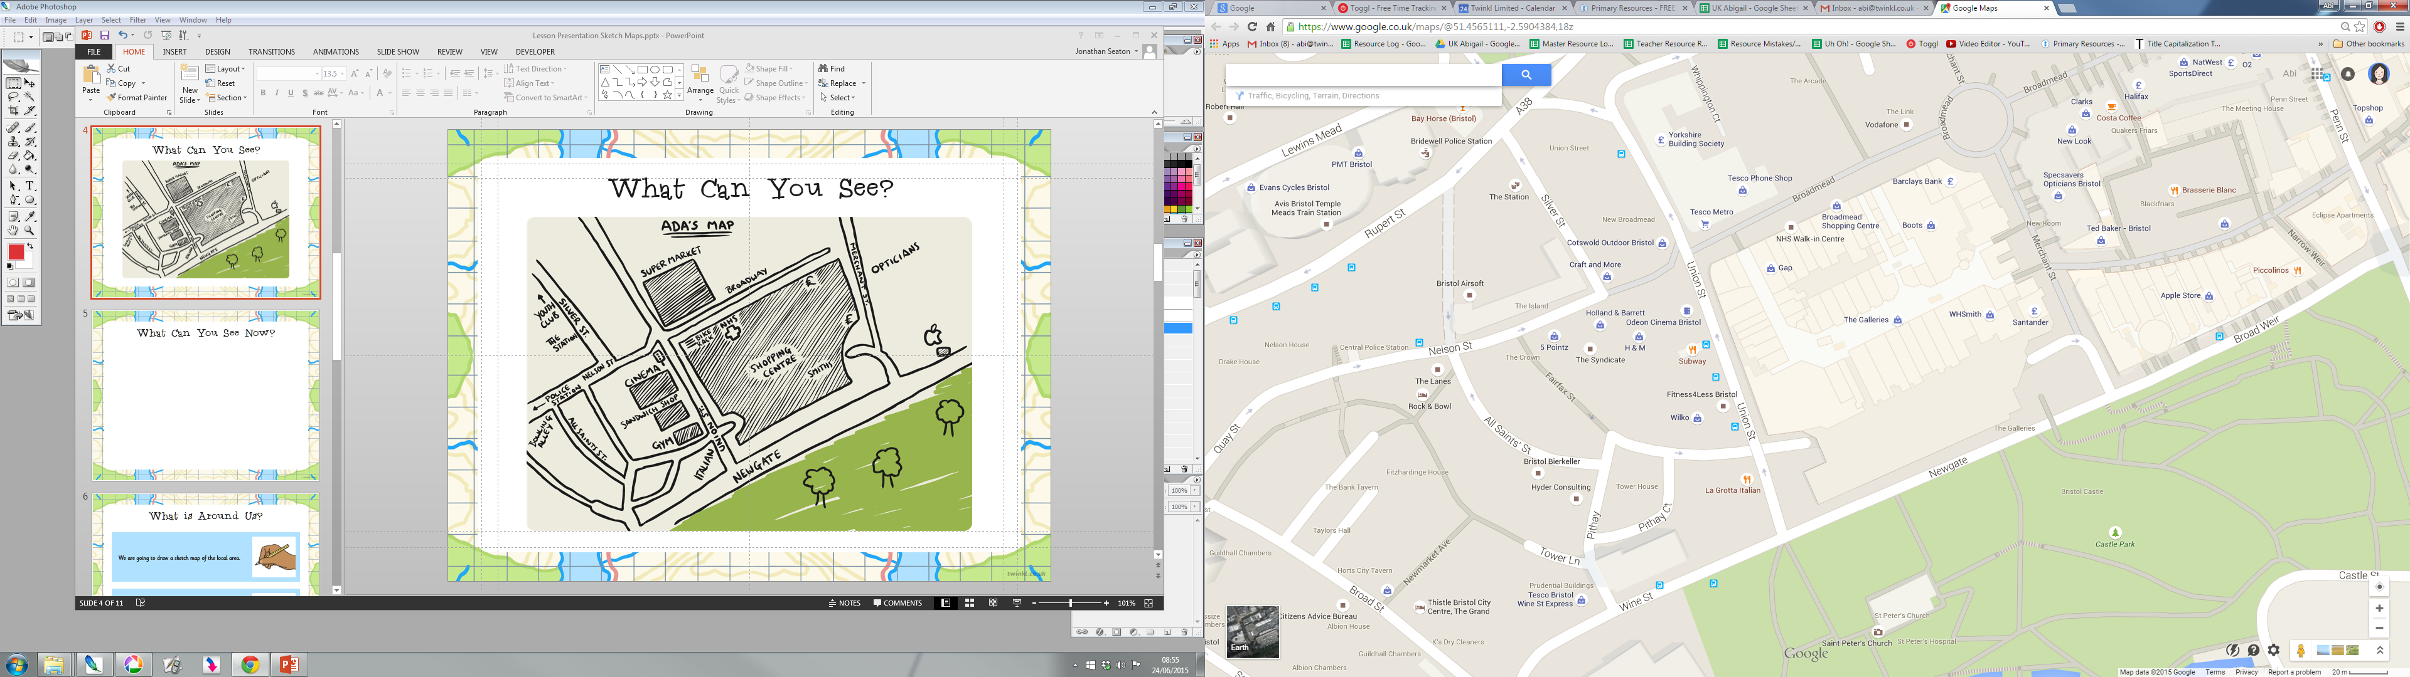
Land Use in the UK
