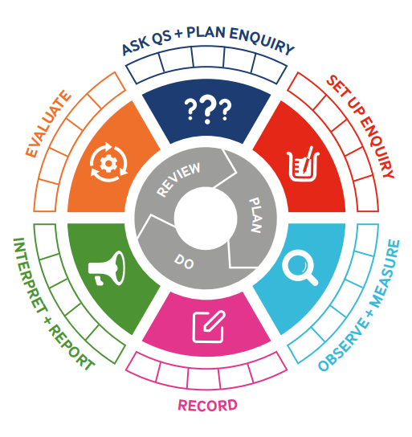
What should I already know?
- To identify and compare the suitability of a variety of everyday materials, including wood, metal, plastic, glass, brick, rock, paper and cardboard for particular uses
- To find out how the shapes of solid objects made from some materials can be changed by squashing, bending, twisting and stretching.

Scientific Skills:
- To record their observations in written, pictorial and diagrammatic forms
- To put forward own ideas about how to find the answers to questions
- To make relevant observations
- To measure using given equipment
- To select equipment from a limited range
- To suggest improvements in their work
- To evaluate their findings
- To use results to draw simple conclusions, suggest improvements and raise further questions. (Assessed)
- To set up simple practical enquiries (Assessed)

Key Vocabulary and Definitions:

Attraction  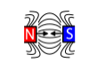 | The act or power of drawing toward something. E.g. magnetic attraction
Force  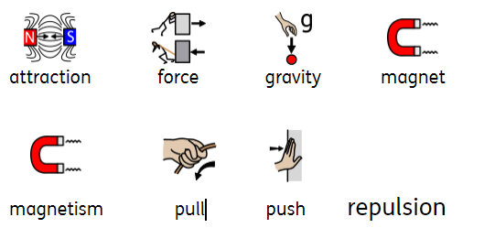 | Force is a push or pull on an object. A force can cause an object to accelerate, slow down, remain in place, or change shape.
Gravity | Gravity is a force caused by a large body, such as the Earth. Gravity pulls objects toward the Earth.
Magnet | A lodestone which has the property of attracting iron.
Magnetism | Magnetism is a force. Metallic objects stick to a magnet because its magnetic force is pulling on the objects.
Pull | Pull as a force could look like opening a door. With greater strength pulling on the handle, the door opens.
Push | An example of push as a force would be to push on a swing. The force moves the swing in a particular direction.
Repulsion  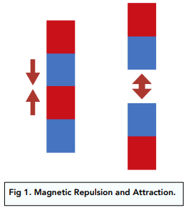 | The force that acts between bodies of like magnetic polarity tending to separate them.

Teaching Sequence
- To show examples of forces in everyday life.
- To explore how forces affect an object’s movement.
- To compare how things move on different surfaces. (TAPS- Forces)
- To identify different types of magnets and show how the poles can attract and repel.
- To compare and group together materials based on their magnetic properties.
- To demonstrate attraction and repulsion between the poles of magnets.

Key Vocabulary and Definitions:

Attraction | The act or power of drawing toward something. E.g. magnetic attraction
Force | Force is a push or pull on an object. A force can cause an object to accelerate, slow down, remain in place, or change shape.
Gravity | Gravity is a force caused by a large body, such as the Earth. Gravity pulls objects toward the Earth.
Magnet | A lodestone which has the property of attracting iron.
Magnetism | Magnetism is a force. Metallic objects stick to a magnet because its magnetic force is pulling on the objects.
Pull | Pull as a force could look like opening a door. With greater strength pulling on the handle, the door opens.
Push | An example of push as a force would be to push on a swing. The force moves the swing in a particular direction.
Repulsion | The force that acts between bodies of like magnetic polarity tending to separate them.

What should I already know?
- To identify and compare the suitability of a variety of everyday materials, including wood, metal, plastic, glass, brick, rock, paper and cardboard for particular uses
- To find out how the shapes of solid objects made from some materials can be changed by squashing, bending, twisting and stretching.

Scientific Skills:
- To record their observations in written, pictorial and diagrammatic forms
- To put forward own ideas about how to find the answers to questions
- To make relevant observations
- To measure using given equipment
- To select equipment from a limited range
- To suggest improvements in their work
- To evaluate their findings
- To use results to draw simple conclusions, suggest improvements and raise further questions. (Assessed)
- To set up simple practical enquiries (Assessed)

Teaching Sequence
- To show examples of forces in everyday life.
- To explore how forces affect an object’s movement.
- To compare how things move on different surfaces. (TAPS- Forces)
- To identify different types of magnets and show how the poles can attract and repel.
- To compare and group together materials based on their magnetic properties.
- To demonstrate attraction and repulsion between the poles of magnets.

Blooms Taxonomy – Specific Verbs to Use in Lesson Aims
Knowledge: Describe, find, identify, list, locate, name, recognise, retrieve Comprehension: Classify, compare, explain, infer, interpret, paraphrase, summarise Application: Carry out, implement, use Analysis: Deconstruct, Organise, outline, structure Synthesis: Construct, design, devise, invent, make, plan, produce, Evaluation: Appraise, assess, choose,

Scientific Skills

Term 2 | Let’s Talk (Explorify) | Scientific Knowledge | Scientific Skill
Lesson 1 | Odd one out  Give it a pull  https://explorify.uk/en/activities/odd-one-out/give-it-a-pull | To record their observations in written, pictorial and diagrammatic forms | Observe and Measure
Lesson 2 | Table-top hovercraft  Tabletop hovercraft - Explorify | To put forward own ideas about how to find the answers to questions. | Ask Qs and Plan Enquiry
Lesson 3  TAPs |  | To record their observations in written, pictorial and diagrammatic forms  To put forward own ideas about how to find the answers to questions  To make relevant observations  To measure using given equipment  To select equipment from a limited range  To suggest improvements in their work  To evaluate their findings  To use results to draw simple conclusions, suggest improvements and raise further questions. (Assessed)  To set up simple practical enquiries (Assessed) | Set up enquiry  Interpret and Report  Reporting on findings from enquiries (TAPS)
Lesson 4 | Have you ever  Have you ever used a magnet?  https://explorify.uk/en/activities/have-you-ever/used-a-magnet | To put forward own ideas about how to find the answers to questions.  To measure using given equipment | Record  Interpret and Report
Lesson 5 | What’s going on?  Mighty magnets  https://explorify.uk/en/activities/whats-going-on/mighty-magnets | To record their observations in written, pictorial and diagrammatic forms | Observe and Measure
Lesson 6 | Odd one out  Marvellous magnets  https://explorify.uk/en/activities/odd-one-out/marvellous-magnets | To record their observations in written, pictorial and diagrammatic forms | Observe and Measure

