Key Vocabulary and Definitions:
Repeat   | To do (something) again or more than once.
Sequence  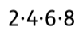 | An arrangement of two or more things in a successive order.
Instruction   | A direction or order.
Pattern   | A repeated design.
Loop   | A structure, series, or process, the end of which is connected to the beginning.
Command   | To give an order.
Programme  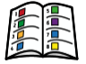 | A series of coded software instructions to control the operation of a computer or other machine.
Indefinite loop   | A loop that will continue to run infinite number of times until and unless it is asked to stop.
Count- controlled loop   | It is used when the number of iterations to occur is already known.

What should I already know?
- That accuracy in programming is important and how to create a program in a text-based language.
- To know what ‘repeat’ means and use it to produce a given outcome.
- To modify codes to produce a given outcome.
- . To create a program that uses repetition and patterns to produce a given outcome.

Computing Skills:
- To design, write, and debug programs that accomplish specific goals, including controlling or simulating physical systems; solve problems by decomposing them into smaller parts.
- Use sequence, selection, and repetition in programs; work with variables and various forms of input and output.
- Use logical reasoning to explain how some simple algorithms work, and to detect and correct errors in algorithms and programs.
- Select, use and combine a variety of software (including internet services) on a range of digital devices to design and create a range of programs, systems and content that accomplish given goals, including collecting, analysing, evaluating and presenting data and information.

Internet safety
- I can describe how to search for information within a wide group of technologies and make a judgement about the probable accuracy (e.g. social media, image sites, video sites).
- I can describe how to find out information about others by searching online.
- I can explain ways that some of the information about anyone online could have been created, copied or shared by others.

Blooms Taxonomy – Specific Verbs to Use in Lesson Aims
Knowledge: Describe, find, identify, list, locate, name, recognise, retrieve Comprehension: Classify, compare, explain, infer, interpret, paraphrase, summarise Application: Carry out, implement, use Analysis: Deconstruct, Organise, outline, structure Synthesis: Construct, design, devise, invent, make, plan, produce, Evaluation: Appraise, assess, choose,
Teaching Sequence
1a. To develop the use of count-controlled loops in a different programming environment.
1b. To describe how to search for information within a wide group of technologies and make a judgement about
the probable accuracy (e.g., social media, image sites, video sites).

2a. To explain that in programming there are infinite loops and count-controlled loops.
2b. To describe how to find out information about others by searching online.

3a. To develop a design that includes two or more loops which run at the same time.
3b. To explain ways that some of the information about anyone online could have been created, copied or shared by others.
4c. To modify an infinite loop in a given program.
5d. To design and create a project that includes repetition.

Key Vocabulary and Definitions:
Repeat | To do (something) again or more than once.
Sequence | An arrangement of two or more things in a successive order.
Instruction | A direction or order.
Pattern | A repeated design.
Loop | A structure, series, or process, the end of which is connected to the beginning.
Command | To give an order.
Programme | A series of coded software instructions to control the operation of a computer or other machine.
Indefinite loop | A loop that will continue to run infinite number of times until and unless it is asked to stop.
Count- controlled loop | It is used when the number of iterations to occur is already known.

What should I already know?
- That accuracy in programming is important and how to create a program in a text-based language.
- To know what ‘repeat’ means and use it to produce a given outcome.
- To modify codes to produce a given outcome.
- . To create a program that uses repetition and patterns to produce a given outcome.

Computing Skills:
- To design, write, and debug programs that accomplish specific goals, including controlling or simulating physical systems; solve problems by decomposing them into smaller parts.
- Use sequence, selection, and repetition in programs; work with variables and various forms of input and output.
- Use logical reasoning to explain how some simple algorithms work, and to detect and correct errors in algorithms and programs.
- Select, use and combine a variety of software (including internet services) on a range of digital devices to design and create a range of programs, systems and content that accomplish given goals, including collecting, analysing, evaluating and presenting data and information.

Internet safety
- I can describe how to search for information within a wide group of technologies and make a judgement about the probable accuracy (e.g. social media, image sites, video sites).
- I can describe how to find out information about others by searching online.
- I can explain ways that some of the information about anyone online could have been created, copied or shared by others.

Blooms Taxonomy – Specific Verbs to Use in Lesson Aims
Knowledge: Describe, find, identify, list, locate, name, recognise, retrieve Comprehension: Classify, compare, explain, infer, interpret, paraphrase, summarise Application: Carry out, implement, use Analysis: Deconstruct, Organise, outline, structure Synthesis: Construct, design, devise, invent, make, plan, produce, Evaluation: Appraise, assess, choose,
Teaching Sequence
1a. To develop the use of count-controlled loops in a different programming environment.
1b. To describe how to search for information within a wide group of technologies and make a judgement about
the probable accuracy (e.g., social media, image sites, video sites).

2a. To explain that in programming there are infinite loops and count-controlled loops.
2b. To describe how to find out information about others by searching online.

3a. To develop a design that includes two or more loops which run at the same time.
3b. To explain ways that some of the information about anyone online could have been created, copied or shared by others.
4c. To modify an infinite loop in a given program.
5d. To design and create a project that includes repetition.

Key Knowledge
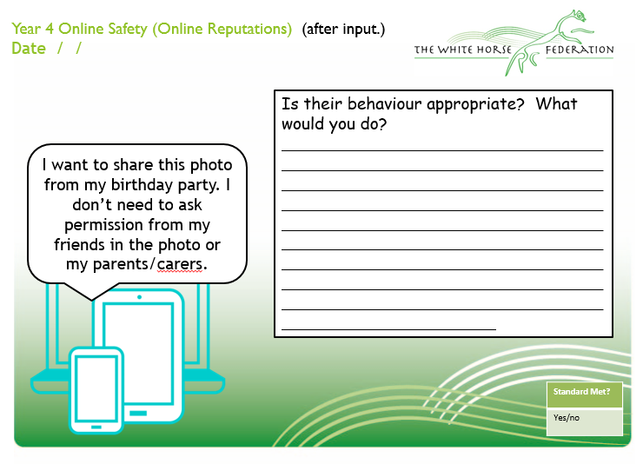

In Term 3, children will be taught how to use the software Scratch and will have similar activities to that carried out in Term 2. Children will be look at the difference between count-controlled and infinite loops and use their knowledge to modify existing animations and games using repetition. Their final project will be to design and create a game which uses repetition, applying stages of programming design throughout.

Blooms Taxonomy – Specific Verbs to Use in Lesson Aims
Knowledge: Describe, find, identify, list, locate, name, recognise, retrieve Comprehension: Classify, compare, explain, infer, interpret, paraphrase, summarise Application: Carry out, implement, use Analysis: Deconstruct, Organise, outline, structure Synthesis: Construct, design, devise, invent, make, plan, produce, Evaluation: Appraise, assess, choose,

