Key Vocabulary and Definitions:

Boiling 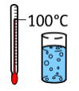 | the action of bringing a liquid to the temperature at which it bubbles and turns to vapour.
Change state  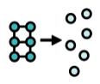 | the process of one state of matter (solid, liquid or gas) changing to another.
Condensation  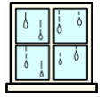 | Turns a gas into a liquid
Cooling 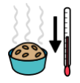 | the action or process of making or becoming less hot or warm.
Evaporation 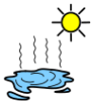 | Turns a liquid into a gas
Freezing 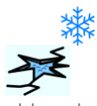 | When a liquid turns into a solid
Gases 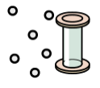 | Do not have a fixed shape and can spread out to completely fill the container or room they are in.
Heating 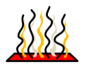 | the process of making something warm
Liquids 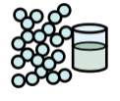 | Liquids take the shape of their container. They can flow or be poured
Melting  | When a solid changes to a liquid
Solids 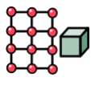 | Materials that keep their shape, unless a force is applied to it.

What should I already know?
Distinguish between an object and the material from which it is made. (Y1 - Everyday materials)
• Identify and name a variety of everyday materials, including wood, plastic, glass, metal, water, and rock. (Y1 - Everyday materials)
• Describe the simple physical properties of a variety of everyday materials. (Y1 - Everyday materials)
• Compare and group together a variety of everyday materials on the basis of their simple physical properties. (Y1 - Everyday materials)
• Identify and compare the suitability of a variety of everyday materials, including wood, metal, plastic, glass, brick, rock, paper and cardboard for particular uses. (Y2 - Uses of everyday materials)
• Find out how the shapes of solid objects made from some materials can be changed by squashing, bending, twisting and stretching. (Y2 - Uses of everyday materials)

Scientific knowledge:

- identify the part played by evaporation and condensation in the water cycle and associate the rate of evaporation with temperature

Teaching Sequence

- To explain why there is condensation on the inside the hot water cup but on the outside of the icy water cup.

- To explain how to speed up or slow down evaporation (TAPS).

- To learn a song about the water cycle.
- To present the water cycle as a scientific diagram.

Blooms Taxonomy – Specific Verbs to Use in Lesson Aims
Knowledge: Describe, find, identify, list, locate, name, recognise, retrieve Comprehension: Classify, compare, explain, infer, interpret, paraphrase, summarise Application: Carry out, implement, use Analysis: Deconstruct, Organise, outline, structure Synthesis: Construct, design, devise, invent, make, plan, produce, Evaluation: Appraise, assess, choose,

Term 3 | Let’s Talk (Explorify) | Scientific Knowledge | Scientific skill
Lesson 1 | The odd one out https://explorify.uk/en/activities/odd-one-out/where-is-the-water | to explain why there is condensation on the inside the hot water cup but on the outside of the icy water cup | To Observe
Lesson 2 | Have you ever?  https://explorify.uk/en/activities/have-you-ever/needed-to-dry-something-quickly | to explain how to speed up or slow down evaporation ( TAPs) | Ask questions and plan enquiries
Lesson 3 | What if?  https://explorify.uk/en/activities/what-if/water-didn-t-evaporate | to learn a song about the water cycle | To Observe
Lesson 4 | What is going on ?  https://explorify.uk/en/activities/whats-going-on/frozen-in-motion | to present the water cycle as a scientific diagram | To Record

