Technical Knowledge and skills:

- Understand and use mechanical systems in their products [levers and cams]

- refine product after testing

- grow in confidence about trying new / different ideas
What should I already know?
Investigate and analyse the existing products that they have researched in small groups to understand their purpose. Discuss the given design brief.
As a class, create their design criteria.
Design their own product using labelled drawings.
List all the resources that they require for the product.
Based on their individual designs, choose from a variety of materials and perform practical skills e.g measuring, cutting joining and finishing the product independently with some accuracy.
Testing their products.
Evaluate their ideas and products against the design criteria using a given sheet with leading questions.

Key Vocabulary
Cam shaft  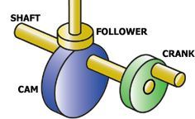 | A shaft with one or more cams attached to it
Snail cam   | Cam that produces a slow rise and quick drop movement
Eccentric cam   | The cam is a disc with its centre of rotation positioned ‘off centre’.
Hand-powered mechanisms | A mechanism that is controlled by turning a handle
Linear motion  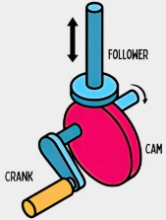 | Movement in a straight line
Rotation  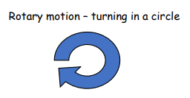 | The action of rotating about an axis or centre
Follower  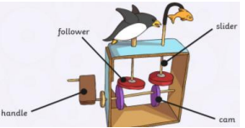 | The follower is in contact with the cam and causes the slider to move the object from rotational to linear motion
Slider | A slider converts rotational movement into linear movement

DT Skills:
Investigate and analyse the existing products that they have researched in pairs to understand their purpose and audience. Discus the given design brief.
Create their design criteria in small groups/ pairs.
Design their own product using labelled drawings and CAD (Paint 3D).
List all the resources that they require for the product.
Based on their individual designs, choose from a variety of materials and perform practical skills e.g measuring, cutting joining and finishing the product independently with accuracy most of the time.
Testing their products.
Evaluate in detail their ideas and products against the design criteria using a given sheet with leading questions incorporating peer feedback.

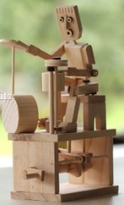

Designer/ Company

https://www.timberkits.com

Key Knowledge

