What should I already know?
- Understand geographical similarities and differences through studying the human and physical geography of a region in the United Kingdom and region in a European country.
- Locate the worlds countries, using maps to focus on Europe
Key Vocabulary and Definitions:

agriculture 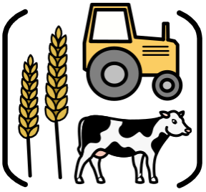 | Land used for growing crops and keeping livestock.
arable 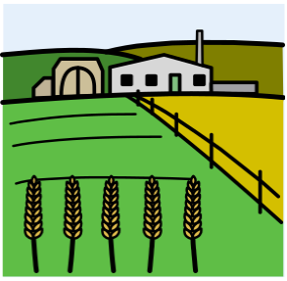 | Land used for producing crops.
climate 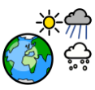 | The usual or average weather conditions over  a long period of time.
continent 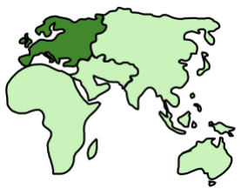 | A large area of land divided into countries.
country 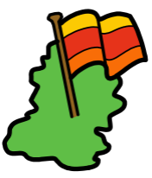 | An area defined by its people, culture, language, geography and government.
human geography  | Anything in an area that is not naturally occurring and that has been shaped by people.
landscapes 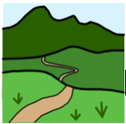 | An area of land and everything you can see on it.
physical geography 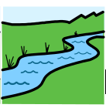 | Anything in an area that is naturally occurring.
population  | The number of people living in an area.
precipitation 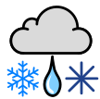 | Water particles that fall from a cloud as rain, hail, sleet or snow.
weather 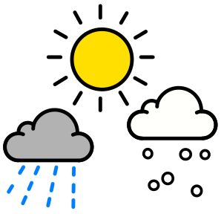 | State of the atmosphere at a particular place and time.

Geography Skills:
- Locate the main countries in Europe. Locate and name principal cities.
- Compare climate in UK with a region in Europe.
- Describe and understand:
- Human geography including trade between UK and Europe and the rest of the World.
- Physical geography including coasts, rivers and the water cycle including transpiration; climate zones, biomes and vegetation belts.
- Distribution of natural resources focusing on energy.

Blooms Taxonomy – Specific Verbs to Use in Lesson Aims
Knowledge: Describe, find, identify, list, locate, name, recognise, retrieve Comprehension: Classify, compare, explain, infer, interpret, paraphrase, summarise Application: Carry out, implement, use Analysis: Deconstruct, Organise, outline, structure Synthesis: Construct, design, devise, invent, make, plan, produce, Evaluation: Appraise, assess, choose,

Teaching Sequence
- To identify countries of Europe and some capital cities.
- To compare the features of Eastern European regions with that of my own area.
- To compare the climate of Eastern European regions with that of my own area.
- To compare the human geography of Eastern European regions with that of my own area.
- To explain the impact of the Chernobyl nuclear disaster.

Key Knowledge

