Year 3 2026/27
Term 1

Dear Parents and Carers,

Welcome to Year Three! We hope that you and your children have had a restful and enjoyable summer break and are now ready to start the new school year revitalised and ready for some hard work!

English | In English, we will be using the book, ‘The Iron Man.’ The children will explore the book and the characters before writing a fictional setting description. They will need to include skills learnt in Year 2 and apply new skills from Year 3 such as expanded noun phrases, prepositions for place and using simple past correctly and consistently. The children will then learn all the skills needed to write a diary entry for their non-fiction outcome. They will be including skills such as using apostrophes for contraction, coordinating conjunctions and continuing to use simple past correctly and consistently.
Reading | In Reading, we will be looking closely at our English text, ‘The Iron Man’. The children will use inference skills to find out about the characters and also make sure they understand the vocabulary used in the text. The children will also practise their scanning skills to aid their reading comprehension understanding and fluency.
Maths | We will be looking at number and place value. We will be focusing on 3-digit numbers up to 999, counting in 10s, 50s and 100s as well as practising ordering and number line skills. The children will also be continuing to work on times tables skills – time spent practising times tables at home will be very helpful.
Science | Our science topic this term is Animals including Humans. Children will be identifying that animals, including humans, need the right types and amount of nutrition, and that they get nutrition from what they eat. They will also find out about humans and some other animals having skeletons and muscles for support, protection and movement.
PE | In PE we will be learning to play Tag Rugby. The children will look at improving their accuracy when throwing the ball, being a member of a team and describing the effects of exercise e.g., sweating, raised heart rate.
Geography | In our geography topic this term we will study ‘The UK’. We will explore the countries, cities, the main rivers and seas of the UK using an atlas or map. We will be identifying some counties that make up the UK and naming some of the major rivers.
Music | We will be exploring whether music brings us closer together during our unit this term. We will be learning about rhythm, pitch and how they can be represented by musical symbols. We will explore how these symbols can be written on a stave and named with special musical names.
Art | In Term 1, we will be learning about collaging, particularly focussing upon “Painting with Scissors”. We will be looking at the work of Henri Matisse and how he used only coloured materials and scissors to create his work. After learning about his techniques, we will create our own work in a similar style.
RE | In RE, the big question we will be considering is “What might Sanatanis learn from the story of Rama and Sita and the celebrations of Diwali?”. We will be learning to investigate what happens during the festival of Divali (a festival that is celebrated by many of our children) and whether the celebrations bring a sense of belonging to Hindus.
Computing | In Computing lessons, we will be looking at computer systems and networks and finding out how computers can be connected. In Online Safety, children will be learning about self-image and identity online and learning the importance of privacy and security when they are being active online.
PSHE | In PSHE, we will be looking at the topic ‘Being Me in My World.’ The children will look at getting to know each other, what their dream school would be like and kindness. We will also look at two of our school values, Respect and Responsibility.

Additional informationPE
PE is done on a Wednesday afternoon in Year 3. Please note that your child will need to have the correct PE kit in school every day. Their kit should consist of a white t-shirt, dark blue or black shorts/jogging bottoms and trainers/daps.
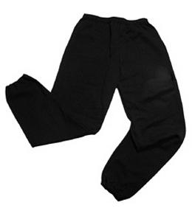
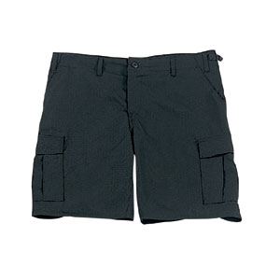
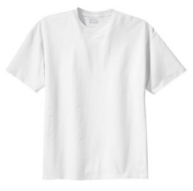

No jewellery is to be worn; hair needs to be tied back and head scarves must be short and tight fitting. These are all to ensure the safety of your child.

READING
Please ensure that your child is reading regularly at home (at least 4 times a week) and please take the opportunity to support your child whilst they read. It is also important that you listen to your child read books as much as possible as this will help both their reading and writing abilities. Reading comprehension is a big focus so they will need your support to help practice the skills we will teach. You can help at home by asking your child questions about their book after they have read such as ‘How do you know he is angry?’ or ‘Why is she happy?’

READING RECORDS
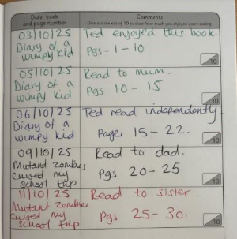
Here is an example of a completed Reading Record entry. Children can read any book of their choice. Reading Records must be brought into school every week to be checked by their teacher. Every 20 reads, the children get a reading prize!

HOMEWORK
Your child will bring home a list of spellings which they will be expected to learn each week. There will also be Maths homework. Your child will bring their homework folder home on a Friday with an expectation that homework is completed and back in school by Wednesday morning.

SNACK
Now that your children are in KS2, they no longer receive a school-provided snack. If your child would like a snack, they may bring one from home. This should be a healthy option, such as fruit, vegetables, or a breakfast bar. Please remember that no items containing nuts are allowed in school.

If you have any questions, please do not hesitate to come and see us at the end of the school day.

Many thanks,
Miss Eatwell, Mrs Qazi and Miss Thorne
Year Three

