Year 3 Term 2

Dear Parents and Carers,
Welcome back to school! After a long but brilliant first term, we hope that you’ve had an enjoyable half term holiday and that your children are ready for Term two. We have been so impressed by how well all the children have settled into KS2 and hope this continues in term two! Our topic this term is ‘The Stone Age’ and we have lots of fun activities planned for the children around it.

English | The high-quality text that we will be using this term is ‘The Winter’s Child.’ The children will explore the book and its characters before writing a character description based around the story. We will also be exploring using past tense, contractions and coordinating conjunctions. Later on in the term we will be writing a persuasive letter.
Reading comprehension | In Reading, we will be looking closely at our English text, ‘The Winter’s Child. We will be continuing to develop our Reader’s Theatre skills to increase our fluency in reading. We will also make inferences from the text and begin to explain and justify our observations with evidence from the text.
Maths | In Maths this term, the children will be building 3, 4 and 8 times tables and learn about the different mental methods to recall times tables facts. Additionally, the children will learn all about additional and subtraction. Later on in the term we will develop our division and geometry knowledge.
Science | Our science topic this term is ‘Rocks’. The children will learn to identify naturally occurring rocks and explore their uses. They will also investigate the hardness and permeability of rocks and group different types of rocks according to their properties.
PE | In PE, we will be learning to play handball. The children will look at improving their throwing and catching including throwing accurately at a target to score points. They will also be aware of the importance of using space and compare and discuss tactics in a game situation.
History | In our history topic this term we will study ‘The Stone Age’. The children will have the opportunity to explore what it was like for people during the Stone Age during our trip to ‘Butser Ancient Farm’. We will explore and understand the term ‘prehistory’ and place the period into the context of British History. The children will also understand how the hunter-gatherers survived in the Stone Age and examine sources of evidence about the Stone Age.
RE | In RE, the big question we will be considering is “Has Christmas lost its true meaning?”. We will be exploring what Christmas means to Christians and how it impacts their lives.
Computing | In computing we are looking at creating media. We will be discussing how to create our very own stop-frame animation, just like Wallace and Gromit. To explore this amazing topic we will be using screenshots from iMotion.
PSHE | In PSHE we will be looking at the topic ‘Celebrating differences.’ The children will understand that everyone’s family is different and important to them, and that conflict can arise in families. Children will also learn about what bullying is and how to use kind words as some words can be hurtful. Our school values for November and December will be Acceptance and Caring.
Art | We are being inspired by Laura McKenzie and Edgar Degas. We will be creating Gestural Drawings using charcoal techniques.

Additional information

PE
Please note that your child will need to have the correct PE kit in school every Monday.
Their kit should consist of a white t-shirt, dark blue or black shorts/jogging bottoms and trainers/daps.
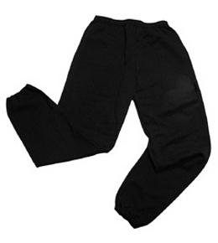
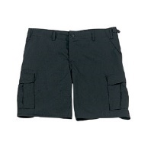


No jewellery is to be worn; hair needs to be tied back and head scarves must be short and tight fitting. These are all to ensure the safety of your child.

READING
Please ensure that your child is reading regularly at home (at least 4 times a week) and please take the opportunity to support your child whilst they read. It is also important that you listen to your child read books as much as possible as this will help both their reading and writing abilities. Reading comprehension is a big focus so they will need your support to help practice the skills we will teach. You can help at home by asking your child questions about their book after they have read such as ‘How do you know he is angry?’ or ‘Why is she happy?’

READING RECORDS

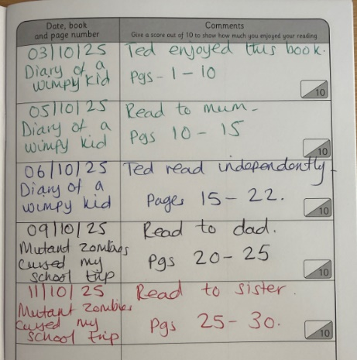
Here is an example of a completed Reading Record entry. Children can read any book of their choice. Reading Records must be brought into school every week to be checked by their teacher. Every 20 reads, the children get a reading prize!

HOMEWORK

Your child will bring home a list of spellings which they will be expected to learn each week. There will also be maths homework. Your child will bring their homework folder home on a Friday with an expectation that they are back in school by Wednesday morning.

If you have any questions, please do not hesitate to come in and see us at the end of the school day.

Many Thanks,

Miss Smith, Mrs Qazi & Miss Shiloh

The Year Three Team.

