Year 3 Summer Newsletter – Term 6

Dear Parents and Carers,

We hope you have had a lovely half term break and you are ready for the last term of Year 3! As it is getting warmer, please ensure that children always come to school with a water bottle and a hat. Sun cream should be applied at home, though some may wish to have a small bottle with them for extra use. We will not be providing sun cream at school.

English | This term, we are reading The Egyptian Cinderella by Shirley Climo. The story follows Rhodopis, a kind servant girl living in Ancient Egypt, who is treated unfairly by others around her. When a magical eagle swoops down and carries away her golden slipper, it leads to an unexpected meeting with the Pharaoh. We will also use year3 skills to write a retelling of the story as well as a diary entry.
Reading | This term in our reading lesson will be focused around Charlie and the Chocolate Factory by Roald Dahl. We will be focusing on our inferencing skills, using clues from the text. We will also practice our predicting skills, using evidence from the text to think about what may happen next.
Maths | We will learn to measure length, mass and capacity. From measuring lengths to comparing capacity of different containers, we will have plenty of opportunities to practically apply the newly learnt skills. We will also find the perimeter of simple 2D shapes by measuring the length of each side with a ruler and then adding the lengths together. The children will also learn about statistics and data handling towards the end of the term.
History | In History this half term, Year 3 will be learning all about the Ancient Egyptians. We will explore what life was like in Ancient Egypt, including the importance of the River Nile, the role of pharaohs, mummification and Egyptian gods and goddesses. The children will enjoy discovering fascinating facts about this ancient civilisation and comparing it to life today.
Science | In Science, we will be learning about ‘Plants’. We will explore the part that flowers play in the life cycle of flowering plants and understand that flowers vary in size, colour, shape and form but all play a crucial role in reproduction. We will investigate the process of fruit development from pollinated flowers and look at the functions of fruit in the life cycle of plants.
RE | In RE our big question is: What do some deities tell Sanatanis about God? We will be learning about some Sanatanis beliefs about Ganesha, Lackshmi and Brahman. We will also describe different deities and explain why they may be important to Sanatanis.
Computing | In Computing, we will be learning to explore a data handling software package / app and determine its uses. We will learn to collect, interpret and present data. We will also use technology to present and interpret given data, identifying simple patterns or trends. In Online Safety we will be learning about Managing Online Information; Copyright and ownership.
PSHE | In term 6 for Jigsaw will be looking at the ‘Changing Me’ unit. This compulsory unit will cover relationships and health including understanding how we have changed since being a baby, the important things that a baby needs to live and grow and understanding stereotypical ideas people may have about parenting and family roles.
PE | In PE this half term, Year 3 will be learning to play Rounders. The children will develop their throwing, catching and batting skills, while also learning the rules of the game and how to work together as part of a team.

Additional information
PE
Year 3 have PE on Monday afternoons; please ensure that your child brings in their PE kit on Monday mornings (otherwise they can be brought in on Friday to leave over the weekend).
Their kit should consist of a white t-shirt, dark blue or black shorts/jogging bottoms and trainers/daps.
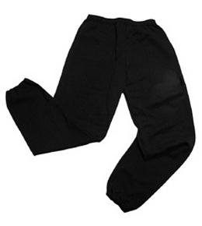
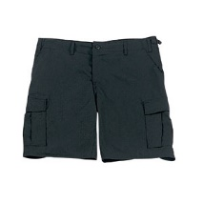


No jewellery is to be worn; hair needs to be tied back and head scarves must be short and tight fitting. These are all to ensure the safety of your child.

READING
Please ensure that your child is reading regularly at home (at least 4 times a week) and please take the opportunity to support your child whilst they read. It is also important that you listen to your child read books as much as possible as this will help both their reading and writing abilities. Reading comprehension is a big focus so they will need your support to help practice the skills we will teach. You can help at home by asking your child questions about their book after they have read such as ‘How do you know he is angry?’ or ‘Why is she happy?’

READING RECORDS
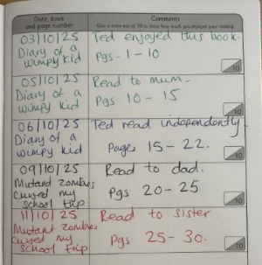
Here is an example of a completed Reading Record entry. Children can read any book of their choice. Reading Records must be brought into school every week to be checked by their teacher. Every 20 reads, the children get a reading prize!

HOMEWORK
Each week your children will bring home a maths and spelling homework sheet with different sections to recap learning which has already taken place. All homework is given out on a Friday and needs to be returned by the following Wednesday. If you have any questions, please do not hesitate to come in and see us at the end of the school day.

SNACKS AND LUNCHBOXES
We encourage all the children to lead fit and healthy lifestyles. Break time snacks should be healthy and include fruit or vegetables – crisps, cakes or chocolate bars will not be allowed at break time. Lunchboxes need to have a variety of food groups within them. A main part of the meal needs to be included (e.g. sandwiches, wraps, rice) alongside some of the following suggestions:
- Yoghurt
- Fruit
- Vegetable sticks
- Jelly
- Crisps / Biscuit
There is lots of advice and suggestions at:
https://www.nhs.uk/healthier-families/recipes/healthier-lunchboxes/

Many thanks,
Miss Smith, Miss Shiloh and Mrs Qazi
Year 3

