Year 4 Autumn 2

Dear Parents and Carers,
We hope that you’ve had an enjoyable half term and that your children are ready for Term two.

English  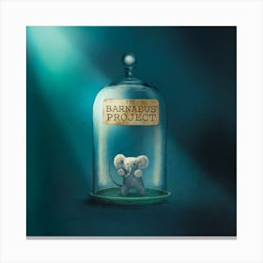 | In English, this term, we will be studying the book ‘ Barnabus project’ using the text to support our year 4 writing skills.  We will cover the national curriculum grammar, punctuation and spelling targets such as noun phrases expanded with prepositional phrases, creating character within narratives. and fronted adverbials for place and manner.
Reading 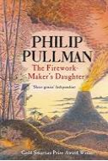 | As well as reading every day, it is also extremely important to practise asking and answering questions about the text. Reading comprehension forms a prominent part of the curriculum and we will practise the skills of answering retrieval and inference questions.  In the guided reading sessions, we will be revealing our new story and we will propose different activities to aid understanding of the theme/ context of the chosen book.
Maths | In numeracy, we will learn about 2 D shapes in Geometry .  We will practise the mental addition and subtraction using bridging or rounding and adjusting methods.
Science | In science, this term covers the topic: ‘States of Matter’. We will look at the properties of solids, liquids and gases. We will complete two scientific experiments to investigate different states of matter: condensation and evaporation.
PE | We will be doing Drumba.
Music | In music this term, the children will be learning to sing using Charanga.
History | This term, our topic will be History and we will be studying Saxons. This includes looking at how the legal system worked in Anglo-Saxon Britain and how the last Anglo-Saxon kings shaped Britain.
Art | In art, we will be focussing on Form 3d work. We will be expanding an insect and making 3D insects’ sculptures.
RE | In RE, we are going to look at and learn about Christianity and what is the most important part of Nativity for Christians .
ICT | In computing lesson, we will be looking at Information technology and online safety including Online Bullying.

Additional information

PE
This year our PE session is on a Wednesday. Please note that your child will need to have the correct PE kit in school every day.
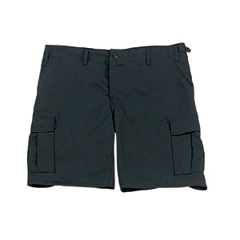
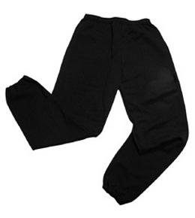
Their kit should consist of a white t-shirt, dark blue or black shorts/jogging bottoms, jumper and trainers/daps.


No jewellery is to be worn; hair needs to be tied back and head scarves must be short and tight fitting. These are all to ensure the safety of your child.

READING
Every child will have their own individual book. It is also important that you listen to your child read books as much as possible, as this will help both their reading and writing abilities. Reading comprehension is a big focus so they will need your support to help practise the skills we will teach. You can help at home by asking your child questions about their book after they have read such as ‘How do you know he is angry?’ or ‘Why is she happy?’

HOMEWORK
Your child will receive homework each week. This homework will be set online on a Friday and should be completed by the following Wednesday. In addition, a spelling activity will be set. There will be a piece of Maths Homework, which will enable your child to practise what they have been learning in class that week, the previous week, as well as work from previous terms as well.

If you have any questions, please do not hesitate to contact the school office.

Many Thanks

Miss Gheorghe, Miss Thorne and Miss Brazewell
The Year 4 Team

