Year 4 -Term 6

Dear Parents and Carers,
We hope that you’ve had an enjoyable holiday and that your children are ready for Term 6.

English  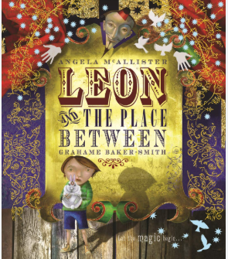 | In English, this term, we will be studying the book Leon and the Place Between by Angela Mcallister/Grahame Baker-Smith (Author), Grahame Baker-Smith (Illustrator) and using the text to support our year 4 writing skills.  We will cover the national curriculum grammar, punctuation, and spelling targets such as developing characters and settings in narratives, fronted adverbials for manner and punctuating speech.
Guided Reading 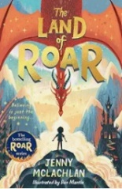 | As well as reading every day, it is also extremely important to practise asking and answering questions about the text. Reading comprehension forms a prominent part of the curriculum and we will continue to practise the skills of answering retrieval, inference and word meaning questions.
Maths | In maths, we will be learning all about time and converting units of measurement, area and perimeter, position and direction and statistics.
Science | Science this term covers the topic, ‘electricity’. We will learn about the sources of electricity; how static electricity is created and conduct investigations by creating circuits.
PE | This term, Year 4, will be focusing on swimming .
Geography | This term, Year 4 will study different settlements in modern Britain. They will be using an 8-point compass and identifying a range of mapping symbols and know their meanings. They will also draw a sketch map of the local area including human and physical features.
DT | This term, Year 4, we will be learning about electrical systems designing a torch aimed at a target audience and testing the torch designs.
RE | In RE, we will be studying Christianity. We will describe some of the ways Christians use churches to worship /celebrate Holy Communion or participate in baptism.
Computing | In computing lessons, we will be looking at ‘Photo Editing’ and  ‘Copyright and Ownership ‘. We are going to look at editing digital photography and how they can be resaved and reused .
PSHE | This term, in PSHE we are going to focus on the topic ‘Changing me.’ The children will learn that some of their personal characteristics have come from their birth parents. Also, we will talk about changes and how some changes are outside of our control.

Additional information

PE
This year our PE session is on a Wednesday. Please note that your child will need to have the correct PE kit in school every day.
Their kit should consist of a white t-shirt, dark blue or black shorts/jogging bottoms, jumper and trainers/daps.

No jewellery is to be worn and hair needs to be tied back. These are all to ensure the safety of your child.

READING
Please ensure that your child is reading at home and update their reading records at least 5 times each week. Please take the opportunity to support your child whilst they are reading from a book. It is important that you listen to your child read books as much as possible, as this will help both their reading and writing abilities. Reading comprehension is a big focus so they will need your support to help practise the skills we will teach. You can help at home by asking your child questions about their book after they have read such as ‘How do you know he is angry?’ or ‘Why is she happy?’

HOMEWORK
Your child will receive homework each week, including Maths and Spelling. This homework will be set on a Friday and should be completed by the following Wednesday. In addition, your child should read at least 5 times a week and fill out their reading records which are also due in on Wednesdays. We encourage the children to use https://urbrainy.com/mtc to practise their times tables.

If you have any questions, please do not hesitate to contact the school office.

Many Thanks

Miss Gheorghe, Miss Brazewell and Miss Lazecka
The Year 4 Team

