Year 5 Autumn Newsletter – Term 2

Dear Parents and Carers,

We hope you are well and that your children have enjoyed their first term back at Drove!
English | In English, our next book for the term will be “The Promise” by Nicola Davis. We will be looking at developing setting descriptions with a focus on figurative language. We will also to look at nouns and pronouns to build cohesion.
Reading | We’re going to be reading ‘‘The Explorer,” by Katherine Rundell. We will be practising retrieval skills and developing our inference skills.
Maths | This term, Year 5 will be expanding their addition and subtraction knowledge by calculating 4-digit and 4-digit including regrouping and exchanging in a number of columns. They will then move on to adding and subtracting decimal numbers up to 3 decimal places. To build on their knowledge of decimal numbers, Year 5 will be multiplying and dividing by 10, 100 and 1000 and recognising patterns when calculating them. Towards the end of Term 2, the children will look at properties of numbers and learn about prime and composite numbers and then learn about squared and cubed numbers and how to calculate them.
Science | Year 5 will be learning about Change of Materials. Children will continue to develop their knowledge of solids, liquids and gases to decide how mixtures might be separated, including through filtering, sieving and evaporating. We will also be investigating whether changes are reversible or irreversible.
PE | Over the next two terms, the Year 5 classes will be either participating in Hockey or Drumba. In Hockey, children will be developing their skills, passing, dribbling and shooting with control in a game. They will also develop their understanding of the rules and tactics in both defending and attacking their opponents.  This year we are excited to offer children Drumba as part of the curriculum. This is a high intensity workout which combines PE and Music. Children will be learning drumming skills whilst dancing to an amazing beat!
Music | This term we will singing and playing in different styles. We learn about music from all around the world, too. When we are singing and playing, we will explore the various tempos of the music in this unit.
Topic | In topic, we are focussing on Geography skills through the topic Exploring Europe. We will be looking at countries and cities in Europe, the climate in eastern European regions and finding out where our food comes from.
RE | In RE our focus this term is Christianity. We will be discussing the question: Is the Christmas Story True? We will be evaluating different accounts of the story to help us understand that stories can be true in different ways. As part of this unit, we have planned a visit to the local Baptist church to discuss aspects of the meaning of Christmas.
Computing | In computing we will be developing learners’ knowledge and understanding of creating media by guiding them systematically through the process involved in creating a video. By the end of this unit, learners will have developed the skills required to plan, record, edit, and share a video.

Additional Information

PE

Year 5 PE is on a Tuesday afternoon, however, please note that your child will need to have the correct PE kit in school every day.

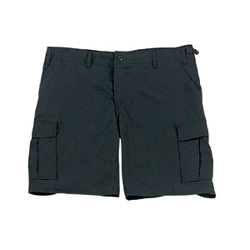
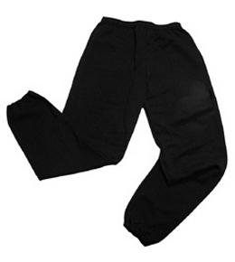
Their kit should consist of a white t-shirt, dark blue or black shorts/jogging bottoms and trainers/daps.
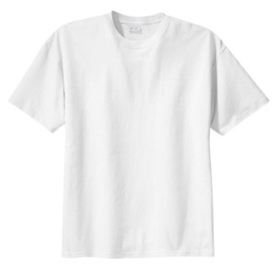

No jewellery is to be worn; hair needs to be tied back and head scarves must be short and tight fitting. These are all to ensure the safety of your child.

If children wear earrings, they need to be able to take them out (independently) for PE lessons.

HOMEWORK

Your child will bring maths, reading comprehension and spelling homework home on a Friday, to be returned by the following Wednesday. Spellings will be tested weekly on a Thursday.

If you have any questions, please do not hesitate to come and see us at the end of the school day.

Many Thanks

Mrs Waller, Miss Wong, Mrs Mathews and Mr Roberts
The Year Five Team

