Year 5 Summer Newsletter – Term 6

Dear Parents and Carers,

We hope you have had a lovely half term break and you are ready for the last term of Year 5! As it is getting warmer, please ensure that children always come to school with a water bottle and a sun hat. Sun cream should be applied at home, though some may wish to have a small bottle with them for extra use. We will not be providing sun cream at school.

English
Reading | This term, we will be looking at a non-fiction text called, ‘Everest.’ Which is based on real events and factual information about Mount Everest and its history of exploration. Children will have opportunities to practise a range of comprehension strategies, to develop their understanding.
Maths | We will be learning how to measure and draw acute, obtuse and reflex angles and measure angles on a line and around a point. Accuracy is very important when measuring the angles as the measurement needs to be accurate within 2°. The last skills to be learnt will be reading a 24-hour digital clock and converting between 12-hour analogue and 24-hour notation. Using that information, we will then learn how to read and interpret information in tables and line graphs.
Geography | In geography, we will be answering the question ‘How did a sandwich change Swindon?’. To learn about our place in the UK, we will look at a map of the UK and find out about how regions and counties split the country up. Then, we will learn about the changes Swindon has been through using a range of maps from the 1800s to the current day. Knowing the 8 points of a compass is an important skill and that will be covered alongside learning how to use grid references.
Science | In Science, we will be learning about ‘Animals including Humans’. We will be understanding the development of a baby and explaining the changes that take place into old age. Towards the end of the term, we will be completing a TAPS assessment that shows our observation of children from reception – year 6 and draw conclusions from our recorded findings.
RE | In RE our big question is: Does belief in the Trinity help Christians make better sense of God as a whole? Children will have the opportunity to explore reasons why Christians believe in the Holy Trinity and how this helps them understand Gods existence and power.
Computing | In Computing, we will develop our knowledge of ‘selection’ by revisiting how ‘conditions’ can be used in programming, and then learning how the ‘if… then… else...’ structure can be used to select different outcomes depending on whether a condition is ‘true’ or ‘false’. These skills will then be used to design a quiz in response to a given task and implement it as a program.
DT | This term, we will be building bridges. We will start by examining work by Isambard Kingdom Brunel, and identifying different types of bridges and the materials they are built from and why. As part of the planning process children will explore how to stabilise and strengthen their structures before building their wooden structure.
PSHE | In Term 6, our PSHE focus will be Changing Me. This will include learning about self-image and puberty for both boys and girls. These lessons are all compulsory and part of the National Curriculum. We would encourage you to discuss these topics further at home.
PE | We are very excited to be able to offer the Year 5 children a series of swimming lessons this term. All children will need to bring a swimming costume and towel to school EVERY MONDAY, so they will be prepared for their lesson.

Additional Information

PE
Year 5 PE is on a Tuesday afternoon. Children will need to bring their PE kits in for the whole week. Their kit should consist of a white t-shirt, dark blue or black shorts/jogging bottoms and trainers. A sun hat or cap may be useful during the summer months.
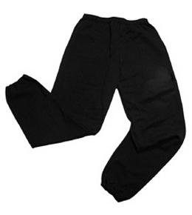
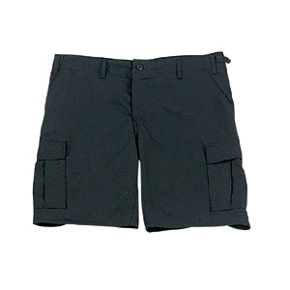


No jewellery is to be worn; hair needs to be tied back and head scarves must be short and tight fitting. These are all to ensure the safety of your child. If children wear earrings, they need to be able to take them out (independently) for PE lessons or cover up.

READING
Listening to your child read every day will help them to improve their fluency and comprehension. They can read their own books at home or take books from the school library. Reading comprehension is vital so they will need your support to help practice the skills we will teach. You can help at home by asking your child questions about their book after they have read such as ‘How do you know he is angry?’ or ‘Why is she happy?’

HOMEWORK
Your child will be given homework to complete on a Friday, to be returned by the following Wednesday. This will include spelling homework (which will be tested weekly), maths to recap prior learning and a short reading comprehension.

If you have any questions, please do not hesitate to come and see us at the end of the school day.

Many Thanks

Mrs Waller, Mrs Mathews and Mrss Wong.
The Year Five Team

