Year 6 Autumn 1 Newsletter

Dear Parents and Carers,

Welcome back after the summer holidays! We hope you all had a wonderful break and are feeling refreshed and ready for an exciting term ahead.
English | In English, we will use Skellig as the inspiration for our writing. Pupils will explore creative writing, poetry and the accurate use of speech punctuation, developing key Year 5 and Year 6 writing skills throughout the term.
Reading comprehension | In Reading, we will use Skellig to strengthen comprehension skills, with a focus on retrieval and inference. Pupils will also explore the book in depth, developing their understanding of its characters, themes, language and narrative style.
Maths | In Maths, we will build confidence with number and place value, alongside the four operations: addition, subtraction, multiplication and division. Towards the end of the term, pupils will also complete their first practice SATs paper to help prepare them for Year 6 assessments.
Science | This term in Science, Year 6 will be exploring “Animals and Their Habitats”. We will learn how living things are classified, discover the work of Carl Linnaeus, investigate micro-organisms and research different groups of animals. We will also become young scientists by surveying living things around our school and using classification keys to organise our findings.
Geography | Our topic in term one is “Natural Disasters”. We will look at earthquakes, volcanoes and extreme weather conditions.
RE | In RE we will be studying Islam and how Muslims show their commitment to Allah.
PSHE | In PSHE we will look at our goals for the year ahead, our learning behaviours, how our actions can affect people around us and the importance of democracy.
Computing | In computing, we will look at the template and layout of different websites before creating our own, using hyperlinks.

PE
This year, our PE session is on a Thursday. All children must arrive to school in their uniform and will get changed for PE just before lunch.
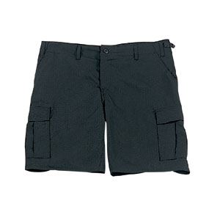
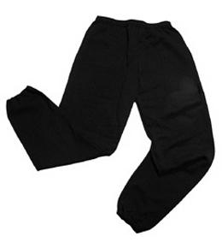
Their kit should consist of a white t-shirt, dark blue or black shorts/jogging bottoms, jumper and trainers/daps.
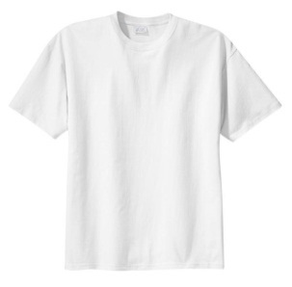

No jewellery is to be worn; hair needs to be tied back and head scarves must be short and tight fitting. These are to ensure the safety of your child.

READING
It is very important that your child is reading at home. We will allow children to take home books from their classroom. We would encourage each child to read for about 20 minutes every day. Please try to listen to your children and ask them questions about the books they are reading.
HOMEWORK
Your child will receive homework each week. This homework will be set online on a Friday and should be completed by the following Wednesday. This will be some maths work, a reading task and some spellings. They will be tested on their spellings every Friday.

If you have any questions, please do not hesitate to contact the school office.

Many Thanks

Mrs Vernon, Mr Richardson and Mrs Ramzan
The Year 6 Team

