Year 6 Term 2 Newsletter

Dear Parents and Carers,

Welcome to Term 2! We have an exciting and enriching term ahead, with plenty of engaging learning opportunities for the children.

In history, our focus will be on World War II. The children will learn about key events, the impact of the war on different countries, and the experiences of those who lived through it. This will give them a deep understanding of the historical significance of the war and its lasting effects on the world.

For our writing sessions, we’ll be using The Snow Queen as a source of inspiration. The children will write both fiction and non-fiction texts, focusing on creating alternative endings to the story and crafting persuasive writing pieces. These activities will allow them to develop their creativity, critical thinking, and argumentative writing skills, helping them to express their ideas effectively.

In science, we’re moving on to a fascinating biology topic: Living Things and Their Habitats. The students will explore various ecosystems, learn about classification of species, and understand how living organisms adapt to their environments. We will also be investigating life cycles and how habitats support different types of life.

We will continue to build on Year 6 writing skills across a range of fiction and non-fiction genres. This will include persuasive writing and narrative storytelling, helping the children to become confident and versatile writers. Our reading comprehension activities will involve a wide range of extracts to develop critical thinking and analysis skills.

In Religious Education (RE), our focus this term is on Christianity. The children will explore key beliefs, practices, and traditions, gaining insight into the role Christianity plays in many cultures around the world.

We are looking forward to an inspiring and productive term!

PE
This year our PE session is on a Monday. All children must arrive to school in their uniform.
Their kit should consist of a white t-shirt, dark blue or black shorts/jogging bottoms, jumper and trainers/daps.
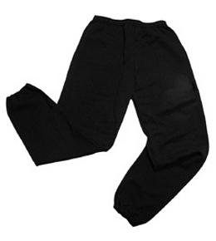
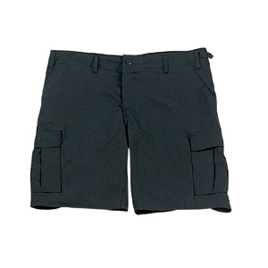
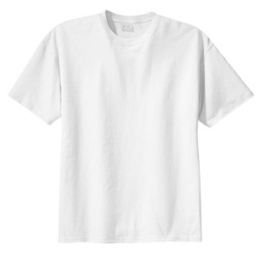

No jewellery is to be worn; hair needs to be tied back and head scarves must be short and tight fitting. These are to ensure the safety of your child.

READING
Every child will have their own individual log in for Reading Boost to access books set by the class teacher. To access the Reading Boost, search for ‘Reading Boost’ on Google. Then enter the user name and password which was given to each pupil last term.

It is also important that you listen to your child read books as much as possible, as this will help both their reading and writing abilities.

HOMEWORK
Your child will receive homework each week. This homework will be set on Friday and should be completed by the following Wednesday. Each week, your child will be set one spelling task, one maths task and a reading task.

If you have any questions, please do not hesitate to contact the school office.

Many Thanks
Mrs Ramzan, Mrs Vernon and Mr Richardson
The Year 6 Team

