Year 6 Summer 2 Newsletter

Dear Parents and Carers,

Welcome back to the final Summer term, we hope that you are all keeping well. This is an exciting term as there are lots of events on the Year 6 calendar, so please keep an eye out for updates. We are going to be busy rehearsing our play, “Beauty And The Beast”. There is also Drove’s GotTalent, the summer fete, the end of year prom and our leavers assembly.

This term we will also be preparing the children for their transitions to Year 7 in September. You should have all been informed by your child’s new school when this will take place. On these days, they will need to attend in their Drove uniform, but do not need to come here first.

PE
This year our PE session is on a Thursday. All children must arrive to school in their uniform and bring their PE kits to school.
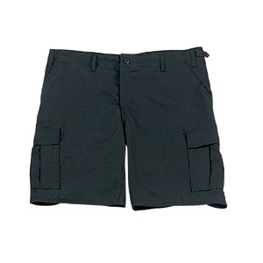
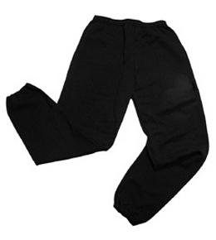
Their kit should consist of a white t-shirt, dark blue or black shorts/jogging bottoms, jumper and trainers/daps.


No jewellery is to be worn; hair needs to be tied back and head scarves must be short and tight fitting. These are to ensure the safety of your child.

PHSE

In Term 6, our PHSE unit is called ‘Changing me.’ The children will learn about puberty and also focus on self-image and relationships. We will also help the children to prepare for their transition to secondary school. These lessons are all compulsory and part of the National Curriculum. We would encourage you to discuss these topics further at home with your child.

READING
It is important that you listen to your child read books as much as possible, as this will help both their reading and writing abilities.

Many Thanks

Mrs Ramzan, Mrs Vernon and Mr Richardson
The Year 6 Team

