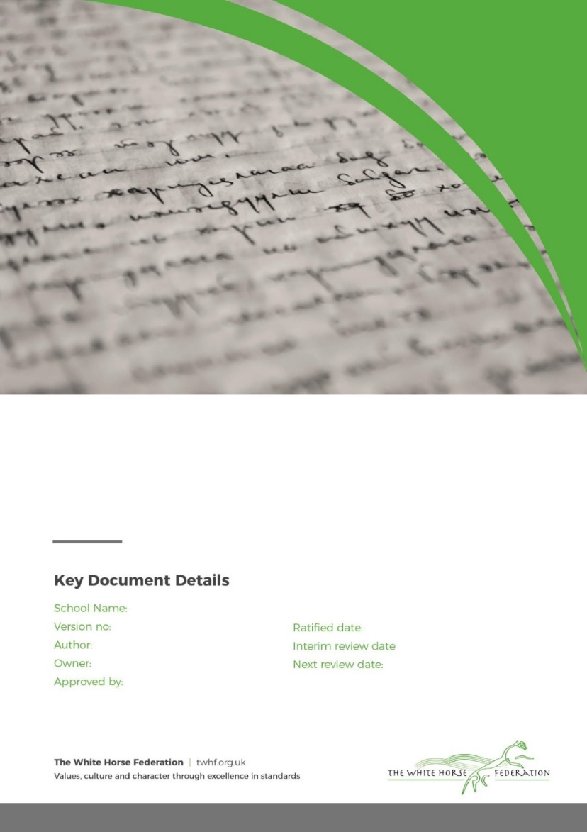

School Name: Drove Primary School

Version no: 1

Author: Lisa Davies & Chloe Hooper

Approved by: Director of Education

Ratified by: Director of Education

**The White Horse Federation**

**Early Years Policy**

Drove Primary School

Ratified date: July 2025

Interim review: July 2026

Next review date: July 2027

**Contents**

1. Aims 2

2. Legislation 3

3. Structure of the EYFS 3

4. Curriculum 3

5. Assessment 6

6. Working with parents and carers 7

7. Safeguarding and welfare procedures 8

8. Monitoring arrangements 9

Appendix 1. List of statutory policies and procedures for the EYFS 10

# **1. Aims**

This policy aims to ensure:

* That children access a broad and balanced curriculum that gives them the broad range of knowledge and skills needed for good progress through school and life
* Quality and consistency in teaching and learning so that every child makes good progress and no child gets left behind
* A close working partnership between staff and parents and/or carers
* Every child is included and supported through equality of opportunity and anti-discriminatory practice

# **Our TWHF Core Commitments: What Matters Most**

At Drove Primary School and The White Horse Federation, we are united by a shared ambition: *The Best Start in Life.*

Our eight EYFS Core Commitments are embedded to ensure that every child receives an equitable, high-quality early years offer. These commitments are not just statements; they are lived values that shape our daily practice and long-term vision.

Our Core Commitments:

1. A Nurturing, Inclusive Environment with a Strong Sense of Belonging
2. Exceptional Teaching, High-Quality CPD, and Meaningful Interactions
3. Oracy and Language-Rich Environments
4. Immersive Literacy and Numeracy: Books, Rhymes, Number and Storytelling
5. Child-Centred, Play-Based Learning
6. Equity for All Groups of Learners
7. Personal Development and Positive Behaviour Foundations
8. Strong Parent and Carer Partnerships

Across our school, we ensure that:

* Quality talk and meaningful discussion permeate every learning environment.
* Children are immersed in language-rich, playful experiences that support their communication, thinking, and creativity.
* A strong sense of belonging and community is nurtured—for both children and their families—so that every child feels safe, valued, and ready to thrive.
* Our staff team are empowered through high-quality CPD and collaboration, ensuring consistency and excellence in teaching and care.
* We foster equity, inclusion, and aspiration, giving every child the very best start in life.

# **2. Legislation**

This policy is based on requirements set out in the [statutory framework for the Early Years Foundation Stage (EYFS)](https://www.gov.uk/government/publications/early-years-foundation-stage-framework--2) for 2024.

# **3. Structure of the EYFS**

At the White Horse Federation, we have children from 2-5 years of age across our Early Years.

At Drove Primary School our EYFS setting is for children from 2-5 years of age. We have 3 classrooms in total in our nursery. One 2-3 year old room and two 3-4 year old rooms. We offer 15 hours per week, attending either morning or afternoon sessions.

In Reception, there are 3 classrooms of 30 children.

# **4. Curriculum**

4.1 Our early years follows the curriculum as outlined in the latest EYFS statutory framework, alongside our TWHF Early Years Common Curriculum.

The EYFS framework includes 7 areas of learning and development that are equally important and inter-connected. Three areas, known as the prime areas, are seen as particularly important for building children’s capacity to learn, form relationships and thrive.

The prime areas are:

* Communication and language
* Physical development
* Personal, social and emotional development

The prime areas are strengthened and developed, and children’s curiosity and enthusiasm are ignited, through 4 specific areas:

* Literacy
* Mathematics
* Understanding the world
* Expressive arts and design

Each area of learning and development is implemented through planned, purposeful play, and through a mix of adult-led and child-initiated activities.

4.2 TWHF ENRich Curriculum

At The White Horse Federation, we are committed to giving every child the best start in life. Our Early Years follows the TWHF ENRich curriculum from the age of 2-5. This ensures a consistent, high-quality offer across all our settings.

Language, Oracy and Literacy

We use the *Talk for Writing* approach across all EYFS age groups. This method supports children in developing their spoken language skills by encouraging them to orally rehearse sentences before writing them. Through this process, children build confidence, fluency, and a deeper understanding of sentence structure.

Each term, children are immersed in a carefully curated selection of high-quality texts. These include a mix of traditional tales and well-loved children’s classics. The chosen texts are not only engaging but also rich in vocabulary and storytelling techniques, helping to foster a genuine love of reading and storytelling.

Our curriculum is intentionally designed to be language-rich, ensuring that children are surrounded by meaningful vocabulary and expressive language throughout their day. This immersive environment helps to break down barriers to learning, enabling all children to access the curriculum and achieve well.

Phonics

Children follow their SSP in phonics, and the love of reading is further developed through the core text immersion, as well as book guides to help teachers reflect on key questions and tier 2 vocabulary when reading with their class . This approach ensures that children develop from the EYFS as confident emerging readers.

At Drove Primary School we follow the Little Wandle SSP to support our children with their phonic knowledge. We follow the progression in Little Wandle where children are taught from the simple to more complex GPCs, as well as taking into account the frequency of their occurrence in the most commonly encountered words, sentences, and later on, in fully decodable books. Children review and revise GPCs and words, daily, weekly and across terms and years, in order to move this knowledge into their long-term memory

Mathematics

We follow our TWHF ENRich EYFS maths curriculum, ensuring children have a strong foundational knowledge of maths.

This is delivered through taught sessions and a number-rich learning environment where children can grow and develop their mathematical understanding.

Play Progressions

TWHF Play progressions have been produced to support effective play in the following 9 areas:

1. Small world
2. Construction
3. Role play
4. Malleable
5. Sand play
6. Water play
7. Mud kitchen play
8. Fine motor skills play
9. Stage, performance and drama

These are carefully constructed to take into account oracy, problem solving and language, alongside a child’s level of play.

4.3 Planning

We use carefully considered and well sequenced TWHF planning for :

* T4W
* Maths
* Continuous Provision Plans
* Book talk
* Play Progressions

TWHF continuous provision plans are carefully mapped out to enrich the stories and tales while still developing our children in all areas.

Our EYFS team also take into account the individual needs, interests, and stage of development of each child in their care, and use this information to plan a challenging and enjoyable experience. It is important that teachers use their baseline knowledge to also purposefully plan their provision to bridge any gaps and so that all children achieve well.

Enhanced provision is always inviting and stimulating, and carefully and well planned to support the needs or interests of the learners.

Where a child may have a special educational need or disability (SEND), staff consider whether specialist support is required, linking with relevant services from other agencies, where appropriate.

In planning and guiding children’s activities, staff reflect on the different ways that children learn and include these in their practice.

4.4 Teaching

Each area of learning and development is implemented through planned, purposeful play, and through a mix of adult-led and child-initiated activities. Staff respond to each child’s emerging needs and interests, guiding their development through warm, positive interaction.

At Drove, our Early Years Settings are attached to an outdoor space. The children have opportunities throughout the day to have ‘free learning’ time, whereby the children can choose which area of the environment they would like to explore. This allows the children to independently explore the indoor and outdoor environment. The outdoor environment has a positive impact on the children’s development and at Drove we see it as an integral part of the children’s learning and development. It acts as an extension to the indoor environment, allowing the children to be physically active and encourages the use of their senses. We go outside in all kinds of weather and adapt activities where necessary.

As the children grow older, and as their development allows, the balance gradually shifts towards more adult-led activities to help the children prepare for more formal learning, ready for year 1.

# **5. Assessment**

At The White Horse Federation, we use ongoing assessment as an integral part of the learning and development processes. Staff observe pupils to identify their level of achievement, interests and learning styles. These observations are used to shape future planning.

Staff also take into account observations shared by parents and/or carers.

2 Year Olds

When a child is **aged between 2 and 3**, staff review their progress and provide parents and/or carers with a written summary using our TWHF 2 Year Progress Check. This ‘progress check’ highlights the areas in which a child is progressing well and the areas in which additional support is needed.

Nursery/ Pre-School

In Nursery, we observe children to help us make judgements on the children’s progress. This also helps us plan to support and enhance the children’s development.

All children in our Nursery are assessed using WELLCOM. This helps us screen a child’s language development and enables us to give targeted support if requited.

Reception

Within the first 6 weeks thata child*starts reception*, staff will administer the reception baseline assessment (RBA).

We also complete our own TWHF baseline to support us understanding the needs of the children and help us plan purposeful provision.

In addition, all children will have a WELLCOM assessment when they start in Reception so we can identify any gaps in speech and language.

*At the end of the EYFS*, staff complete the EYFS profile for each child. Pupils are assessed against the 17 early learning goals, indicating whether they are:

* Meeting expected levels of development
* Not yet reaching expected levels (‘emerging’)

The profile reflects ongoing observations, and discussions with parents and/or carers. The school shares the results of each child’s assessment with their parents and/or carers.

The profile is moderated internally (referring to the Development Matters [guidance](https://www.gov.uk/government/publications/development-matters--2)) and in partnership with TWHF schools, to ensure consistent assessment judgements. EYFS profile data is submitted to the local authority.

# **6. Working with parents and carers**

We recognise that children learn and develop well when there’s a strong partnership between staff and parents and/or carers. This is why it is one of our TWHF Core Commitments for Early Years.

Parents and/or carers are kept up to date with their child’s progress and development. The progress check and EYFS profile helps to provide parents and/or carers with a well-rounded picture of their child’s knowledge, understanding and abilities.

In Nursery, each child is assigned a key person who helps to ensure that their learning and care is tailored to meet their needs. The key person supports parents and/or carers in guiding their child’s development at home. The key person also helps families to engage with more specialist support, if appropriate.

In addition, We hold termly events, parent workshops and invite parents to come into the class and spend time with the children. The teachers plan a range of activities throughout the year to promote parent engagement. It is a very happy and welcoming time and enables parents to have valuable 1:1 time with their child. It also allows the parents to ask the teachers any questions.

As well as these we also build our partnership through:

* Home visits before their child starts school or nursery
* Before the children start school they, along with their parents, have the opportunity to come into school to spend time in the environment and get to know their teacher.
* They are invited into the school for story sessions where they can sit and listen to stories with the children.
* We invite all parents to an induction meeting in July, before the children start school. This explains everything they need to know about Drove, what their children will be learning and how they can help at home.
* Parents are invited to parent workshops where hear and see example of what their child will be leaning in Maths and phonics.
* Offering parents regular opportunities before and after school to discuss their child’s progress or any concerns they have.

# **7. Safeguarding and welfare procedures**

We recognise that children learn best when they are healthy, safe and secure, when their individual needs are met and when they have positive relationships with the adults caring for them. We follow safeguarding and welfare requirements to provide a welcoming, safe and stimulating environment where children are able to enjoy learning and grow in confidence.

We follow guidance from KCSIE, as well as the EYFS Safeguarding Reforms:

[Early Years Foundation Stage safeguarding reforms - consultation response](https://assets.publishing.service.gov.uk/media/6705184530536cb927482dd6/Early_years_foundation_stage_safeguarding_reforms_-_response.pdf)

We make sure that the appropriate statutory staff:child ratios are maintained in our setting to meet the needs of all children and ensure their safety:

* For children aged 2, we have at least 1 member of staff for every 5 children
* For children aged 3 and over:
  + Where a person with Qualified Teacher Status, Early Years Professional Status, or Early Years Teacher Status is working directly with the children, we have at least 1 member of staff for every 13 children

For Reception classes :

* + We comply with infant class size legislation and have at least 1 teacher per 30 pupils

For mixed classes:

* + We determine ratios guided by all relevant ratio requirements and by the needs of the children within the group

When recruiting staff, we will follow the procedures set out in the latest EYFS framework guidance on checking the suitability of new recruits and recording information about staff qualifications and identity checks, vetting processes and references.

We have at least 1 person with a current paediatric first aid (PFA) certificate on the premises and available at all times when children are present, including on outings.

This PFA certificate is renewed every 3 years as required.

In addition, trainees, apprentices and students will hold a Level 2 Paediatric First Aid (PFA) certificate in order to be included in staff-to-child ratios, in line with EYFS statutory requirements.

We also have a designated lead practitioner who is responsible for safeguarding children. They are also responsible for:

* Liaising with local statutory children's services agencies, and with the LSP (local safeguarding partners)
* Providing support, advice and guidance to any other staff on an ongoing basis, and on any specific safeguarding issue as required
* Attending a child protection training course that enables them to identify, understand and respond appropriately to signs of possible abuse and neglect

All practitioners are alert to any issues of concern in children’s life at home or elsewhere.

7.1 Oral health and tooth brushing

We promote good oral health, as well as good health in general, in the early years by teaching children:

* The effects of eating too many sweet things
* The importance of brushing your teeth
* How and when they should be brushing their teeth

The rest of our safeguarding and welfare procedures are outlined in our school’s child protection and safeguarding policy, which can be found here [Policies & Procedures | Drove Primary School](https://drove-pri.swindon.sch.uk/about-us/school-information/policies-procedures).

# **8. Monitoring arrangements**

This policy will be reviewed and approved by Lisa Davies, Executive Headteacher every two years.

This policy will also be reviewed accordingly by the school’s headteacher and EYFS Lead.

At every review, the policy will be shared with the school’s governing board.

# 

# Appendix 1. List of statutory policies and procedures for the EYFS

This isn’t an exhaustive list of policies and only includes policies specific to the EYFS. For a full list of our policies, see [Policies & Procedures | Drove Primary School](https://drove-pri.swindon.sch.uk/about-us/school-information/policies-procedures)

| Statutory policy or procedure for the EYFS | Where can it be found? |
| --- | --- |
| Safeguarding policy and procedures | See child protection and safeguarding policy |
| Procedure for responding to illness | See supporting pupils with medical conditions policy |
| Administering medicines policy | See supporting pupils with medical conditions policy |
| Emergency evacuation procedure | (Not online) |
| Procedure for checking the identity of visitors | See child protection and safeguarding policy |
| Procedures for a parent/carer failing to collect a child and for missing children | See child protection and safeguarding policy |
| Procedure for dealing with concerns and complaints | See complaints policy |
| Intimate Care | See Intimate Care Policy |

Please also refer to our school’s handbook for more information about your school.