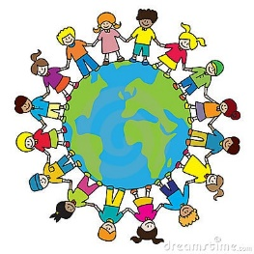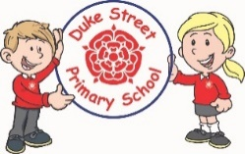

**Understanding the world**

The children will be talking about members of their immediate family and will name people who are familiar to them. Using their chatter bags they will comment on images from their past. The children will be visiting the park and drawing a simple map.

**Mathematics:**

Following Red Rose Maths the children will be looking at numbers 1-10 using numberland. They will develop their 1:1 correspondence when counting, practice forming these numbers correctly and learning to show how to represent these numbers in different ways.

**Physical development**

The children will be completing Forest school and PE on alternate weeks.

They will also be developing their gross and fine motor skills through continuous provision challenges inside and outside.

**Literacy**

**Autumn 1 and 2 Focused Texts:**

Shark in the park on a windy day, Starting School, Harry and his Bucketful of dinosaurs start school, Topsy and Tim start school, Elmer, Peace at Last, Wriggle and Roar (rhymes to join in with) All about families, welcome to the world

**Phonics:** The children will have daily phonics sessions learning sounds from phase 2 following the Red Rose phonics scheme.

We will begin to form the letter sounds and write simple CVC words.

The children will be learning to write their name independently.

Autumn 1 Me and My world

Autumn 2 Sparkle and Shine

**EYFS**

Autumn 2025-2026

**Communication and Language**

The children will working in key worker groups to develop their listening and attention skills for a short period of time.

We will be developing our vocabulary through the stories that we hear.

**Important dates:**

September Buddy Brunch

11th November Remembrance Day

December Christmas songs around the Christmas tree

December Pantomime

December Reception Christmas party.

**Personal, social and emotional development**

We will be following “My Happy Mind” to focus on feelings and emotions. We will also look at routines and boundaries and developing relationships with their peers.

**Expressive arts and design**

The children will be using different tools to mix and explore different colours. They will practise different printing styles to make wrapping paper for our celebrations.