Mathematics: Daily mathematics lesson will cover:
All year 3 and year 4 children will follow the Lancashire Red Rose scheme looking at the 4 operations in number, place value, fractions, 2d shape, position & direction, area, time and statistics.

History:
Spring 2: The Romans
The Roman invasion of Britain.
The impact the Roman Empire had on British life.

Science:
Summer 1: Living things and their habitats.
Looking at classification and branching databases (Computer curriculum links)
Summer 2: Sound- identify how sounds are made, associating some of them with something vibrating.
English: Daily English lessons
Y3 & Y4 National Curriculum Objectives
Summer 1 – What the Romans did for us.
Key Texts – Stage Start by Julie Meighan, Playtime by Julia Donaldson & Romans on the Rampage by Jeremy Strong
Writing focus: Playscripts and information texts.
Summer 2 – Hunted – folk tales
Key text: Anansi -The trickster spider by
Brer rabbit.
Wring focus: Story writing & a debate along with performance poetry

Year 3 and 4 Curriculum Plans Summer 2026
Autumn Term 2025-26

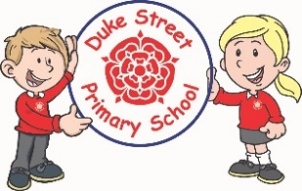






Music
All children in year 3&4 will have the opportunity to learn to play the ukulele. This will be done on a rota basis. Beech continuing in the Summer term along with Rowan.
Charanga units of work will be done for all other music lessons concentrating on singing and instrument playing (glockenspiels)

PE:
Summer 1: Athletics & Tennis culminating in Sports Day.
Summer 2 : Cricket and football
We will be learning a range of skills as well as focussing on displaying good sportsmanship.
The children will also be having swimming lessons on site.

Geography
Summer 1: Studying the physical and natural feature of Rome in Italy.

French Primary Languages Network scheme.
Summer 1: Beech & Maple : Animals.
Rowan: The Hungry giant
Summer 2: Beech & Maple :Numbers & carnivals
Rowan: Going on a picnic
Computing:
Summer 1:Branching databases
Summer 2:Photo editing

DT:
Summer 1: Levers and linkages
Skills: Continuing to learn how levers work to increase force and reduce effort. We will create an iron man with a waving arm.
Summer 2: Shell structures
Creating boxes to home doughnuts.
To include: appraising current products, designing new packaging , prototyping then building them.

Our Core Values
School Aims:
Duke Street Primary School aims to:
- provide a secure, caring and stimulating learning environment,
- promote self-discipline, moral values and self-esteem,
- set challenging yet realistic goals in order to allow each child and member of staff to reach his or her potential
- encourage an enthusiastic attitude to learning through a well-balanced and varied curriculum.
- work in partnership with parents to provide the best for each child in order to get the best from each child
- offer colleagues an enjoyable, positive environment in which to work, fostering both team commitment and the well-being of everyone within our school.

PSHE:
My Happy Mind: Relate & engage modules
Coral SCARF scheme
Summer 1: Being my Best
Summer 2: Growing and changes
RE:
Summer 1 Islam – Why do Muslims fast at Ramadan?

Summer 2 Christianity – Parables – what does ‘love your neighbour’ really mean?

Curriculum Drivers:
Enrichment field to Blackpool Zoo.
To observe and study the habitats of different animals at the zoo.

School Expectations
- We are kind and helpful
- We listen
- We are honest
- We work hard and take pride in our work
- We look after property

British Values:
Our work throughout the curriculum will promote the British Values of:
- Democracy
- Rule of Law
- Mutual Respect
- Individual Liberty
- Tolerance & harmony
- Responsibility/positive contribution
- Public Institution

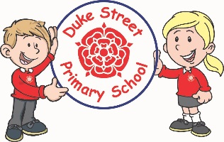
Enrichment:
Enrichment days will be schedules over the two half terms.
Clubs will continue to run for children to participate in .
- Trip to a local church for R.E

