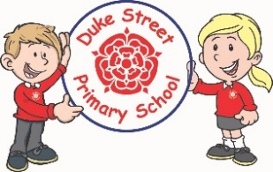
Music:
All children in year 3&4 will have the opportunity to learn to play the ukulele. This will be done on a rota basis. Beech during the spring term , Rowan in the in the summer.

Music will also be taught cross-curricular through dance units in P.E.

Computing:
Spring 1: Events in action
Spring 2: Repetition of shapes

Year 3 and 4 Curriculum Plans Spring 2026
Autumn Term 2025-26
Geography
Spring 1: Coastal Area
We will be learning about a coastal area. We will identify human and physical features. We will visit a coastal area and complete some field work.

Mathematics: Daily mathematics lesson will cover:
All year 3 and year 4 children will follow the Lancashire Red Rose scheme looking at the 4 operations in number, place value, fractions, 2d shape, position & direction, area, time and statistics.

English: Daily English lessons
Y3 & Y4 National Curriculum Objectives
Spring 1:
Focused text: 101 Dalmatians
Spring 2:
Focussed text: The Iron Man
In each unit, the children will study each text and produce their own compositions based on these texts. They will also study poetry during each unit too.
Science: States of Matter
This term the children will explore the 3 states of matter: solids, liquids and gases.
They will discover the properties of each state and how they can change. The children will also recap the water cycle. During the unit they will have the opportunity to practise different science skills using different equipment.

History:
Spring 2: The Great Plague
We will be learning about how the great plague effected people in Lancashire and what life would have been like in Chorley during 1665 to 1666. This will build on learning about The Great Fire of London from Key Stage 1.

DT:
Spring 2: Levers and linkages
Skills: We will be learning how levers work to increase force and reduce effort. We will create an iron man with a waving arm.

Our Core Values

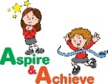
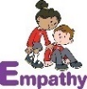
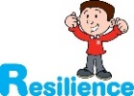

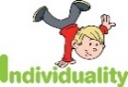
PE:
Spring 1: Dance and basketball
Spring 2: Tag rugby
We will be learning a range of skills as well as focussing on displaying good sportsmanship.

Art:
Spring 1: Sculpture
Skills: Joan Miro
We will be learning about famous sculpture artist Joan Miro. We will be working with clay and learning about making marks of clay, creating joins, slipping, scoring and pinching.

RE:
Spring 1: Sikh Dharam (Sikhism)
How do Sikhs express their beliefs and values?
Spring 2: Christianity
Is sacrifice an important part of religious life?

Curriculum Drivers:
Enrichment days -
Field trip to Duxbury Park for Geography unit on rivers and for History to visit the Myles Standish garden.
Trip to a coastal area to look at human and physical features and complete fieldwork.
French Primary Languages Network scheme.

Spring 1: Calendar and celebrations
Spring 2: Animals
School Aims:
Duke Street Primary School aims to:
- provide a secure, caring and stimulating learning environment,
- promote self-discipline, moral values and self-esteem,
- set challenging yet realistic goals in order to allow each child and member of staff to reach his or her potential
- encourage an enthusiastic attitude to learning through a well-balanced and varied curriculum.
- work in partnership with parents to provide the best for each child in order to get the best from each child
- offer colleagues an enjoyable, positive environment in which to work, fostering both team commitment and the well-being of everyone within our school.

PSHE:
My Happy Mind: ‘Appreciate’ and ‘Relate’ sessions
Coral SCARF scheme
Spring 1: Keeping myself safe
Spring 2: Rights and responsibilities

School Expectations
- We are kind and helpful
- We listen
- We are honest
- We work hard and take pride in our work
- We look after property
British Values:
Our work throughout the curriculum will promote the British Values of:
- Democracy
- Rule of Law
- Mutual Respect
- Individual Liberty
- Tolerance & harmony
- Responsibility/positive contribution
- Public Institution

Enrichment:
Enrichment days will be schedules over the two half terms.
Clubs will continue to run for children to participate in .
- Trip to a local church for R.E
