
Year 1 and 2 Curriculum Plans
Spring 2026
Mathematics: Daily mathematics lesson
(Y1 & Y2 National Curriculum Objectives)
Red Rose maths
This term we will focus on multiplication and division, money and mass, volume and capacity. In spring 2, we shall explore length, time, position and direction. The children will continue to use our maths characters to further develop their reasoning skills and engage in daily maths mastery sessions and early bird maths.

Computing:
Spring 1 – Moving a Robot
Using the buttons on a robot to plan and follow a route and look at individual commands.

Spring 2 – Introduction to animation
Children will be using Scratch Jnr to look at sprites and backgrounds. They will use the programming block to create and modify programs.

English: Daily English and phonics lesson
(Y1 & Y2 National Curriculum Objectives)

Focused Text:
Fiction: Man on the moon
We will be practicing writing in full sentences and building up to write our own version of the story.

Non- Fiction: Writing a non-fiction report on the Great Fire of London
Poetry:
Art:
3D Sculpture:

We are focusing on pinching and kneading clay supporting our motor skills.
Science:
Spring 1 – Animals including Humans
We will be looking at the importance of exercise and healthy eating.

Spring 2 – Everyday Materials
Identify and compare the suitability of different materials including plastic, glass, brick, wood, paper and cardboard, and rock and their uses.
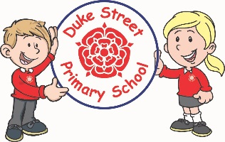
Our Core Values
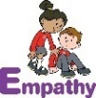
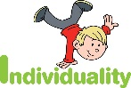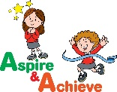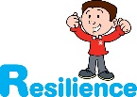
History:
Florence Nightingale

The children will explore the life of this inspirational woman and why she is significant in history.
Geography:
Looking at the small area of North America.

Children will explore the location of North America and compare its similarities and differences. We will look at physical and human features.
Curriculum Drivers:
- Enterprise – Develop collaborative learning within a group, class and whole school context.
- Resilience – Develop resilience when tackling challenging tasks.
- Aspiration – Complete your best work at all time.
- Real Experiences – Develop opportunities for outdoor learning.

Music:
Spruce - Recorders
Acer and Redwood - Sp1 – Music linked to dance/PE (Dance with the Elements- BBC)
Sp2 - Learning to Listen – following our Charanga scheme.
PE:Spring 1 –Dance and Movement Skills
Underarm throw, run, hop, jump, overarm throw, skip, bounding, rolling, kicking and catching. In Dance, the children will look at creating a dance with the inspiration of the Great Fire of London.
Spring 2 – Net and wall games and fundamental movements.
Underarm throw, run, hop, jump, overarm throw, skip, bounding, rolling, kicking and catching. The children will use these skills to develop in games.

RE:
Islam-
Key question: How should we respond to things that really matter?
We will look at what Muslim’s do to obey God and how they show their respect .

DT: sliders and leavers
Skills:
Finished Product: we will be creating a moving picture.


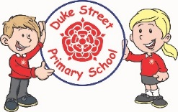
PSHE:
My Happy Mind
Spring 1 – Appreciate
The children will learn about the importance of being grateful for experiences.
Spring 2 – Relate
The children will learn about developing relationships with other people.

In our Weekly lessons, we shall be looking at Keeping ourselves safe.

British Values:
Our work throughout the curriculum will promote the British Values of:
- Democracy
- Rule of Law
- Mutual Respect
- Individual Liberty
- Tolerance & harmony
- Responsibility/positive contribution
- Public Institution

Enrichment:
- Enrichment Day
- Trip to the Hindu Temple

School Expectations
- We are kind and helpful
- We listen
- We are honest
- We work hard and take pride in our work
- We look after property
School Aims:
Duke Street Primary School aims to:
- provide a secure, caring and stimulating learning environment,
- promote self-discipline, moral values and self-esteem,
- set challenging yet realistic goals in order to allow each child and member of staff to reach his or her potential
- encourage an enthusiastic attitude to learning through a well-balanced and varied curriculum.
- work in partnership with parents to provide the best for each child in order to get the best from each child
- offer colleagues an enjoyable, positive environment in which to work, fostering both team commitment and the well-being of everyone within our school.

