
Year 1 and 2 Curriculum Plans
Spring 2026
Mathematics: Daily mathematics lesson
(Y1 & Y2 National Curriculum Objectives)
Red Rose maths
This term we will focus on number, addition, subtraction, measure and shape. The children will continue to use our maths characters to further develop their reasoning skills and engage in daily maths mastery sessions and early bird maths.

Computing:
Spring 1 – Grouping data
This unit introduces learners to data and information. Labelling, grouping, and searching are important aspects of data and information
Spring 2 – Digital writing
Children will be using Scratch Jnr to look at sprites and backgrounds. They will use the programming block to create and modify programs.

English: Daily English and phonics lesson
(Y1 & Y2 National Curriculum Objectives)
Focused Text -Fiction: The Great Paper caper
We will be practicing writing in full sentences. listening to and exploring the new characters before innovating our own characters and story.

Non- Fiction: Writing a non-fiction report on the Great Fire of London
Poetry:
ART
Changes to come.
Science
Summer 1 – Uses of everyday materials.
Objects made of some materials can be changed in shape by bending, stretching, squashing and twisting. For example, clay can be shaped by squashing, stretching, rolling, pressing etc. This can be a property of the material or depend on how the material has been processed e.g. thickness.
Summer 2 – Living things and their habitats
They will explore what makes something alive, discover different types of plants and animals, and learn how living things depend on their environments to survive. We will also look at a variety of habitats, from woodlands to oceans, and how these support different kinds of life.

Summer 2 – Living things and their habitats
They will explore what makes something alive, discover different types of plants and animals, and learn how living things depend on their environments to survive. We will also look at a variety of habitats, from woodlands to oceans, and how these support different kinds of life.
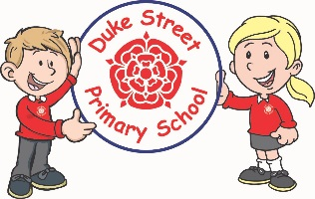
Our Core Values
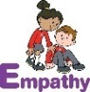
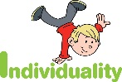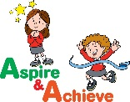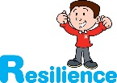
History:
The Victorian Seaside
We will learn about changes to holidays and the seaside between the Victorian times and now.
Geography:
Looking at the small area of North America.
Children will explore the location of North America and compare its similarities and differences. We will look at physical and human features.
Curriculum Drivers:
- Enterprise – Develop collaborative learning within a group, class and whole school context.
- Resilience – Develop resilience when tackling challenging tasks.
- Aspiration – Complete your best work at all time.
- Real Experiences – Develop opportunities for outdoor learning.

Music:
S1 - Having fun with improvisation
S2 - Our big concert
PE:Spring 1 –Dance and Movement Skills
Underarm throw, run, hop, jump, overarm throw, skip, bounding, rolling, kicking and catching. In Dance, the children will look at creating a dance with the inspiration of the Great Fire of London.
Spring 2 – Net and wall games and fundamental movements.
Underarm throw, run, hop, jump, overarm throw, skip, bounding, rolling, kicking and catching. The children will use these skills to develop in games.

RE:
KS1 Hindu Dharma
Key question: How might people express their devotion?
We will investigate Hindu's beliefs about God and how God is worshiped in many forms.

DT: sliders and leavers
In DT we are focusing on sliders and leavers in books and how we can make our own to represent under the sea.


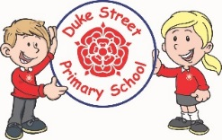
PSHE:
My Happy Mind
Spring 1 – Appreciate
The children will learn about the importance of being grateful for experiences.
Spring 2 – Relate
The children will learn about developing relationships with other people.

In our Weekly lessons, we shall be looking at Keeping ourselves safe.

British Values:
Our work throughout the curriculum will promote the British Values of:
- Democracy
- Rule of Law
- Mutual Respect
- Individual Liberty
- Tolerance & harmony
- Responsibility/positive contribution
- Public Institution

Enrichment:
- Enrichment Day
- Trip to the Hindu Temple

School Expectations
- We are kind and helpful
- We listen
- We are honest
- We work hard and take pride in our work
- We look after property
School Aims:
Duke Street Primary School aims to:
- provide a secure, caring and stimulating learning environment,
- promote self-discipline, moral values and self-esteem,
- set challenging yet realistic goals in order to allow each child and member of staff to reach his or her potential
- encourage an enthusiastic attitude to learning through a well-balanced and varied curriculum.
- work in partnership with parents to provide the best for each child in order to get the best from each child
- offer colleagues an enjoyable, positive environment in which to work, fostering both team commitment and the well-being of everyone within our school.

