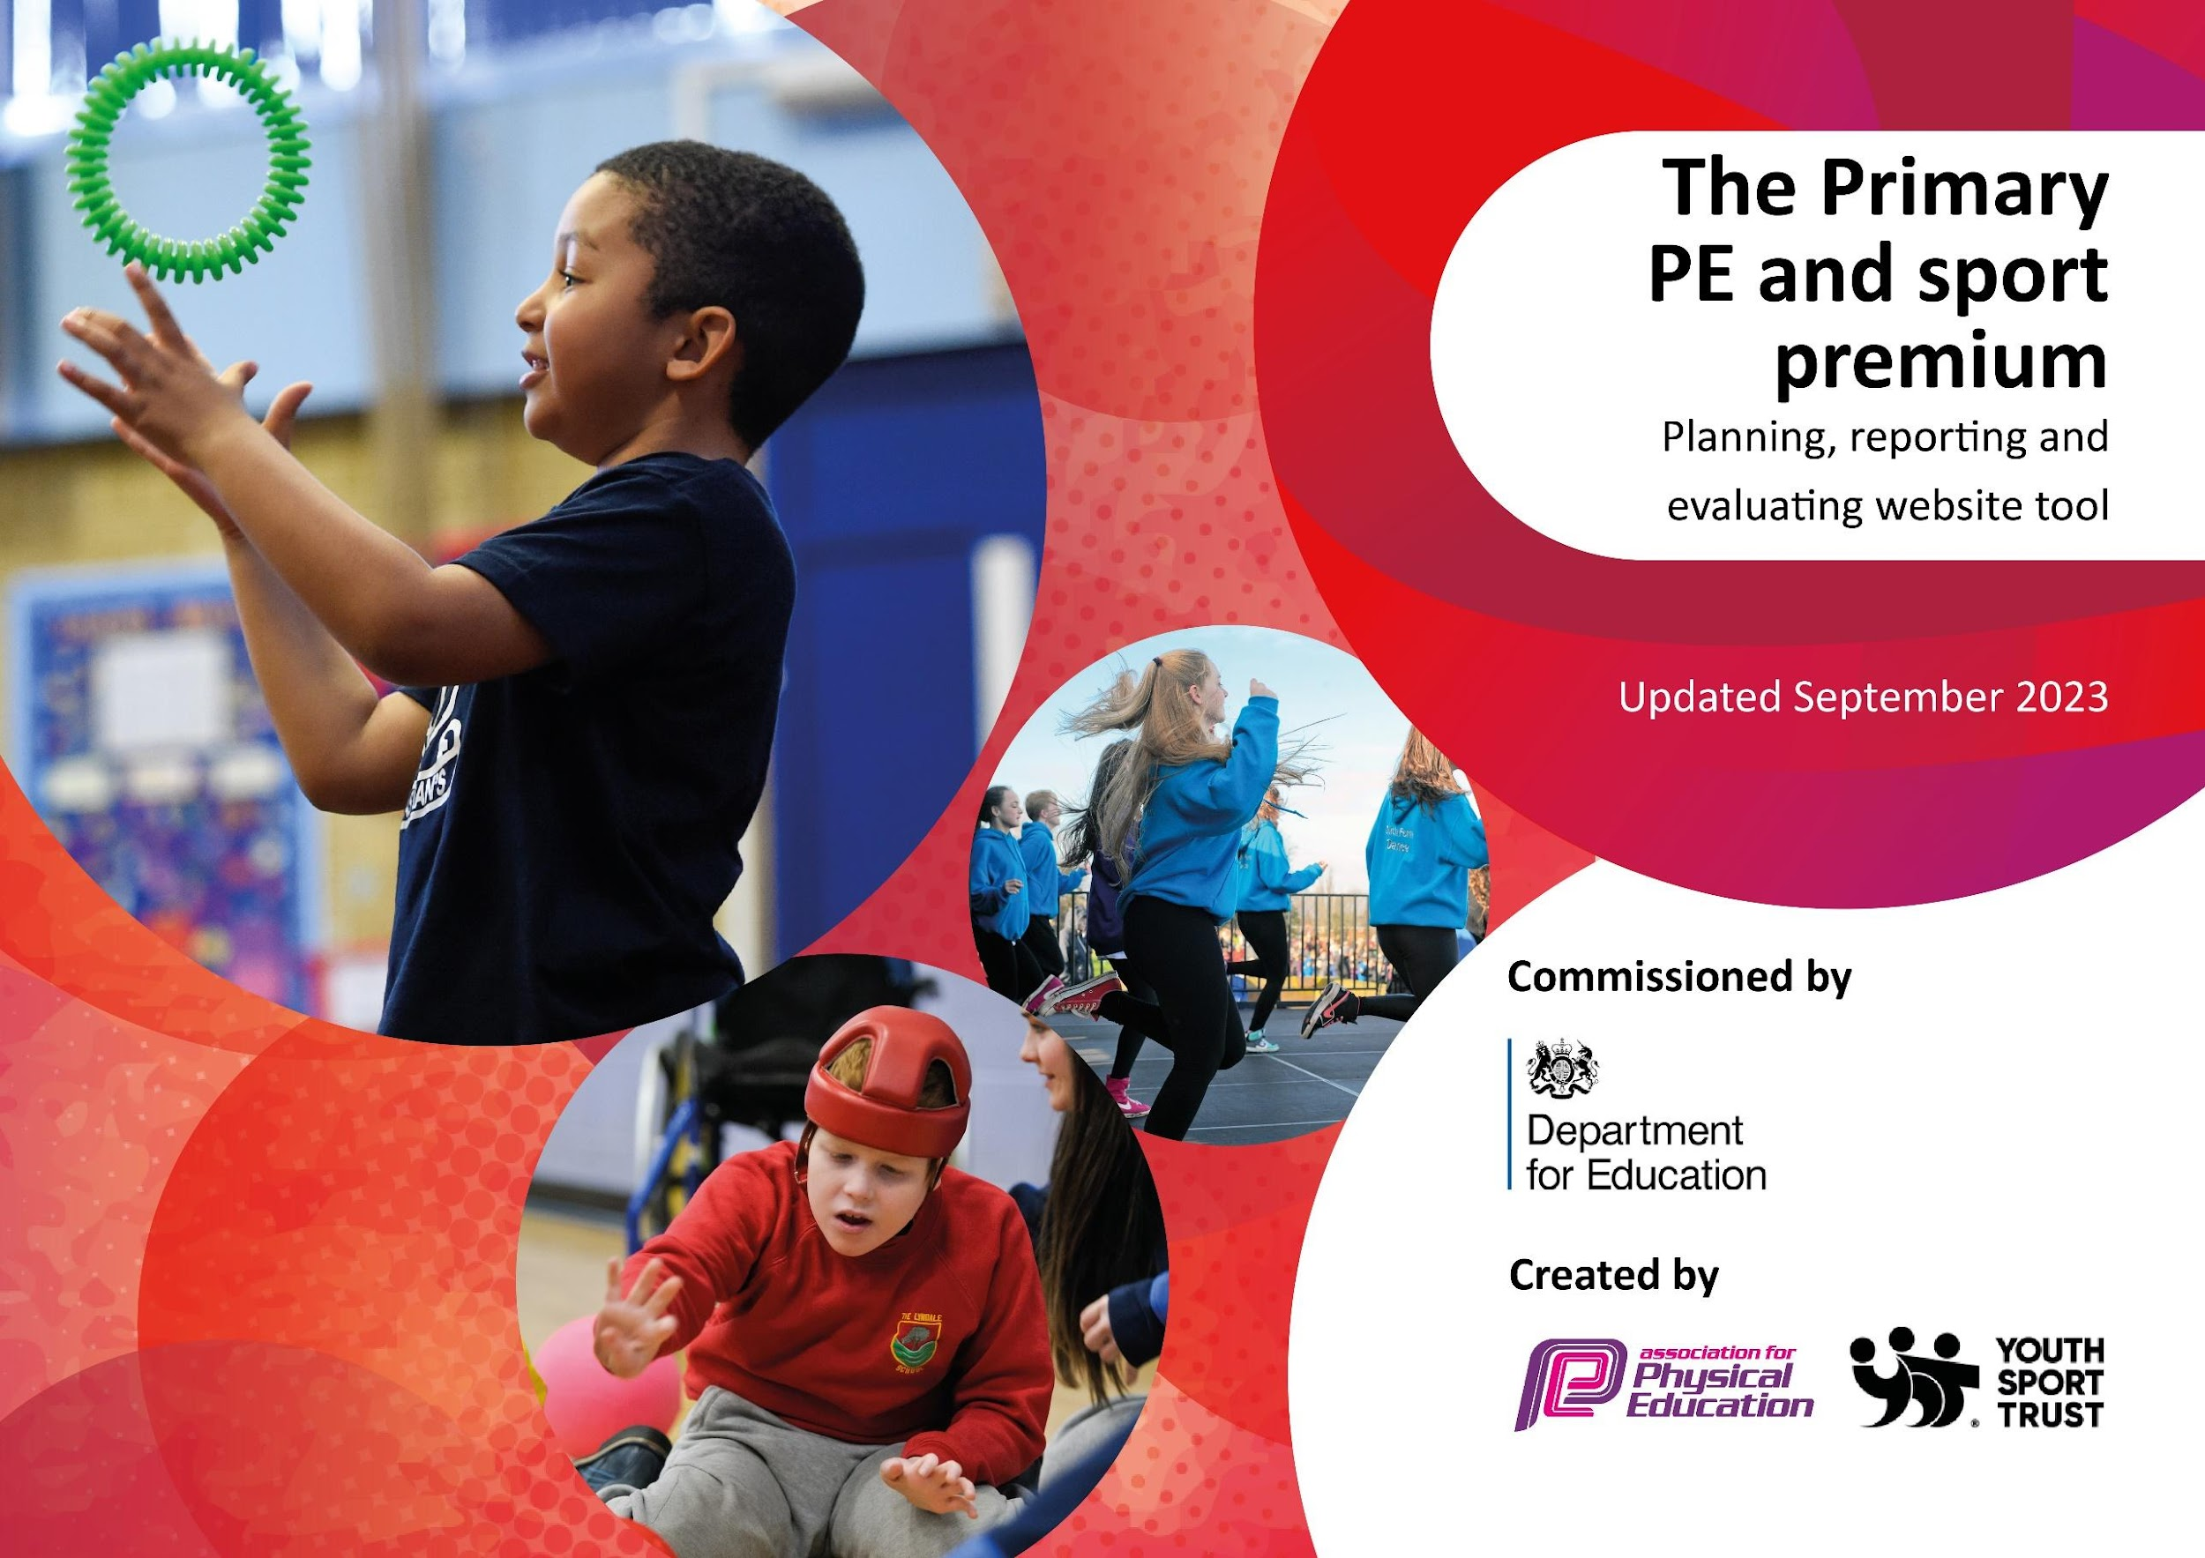

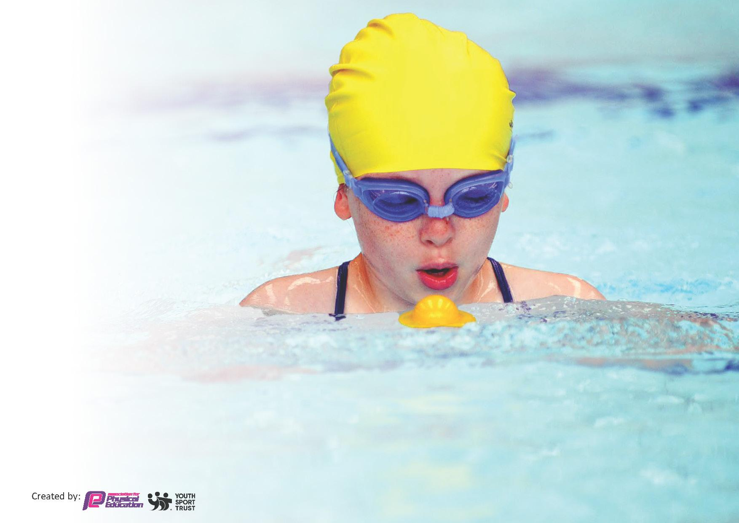
This template can be used for multiple purposes:
by:
- It enables schools to effectively plan their use of the Primary PE and sport premium
- It helps schools to meet the requirements (as set out in guidance) to publish information on their Primary PE and sport premium
- It will be an effective document to support Ofsted inspections enabling schools to evidence progress in Physical Education (PE) and evidence swimming attainment, which forms part of the PE National Curriculum. We would recommend schools consider
the Intent, Implementation and Impact of any spend, as examined within the Education Inspection Framework.

It is important that your grant is used effectively and based on school need.

Schools must use the funding to make additional and sustainable
improvements to the quality of the PE, School Sport and Physical Activity (PESSPA)
they offer. This means that you should use the Primary PE and sport premium to:

- Build capacity and capability within the school to ensure that improvements made now will benefit pupils joining the school in future years
- Develop or add to the PESSPA activities that your school already offers.

The Primary PE and sport premium should not be used to fund capital spend projects; the school’s core budget should fund these. Further detail on capital expenditure can be found in the updated Primary PE and sport premium guidance.

The Primary PE and sport premium guidance, outlines 5 key priorities that funding should be used towards. It is not necessary that spending has to meet all the key priorities, you should select the priorities that you aim to use any funding towards.

Although completing this template is not a requirement for schools, schools are required to publish details of how they spend this funding. Schools must also outline what the impact this funding has had on pupils’ PE and sport participation and attainment and how any spending will be sustainable in the future. All funding must be spent by 31st July 2024.

The Department for Education has worked closely with the Association for Physical Education (afPE) and the Youth Sport Trust (YST) to develop this template and encourages schools to use it. This template is an effective way of meeting the reporting requirements of the Primary PE and sport premium.
Review of last year’s spend and key achievements (2022/2023)

We recommend you start by reflecting on the impact of current provision and reviewing your previous spend.

Activity/Action | Impact | Comments
Daily physical activity has increased in all classes through support from the specialist PE teacher, initially through a whole school staff meeting in which staff received training about why daily activity is important and how to effectively incorporate active minutes in an already busy timetable. This was followed up through “in class support” for 6 weeks. | Class teachers felt more confident in delivering active minutes at regular intervals during the day, resulting in pupils being more active during the school day. We made this competitive and the minutes are added up over the week and shared in celebration assembly. This has certainly increased the amount of activity taking place as both pupils and staff have enjoyed competing. This had been aided by Y6 sports leaders taking weekly totals from each class. They have enjoyed this responsibility and never need reminding to do their job. The Y5 teacher reported that she couldn’t believe the improvement in the timetables ability of the class after completing the active challenges associated with it as shared by the specialist PE teacher. Y5 pupils and the class teacher were proud to share the progress. | We will continue to promote daily active minutes and monitor and share the results. Continue to share good practice.
Following both pupil and staff voice as a school RA decided to change the scheme of work that we follow for PE, changing from the Lancashire PE planning to PE passport. | We have a new curriculum map offering a much broader range of activities and more engaging lessons with less repetition than the previous scheme. Staff report that find PE passport easier to follow than the Lancashire planning as well as much more progressive and varied. Some staff have even reported that they enjoy teaching PE more as a result of the new scheme. RA conducted pupil voice and it was strongly agreed across all year groups that pupils enjoy PE and they enjoyed the new activities offered this year. | To ensure continuity we will continue to subscribe PE passport as both pupils and staff have seen improvement.
OAA cross curricular scheme, resources and training. | All staff received training on the new scheme and the providers set up various courses around school for a variety of subject areas and year groups. RA ensured that staff could easily teach the first Orienteering unit through having all of the resources available and to hand in “grab boxes”. Staff have stated that this has been particularly helpful and that the children have found the scheme fun and interesting. The scheme has also helped to improve orienteering skills as well as math’s and English through communication skills. RA ensured that all staff were timetabled to teach OAA straight after the training to ensure that they felt confident and could support each other. | As we have signed up to a three-year subscription we can continue to use a wider range of units within the scheme.
Key priorities and Planning
This planning template will allow schools to accurately plan their spending.

Action – what are you planning to do | Who does this action impact? | Key indicator to meet | Impacts and how sustainability will be achieved? | Cost linked to the action
Improve attainment in swimming across the whole school by providing swimming lessons for all pupils in KS2. We have decided to change our swimming provision. For some time, we have been considering changing our current swimming provision as it does not work for our pupils, and we feel that it would be good to trial an alternative. To this end we will research other options available to us. | Pupils, teachers, parents. | KI4 Broader experience of a range of sports and activities offered to all pupils. | This year we changed our swimming provider from the local leisure centre to Pools 2 Schools. RA visited a local school who had employed Pools 2 Schools to provide their swimming lessons having faced similar issues and they shared impressive feedback and results. We had a pop-up pool on our playground for 3 weeks and children from all of KS2 participated in swimming lessons every day for 3 weeks. This was a great success which saw 74% of Y6 swimmers meet the national curriculum requirements, which is an improvement of 38% from last year. The children really enjoyed their swimming lessons and made excellent progress. The TA’s accompanying the small groups stated many times over the three weeks how much they had enjoyed witnessing the improvement in water confidence as well as swimming ability. We were able to ensure that all pupils in KS2 as well as Acorn class (our SEN Nurture provision) all had the opportunity to get into the pool. This has proved to be hugely successful as by providing swimming on site to pupils at an earlier age has eradicated a lot of the fear experienced as pupils get older and have to travel by coach to a busy leisure centre. By having a teacher in the pool, as well as on the outside has also allowed our pupils to make progress much faster.  It has also been significantly less disruptive for classes as we have had no travel time to the pool. We will continue to use this provision as the intensive sessions really have benefitted our pupils and when they reach Y6 they will have had as much pool time as if they had received our normal provision.  Parents have been curious about the pool and it has raised awareness around our school swimming provision. We also provided staff swimming sessions after school to allow staff to experience the pool and to promote staff wellbeing. | £2512 additional to our normal swimming provision.  £295.38 swimming shorts, caps, swimsuits, towels walkie talkies to support swimming provision.
Staff development in teaching PE and provide support with teaching in new year groups, new activities, new staff.  Broader range of activities taught across the curriculum.  Continued support for RA as subject leader to continue to keep PESSPA at the heart of school life. | Teaching Staff, TA’s and pupils | KI 1: Increased confidence, knowledge, and skills of all staff in teaching PE and sport.  KI 3 The profile of PE and sport is raised across the school as a tool for whole school improvement.  KI 4 Broader experience of a range of sports and activities offered to all pupils. | Upon positive staff and pupil consultation last year, it was decided to continue with PE passport as our scheme of work. To enhance our curriculum further we decided to include new areas within our curriculum map to offer our pupils a wider range of opportunities. In order to introduce these units we needed to purchase new equipment to support delivery. The new units have proved very popular with the pupils. Coaches from the Sports Partnership also provided support for a new member of staff who needed support in teaching dance and an existing member of staff who also requested support in teaching dance. Both teachers now feel more confident in teaching dance and feel that are confident to deliver this area in the future. We also subscribe to Imoves to support all staff in teaching dance as this is regularly identified as an area in which staff would like support.  Subject leader PE observations demonstrated that staff are teaching HQ PE lessons. The staff observed were following the scheme but adapted the lesson using their own subject knowledge and knowledge of the pupils in their class. All lessons observed were very different but all high quality. The PE subject leader was observed by the HT and again feedback was very positive showing good progression. The HT was impressed by the pupil’s knowledge of the rules and their ability to play by the rules fairly with very clear roles within the lesson. Pupils demonstrated independence in their learning at the end of a game’s unit of work.  The CSSP also came to assess our Y2 and Y6 pupils at the start of the year. This provided in depth results and gave staff the information to help pupils achieve and improve their skills. RA sat down with Y6 pupils and discussed their results providing feedback as well as signposting pupils to opportunities such as clubs out of school. RA and the Y2 teacher also provided interventions and support for the Y2 pupils who were considerably below the expected level in their FMS.  As subject leader, RA is supported by ESPE and the Chorley Sports Partnership. RA has benefited from networking opportunities and updates provided through CSSP PLT days as well as working regularly with ES to continue to develop PESSPA across the school. This has resulted in the development of many opportunities across the school, particularly in the development of the curriculum and opportunities for a wider range of physical activities for all pupils.  RA also attended the PE passport conference and participated in a wide range of workshops as well as getting important national updates regarding PESSPE. RA has also completed the PE CPD for teachers from the FA in Modules 1 and 2 – Teaching through Games. | CSSP £1990  ESPE £1890  Table Tennis resource £51.99  Cross Curricular Orienteering subscription£300  Imoves £997  £1203.54 equipment to provide new areas of activity in PE  £1750 subject leader release time
Promotion of physical and mental health  Encourage more physical activity during the school day and beyond. | Pupils, staff, parents | KI3 The profile of PE and Sport is raised across the school as a tool for whole school improvement.  KI1 Increased confidence, knowledge and skills of all staff in teaching PE and Sport.  KI2 Engagement of all pupils in regular physical activity.  KI4 Broader experience of sports and activities offered to all pupils. | Improving both mental and physical health for ALL of our pupils is a whole school priority. We have had support in school from Dr Andy Cope and have received “An outstandingly Happy School” status through which we have seen a huge shift in both staff and pupils’ self-awareness and self-esteem. To continue this further we have subscribed to the My Happy Mind program to reinforce the importance of leading a healthy, active lifestyle. This program is backed by the NHS and develops positive behaviour to strengthen mental health, resilience and wellbeing to improve overall health. Staff and pupils alike are enjoying the activities and resources that are used weekly.  To promote physical activity within our nurture unit and our most vulnerable pupils in school we have invested in resources to enhance the provision of physical activity and development of gross motor skills.  We continue to promote daily active minutes through the monitoring of weekly minutes and sharing in assembly. This is now well established and embedded withing our school day. Staff have enjoyed the freedom to complete the active minutes at times they find are suitable for their own classes. As a result pupils are more active during learning time.  Play leader and Buddies took place early in the year, training our older pupils to play with and support our youngest children in school. The pupils responded really well to the training and have taken their role very seriously this year and have enjoyed playing with the EYFS and KS1 pupils. The EYFS and KS1 children feel more confident in school with their buddies and are fully engaged in playing with them. We have invested in new equipment to promote physical activity and play at lunchtimes, such as space hoppers, skipping ropes, bats and balls, pogo sticks, bowling sets etc.  Any certificates and success in sport outside of school is also celebrated weekly in the celebration assembly.  Bikeability continues to be an important part of the school calendar. We have a large number of children who cycle to school, and this not only teaches them to ride safely but encourages less reluctant children to do so too. This year all pupils in Y5 and Y6 participated in Bikeability. In year 5 all pupils passed level 1 with 4 pupils highlighted to receive learn 2 ride sessions at the start of Y6. By providing additional Bikeability in year 5 has better prepared our pupils for Y6. In year 6 all pupils passed level 1 and only four pupils did not achieve level 2. All pupils who did not pass level 2 took part in Learn 2 ride sessions to increase their confidence and control on their bikes. Children made excellent progress across the 2 days and became much more confident on bicycles. This is very important as the road around school are very busy. EYFS and Acorn class enjoyed their sessions of Balance Bikes and the EYFS teacher commented on how much the pupils' gross motor skills improved in such a short time within the session. | £750 My Happy Mind  £60 Bikeability  £200 Balance Bikes  £3229.65 Enhancement oof Acorn outdoor area.  £600  Lunchtime play equipment.

Clubs, competitions and opportunities that extend beyond the school day have always been an important part of school life at Duke Street, however, since Covid we have found a decline in the number of pupils attending these clubs. To improve this we have carefully considered, with pupil voice, how to improve the take up of these opportunities. | Pupils | KI 4 Broader range of sport and activities offered to all pupils.  KI5 Increased participation in competitive sport | We have offered 21 clubs in a wide range of activities including Y5&6 Table tennis, Y5&6 Basketball, PASTA, Y1, Y2, Y5&6 Girl’s football, Y1/2 Football, Martial arts, KS2 FMS intervention and Y5&6 dodgeball. We also introduced the Disney Shooting Stars program as a club this year which promotes girls’ football to lower ability Y1 and 2 girls. The girls absolutely enjoyed this club and it really helped to improve their confidence in PE. We also held a “Let Girls Play” day which is a national campaign, in which everyone was invited to come to school in a Football kit to promote girls football.  We also ran a fitness club for targeted pupils and invited their parents to attend. Both pupils and parents really enjoyed these sessions, not only the activity but spending time together.  As a result of our PESSPA offer, we are proud to receive the Gold School Games award this year.  We have also attended several competitions including, sports hall athletics, Y5/6 girls football league, Y3/4 Glo Dodgeball, Y3/4 Invasion Festival, Y5/6 Basketball, Y3/4 and Y5/6 Football friendlies. We also attended the NW regional SEN bowling competition and Pan Athlon. Highlights include the Girls football team winning the Euxton Girl’s tournament and reaching the North West finals in the Bowling competition.  From previous years we are aware that the youngest children in school (EYFS and KS1) have not had the same opportunity for competitions as KS2. With this in mind the CSSP have delivered three competitions for EYFS over the year as well as Intra school competitions for KS1. The EYFS children came first in this competition across the Chorley Schools. This has allowed all of our pupils to experience competition in the school environment. Both the EYFS and KS1 competitions helped pupils to understand the importance of taking turns and provided a valuable experience of competition in a safe space. They also learnt social skills and sportsmanship as well as using the skills learnt in their PE lessons in a competitive situation.  Our annual sports day is an important part of our school calendar and we do make a big day out of it, even more so this year as we decided to also tie a healthy body and mind enrichment day. Our Sports Day is split into KS1 and KS2 so the classes who were not taking part in sports day enjoyed enrichment activities. We had a professional football player come in as the goal keeper for a penalty shoot-out, a freestyle football workshop, a DJ for dancing, T-shirt design and a sports quiz. This made the day even more special and a positive focus on PESSPA for all of our pupils. | £300 Reception multi skills competitions (x3)  £360 Intra school competitions (Level 1)  £1200 Inter school competitions (Level 2)  £300 Martial Arts club  £125 transport for SEN to NW bowling comp.  £809.08  Sports Day/Enrichment Day resources

Key achievements 2023-2024
This template will be completed at the end of the academic year and will showcase the key achievements schools have made with their Primary PE and sport premium spending.

Activity/Action | Impact | Comments
Greater range of sporting clubs offered and high engagement in these.  After several years of very disappointing achievement and attainment in swimming we changed our swimming provision. Instead of attending weekly lessons at the local pool which is disruptive for the whole year and more importantly has not been overly successful with pupils achieving the end of Y6 expectations we decided to try a different approach to swimming and employed Pools for Schools. | Due to the wider range of clubs offered we have had an excellent level of engagement in these clubs. This has also resulted in us having better success at competition due to pupils having the chance to practice in advance. We also achieved the Gold School Games Mark.  We have seen a much higher success rate at meeting the required standards in swimming after many years of pupils not achieving. Children reported that they felt more comfortable and confident swimming at school, especially non swimmers. Pupils were also taught in smaller groups which was also a key factor. Having the pool on site also gave us the opportunity for more pupils to swim, therefore getting pupils in the water much sooner. The pupil and staff feedback was wholly positive with many very positive comments, which reinforces our observations. | Having tried this approach this year we have decided to continue with Pools for Schools as it has been so positive for staff, pupils and parents.

Swimming Data
Meeting National Curriculum requirements for swimming and water safety.
Priority should always be given to ensuring that pupils can perform safe self-rescue even if they do not fully meet the first two requirements of the National Curriculum programme of study

Question | Stats: | Further context  Relative to local challenges
What percentage of your current Year 6 cohort can swim competently, confidently and proficiently over a distance of at least 25 metres? | 74% | Having the flexibility of pools for schools has dramatically improved our swimming results from previous years. Our pupils are more confident in swimming at school and parents are much more aware of the swimming provision as the pool is visible on the school playground, increasing the awareness of our swimming provision.
What percentage of your current Year 6 cohort can use a range of strokes effectively [for example, front crawl, backstroke, and breaststroke]? | 74%

What percentage of your current Year 6 cohort are able to perform safe self-rescue in different water-based situations? | 100%
If your schools swimming data is below national expectation, you can choose to use the Primary PE and sport premium to provide additional top-up sessions for those pupils that did not meet National Curriculum  requirements after the completion of core lessons. Have you done this? | Yes
Have you provided CPD to improve the knowledge and confidence of staff to be able to teach swimming and water safety? | No

Signed off by:

Head Teacher: | A.Kiddd
Subject Leader or the individual responsible for the Primary PE and sport premium: | R.Allen  18/07/24
Governor:
Date: | 31/7/24

