icare

**Computing:**

Technology around us

We will be looking at technology around the classroom. We will use computers and develop our mouse and keyboard skills. We will learn about using a computer responsibly and safely.

Digital painting

We will learn about using computers to pain, by making lines and shapes. We will make careful choices and create our own digital artwork.

**Mathematics:** Daily mathematics lesson

(Y1 & Y2 National Curriculum Objectives)

*Red Rose Maths*

This term we will focus on number and place value, as well as addition and subtraction. The children will continue to use our maths characters to further develop their reasoning skills and engage in daily maths mastery sessions and Early bird maths.

**Year 1 and 2 Curriculum Plans**

Autumn 2023-2024

**English:** Daily English and phonics lesson

(Y1 & Y2 National Curriculum Objectives)

**Focused Text:** Bog Baby

**Fiction:** We will be exploring the text and building up to retelling and adapting the story. We will focus on using capital letters, finger spaces and full stops.

**Non- Fiction:** We will be creating a

**Art:**

We are focusing on *drawing* this half term. We will be

**Science:**

*Living things and their habitats*

We will explore and compare the differences between things that are deal, things that are living and things that have never been alive.

*Animals including humans*

We will learn about animals having offspring. We will discover the basic needs of animals, including humans, for survival (water, food and air). We will describe the importance of exercise, eating the right amounts of different types of food and hygiene.

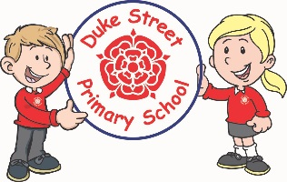

**History:**

We will be learning about The Great Fire of London. We will be focusing on the historical significance of this event and learning about what caused it and how it changed London. We will be asking questions and using historical sources.

Our Core Values

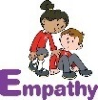  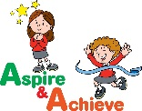 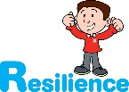

**Geography:**

*London*

The children will be learning about London and identifying some famous landmarks. They will compare London to Chorley.

They will be learning how to use digital maps to identify human and physical features.

**Curriculum Drivers:**

* **Enterprise** – Develop collaborative learning within a group, class and whole school context.
* **Resilience** – Develop resilience when tackling challenging tasks.
* **Aspiration** – Complete your best work at all time.
* **Real Experiences** – Develop opportunities for outdoor learning.

**Music:**

**Acer & Spruce** – Exploring simple patterns. We will be learning to sing, play, improvise and compose a song, children will listen to and appraise a variety of songs.

**Redwood** - Recorders

**DT:**

**Skills:** We will be learning about food safety. We will be chopping, peeling and grating vegetables to create our own salad. We will design our own final piece and create it and evaluate it.

**Finished product:** Making a salad

**PE:**

**Autumn 1 -**

...

**Autumn 2 -**

…

**RE:**

We will be learning about Christianity.

We will learn that Christians believe in God. We will talk about Christian celebrations including Harvest and Christmas.

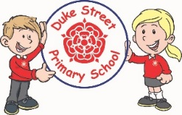

**PSHE: My Happy Mind**

**Autumn 1 – Meet your brain**

We will be focusing on giving children a foundational knowledge of the brain and teaching them how they can look after their minds to be at their very best.

**Autumn 2 - Celebrate**

We will learn about the different character strengths and help the children to use them as much as possible to be at their best.

**Enrichment:**

* PSHE enrichment days

**School Expectations**

* We are kind and helpful
* We listen
* We are honest
* We work hard and take pride in our work
* We look after property

**British Values:**

Our work throughout the curriculum will promote the British Values of:

* Democracy
* Rule of Law
* Mutual Respect
* Individual Liberty
* Tolerance & harmony
* Responsibility/positive contribution
* Public Institution

**School Aims:**

Duke Street Primary School aims to:

* provide a secure, caring and stimulating learning environment,
* promote self-discipline, moral values and self-esteem,
* set challenging yet realistic goals in order to allow each child and member of staff to reach his or her potential
* encourage an enthusiastic attitude to learning through a well-balanced and varied curriculum.
* work in partnership with parents to provide the best for each child in order to get the best from each child
* offer colleagues an enjoyable, positive environment in which to work, fostering both team commitment and the well-being of everyone within our school.