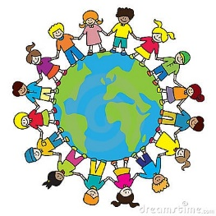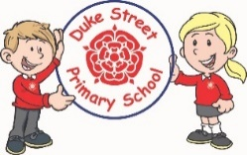

**Understanding the world**

The children will be talking about members of their immediate family and will name people who are familiar to them. Using their treasure boxes they will comment on images from their past. The children will be visiting the park and drawing a simple map.

**Mathematics:**

Daily mathematics lesson

Using number blocks the children will be looking at numbers 1-5. They will develop their 1:1 correspondence when counting, practice forming these numbers correctly and learning to show how to represent these numbers in different ways.

**Physical development**

The children will be completing Forest school with Mrs Haddon and PE with Mr Allen on alternate weeks.

They will also be developing their gross and fine motor skills through continuous provision challenges inside and outside.

**Literacy**

**Autumn 1 and 2 Focused Texts:**

Colour monster, Shark in the park, Leaf man, Mrs Blackhat, Diwali, Kippers birthday, Kippers birthday (dog), The best birthday present ever and The best Christmas presentever**.**

**Phonics:** The children will have daily phonics sessions learning sounds from phase 2 following the Red Rose phonics scheme.

We will begin to form the letter sounds and write simple CVC words.

We will be learning to write our name independently.

Autumn 1 Me and My world

Autumn 2 Sparkle and Shine

**EYFS**

Autumn 2023-2024

**Communication and Language**

The children will working in key worker groups to develop their listening and attention skills for a short period of time.

We will be developing our vocabulary through the stories that we hear.

**Important dates:**

September Buddy Brunch

October: Be your best self enrichment day

11th November Remembrance Day

27th November Bedtime reading hour

11th December Breakfast with Santa.

14th December Pantomine

15th December Enrichment Day

18th December songs around the Christmas tree

21st December Reception Christmas party.

**Personal, social and emotional development**

We will be following “My Happy Mind” to focus on feelings and emotions. We will also look at routines and boundaries and developing relationships with their peers.

**Expressive arts and design**

The children will be using different tools to mix and explore different colours. They will practise different printing styles to make wrapping paper for our celebrations.