icare

**Mathematics:** Daily mathematics lesson

(Y1 & Y2 National Curriculum Objectives)

Red Rose maths

This term we will focus on place value, addition and subtraction, as well as shape, space and measure. The children will continue to use our maths characters to further develop their reasoning skills and engage in daily maths mastery sessions and early bird maths.

**Year 1 and 2 Curriculum Plans**

Autumn 2025 - 2026

**Computing:**

**Autumn 1 – Technology Around Us**

Children will develop their understanding of technology and how it can help them in their everyday lives. They will start to become familiar with the different components of a computer by developing their keyboard and mouse skills. Children will also consider how to use technology responsibly.

**English:** Daily English and phonics lesson

(Y1 & Y2 National Curriculum Objectives)

**Focused Text:** Harry the Happy Mouse

**Fiction:** We will be exploring the text and building up to retelling and adapting the story. We will focus on writing in sentences with full stops, capital letters and finger spaces.

**Non- Fiction:** Writing a non-fiction report mice.

**Poetry:** looking at rhyming words and learning a poem to recite.

**Art:**

**Drawing:**

Focus Artist: Paul Caddon

The children will learn about different mark-making techniques using various types of drawing equipment. They will use Paul Caddon’s work as inspiration to complete their own drawing.

**Science:**

**Living Things and Habitats (Autumn 1)**

Children will explore the difference between living and not living. They will explore the school grounds for examples of both and use pictograms to present data. They will look at simple food chains.

**Animals including Humans (Autumn 2)**

The children will look at different parts of the body and how people are different. They will explore their senses. Children will also look at other animals and how they may be the same and different.

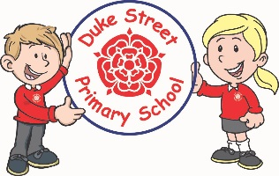

Our Core Values

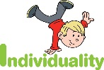  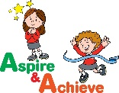 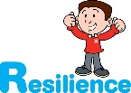

**History:**

**Great Fire of London**

The children will look at how the Great Fire of London started and why it spread so quickly. They will learn about Samuel Pepys and the importance of his diaries. The children will be able to create a timeline of events.

**Geography:**

Countries and Capital cities of the UK – Focusing on London.

Children will learn the continents and oceans of the world through song and making up rhymes.

They will focus on the countries of the United Kingdom and their capital cities. Children will explore the difference between human and physical features. As our History Topic is London, we will look in more depth at this city.

**Curriculum Drivers:**

* **Enterprise** – Develop collaborative learning within a group, class and whole school context.
* **Resilience** – Develop resilience when tackling challenging tasks.
* **Aspiration** – Complete your best work at all time.
* **Real Experiences** – Develop opportunities for outdoor learning.

**Music:**

**Redwood - Recorders**

**Acer and Spruce**

We will be learning to sing, play, improvise and compose with a key song, children will listen to and appraise a variety of music.

**PE:**

**Autumn 1 –Fundamental Movement Skills**

Underarm throw, run, hop, jump, overarm throw, skip, bounding, rolling, kicking and catching.

**Autumn 1 - Gymnastics**

Warming up, healthy heart, strong muscles, gymnastics movements both using equipment and the floor.

**RE:**

We will be learning about Christianity.

We will learn about Christian prayer and why Christians refer to God as Father. We will understand the human need for someone to talk to for comfort.

We will also be looking at the Christian beliefs about Jesus and why they believe he was a special baby.

**DT:**

**Skills:** Food

**Finished Product:** Making Salads

We shall be tasting a range of salad products and dressings. We shall make our own salads.

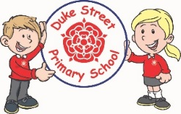

**School Expectations**

* We are kind and helpful
* We listen
* We are honest
* We work hard and take pride in our work
* We look after property

**PSHE: My Happy Mind**

**Autumn 1 – Meet your brain**

Understanding how your brain works and how to ensure we look after it so that we can manage our emotions and be at our best. Growth mindset is a key part of this too.

**Autumn 2 – Celebrate**

Understanding your unique character strengths and learning to celebrate them. This is a fantastic module for building self esteem

**Enrichment:**

* Enrichment Day
* Harvest
* Christmas Play
* Great Fire of London Visitor workshop
* New School Councillors

**British Values:**

Our work throughout the curriculum will promote the British Values of:

* Democracy
* Rule of Law
* Mutual Respect
* Individual Liberty
* Tolerance & harmony
* Responsibility/positive contribution
* Public Institution

**School Aims:**

Duke Street Primary School aims to:

* provide a secure, caring and stimulating learning environment,
* promote self-discipline, moral values and self-esteem,
* set challenging yet realistic goals in order to allow each child and member of staff to reach his or her potential
* encourage an enthusiastic attitude to learning through a well-balanced and varied curriculum.
* work in partnership with parents to provide the best for each child in order to get the best from each child
* offer colleagues an enjoyable, positive environment in which to work, fostering both team commitment and the well-being of everyone within our school.