icare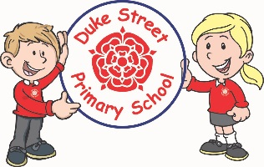

**Computing:**

The children will be learning about technology that is around us. They will be identifying key hardware we use such as mouse, keyboard. The children will develop their mouse and keyboard skills. They will also demonstrate safe use of information technology and using it responsibly.

**Mathematics:** Daily mathematics lesson

(Y1 & Y2 National Curriculum Objectives)

Red Rose maths

This term we will focus heavily of place value, number, addition and subtraction. The children will continue to use our new maths characters to further develop their reasoning skills. Children will explore work with shape, space and measure also.

**Geography:**

The children will be learning about the United Kingdom and the location of London. They will learn about the physical and human features and compare to Chorley. The children will be creating grid maps and use digital technology to label landmarks found in London.

**History:**

The children will be learning all about the Great Fire of London. We will look at the causes of the fire and the reason that the fire was able to go on for so long. We will look at artefacts and 1st person accounts to find out more about this great event.

**Year 1 and 2 Curriculum Plans**

Autumn 2021

**Topic:** Great Fire of London

Our Core Values

**English:** Daily English and phonics lesson

(Y1 & Y2 National Curriculum Objectives)

**Focused Text:** The Bog Baby

**Fiction:** We will be exploring the text and building up to retelling and adapting the stories, using our own experiences.

**Non- Fiction:** We will be doing lots of research about animals from a seaside habitat and creating a fact file.

**Science:**

Autumn 1: Amazing Me!

The children will be learning all about senses and which part of the body is used. The children will be labelling the human body such as legs, arms. They will also be learning about what food humans need to survive and stay healthy

Autumn 2 - Weather

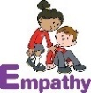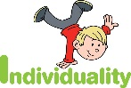  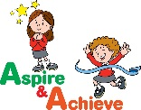 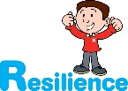

**Art:**

This term we will be developing our drawing skills using different drawing tools. We will be taking inspiration from artwork produced by a Scottish artist, Paul Cadden, who focuses on drawing realistic landscapes based on environmental issues such as litter. We will be creating our own ‘landscape’ drawing in the style of Paul Cadden.

**Curriculum Drivers:**

* **Enterprise** – Develop collaborative learning within a group, class and whole school context.
* **Resilience** – Develop resilience when tackling challenging tasks.
* **Aspiration** – Complete your best work at all time.
* **Real Experiences** – Develop opportunities for outdoor learning.

**Music:**

The children will listen and respond to various pieces of music. They will join in with familiar songs by singing and using instruments. They will experiment with pitch, duration, dynamics, tempo, timbre and texture.

**RE:**

The focus for this term is Christianity. For the first half term, we learn about how Christians believe that God created the world, why they think it is important to look after the world and how we can look after our world. For the second half term, we learn about the Christian view of Jesus as the ‘light of the world’, and how we could be a light in someone else’s life.

**DT:**

**Salad:**

We will be designing and making our own salad. We will practice chopping, peeling and grating vegetables and then use these skills to create our own salad.

**Skills:** Preparing vegetables

**Finished Product:** Design, make and evaluate a salad

**PE:**

The children will be developing skills in bouncing a ball (whilst moving), passing, catching, simple games, throwing balls at a target and moving into spaces.

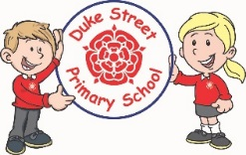

**Enrichment:**

* Trips / Visits linking to current learning
* Enrichment activities linking to current learning

**School Expectations**

* We are kind and helpful
* We listen
* We are honest
* We work hard and take pride in our work
* We look after property

**British Values:**

Our work throughout the curriculum will promote the British Values of:

* Democracy
* Rule of Law
* Mutual Respect
* Individual Liberty
* Tolerance & harmony
* Responsibility/positive contribution
* Public Institution

**PSHE:**

**Core Values:** Empathy

**Core Themes:** Me and my relationships

**Focus:**

* Conflict
* Feelings & Emotions
* Friendships
* Valuing difference
* Positive Mental Health

**School Aims:**

Duke Street Primary School aims to:

* provide a secure, caring and stimulating learning environment,
* promote self-discipline, moral values and self-esteem,
* set challenging yet realistic goals in order to allow each child and member of staff to reach his or her potential
* encourage an enthusiastic attitude to learning through a well-balanced and varied curriculum.
* work in partnership with parents to provide the best for each child in order to get the best from each child
* offer colleagues an enjoyable, positive environment in which to work, fostering both team commitment and the well-being of everyone within our school.