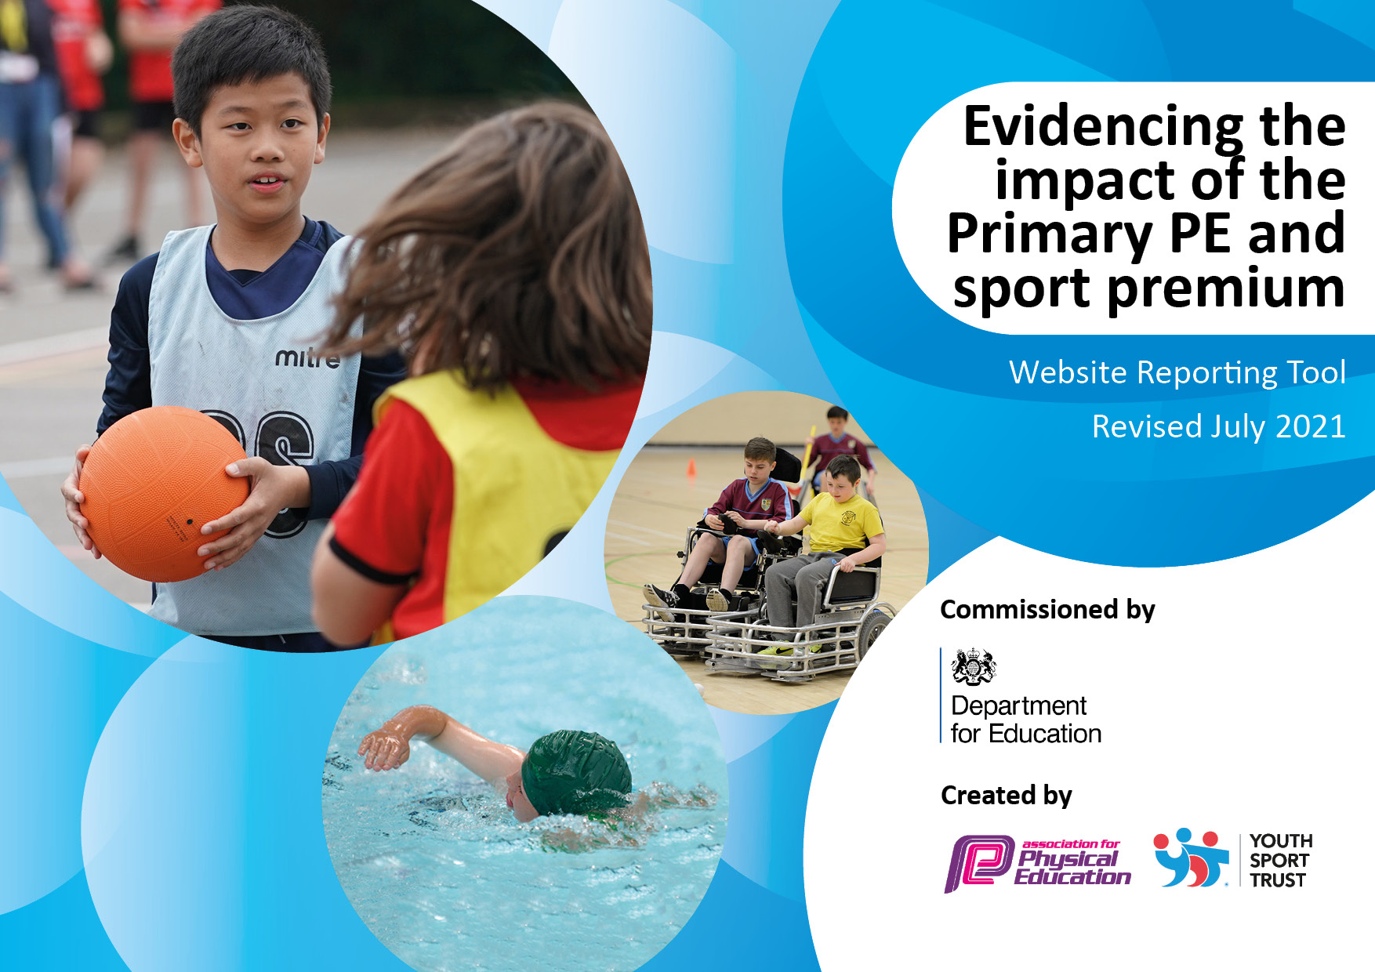

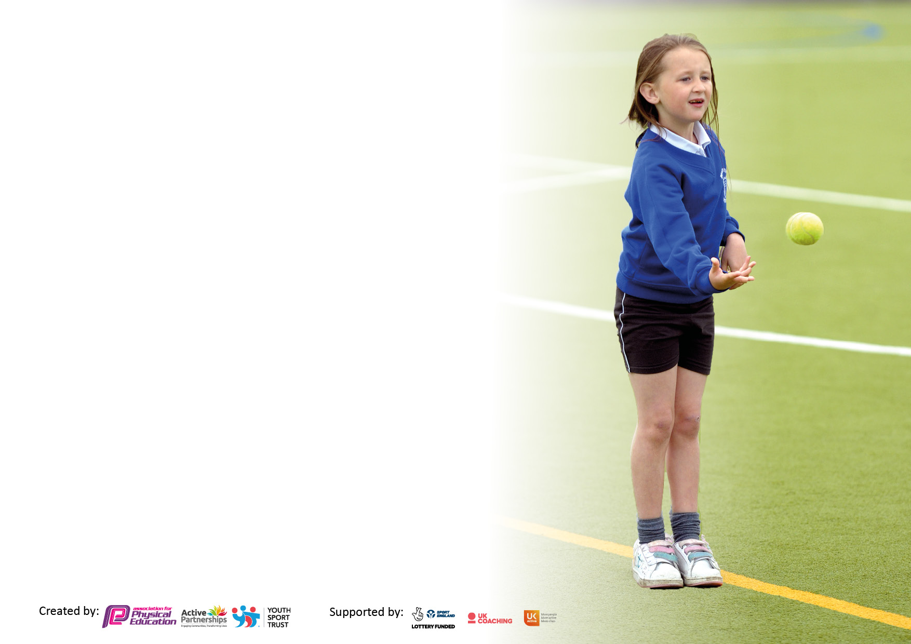

It is important that your grant is used effectively and based on school need. The Education Inspection Framework makes clear there will be a focus on ‘whether leaders and those responsible for governors all understand their respective roles and perform these in a way that enhances the effectiveness of the school’.

Under the Quality of Education Ofsted inspectors consider:
Intent - Curriculum design, coverage and appropriateness
Implementation - Curriculum delivery, Teaching (pedagogy) and Assessment
Impact - Attainment and progress

To assist schools with common transferable language this template has been developed to utilise the same three headings which should make your plans easily transferable between working documents.

Schools must use the funding to make additional and sustainable improvements to the quality of Physical Education, School Sport and Physical Activity (PESSPA) they offer. This means that you should use the Primary PE and sport premium to:

- Develop or add to the PESSPA activities that your school already offer
- Build capacity and capability within the school to ensure that improvements made now will benefit pupils joining the school in future years
- The Primary PE and sport premium should not be used to fund capital spend projects; the school’s budget should fund these.

Pleasevisitgov.ukfortherevisedDfEguidanceincludingthe5keyindicatorsacrosswhichschoolsshoulddemonstrate animprovement.Thisdocumentwillhelpyoutoreviewyourprovisionandtoreportyourspend.DfEencouragesschools to use this template as an effective way of meeting the reporting requirements of the Primary PE and sport premium.

We recommend you start by reflecting on the impact of current provision and reviewing the previous spend.

Schools are required to publish details of how they spend this funding, including any under-spend from 2019/2020, as well as on the impact it has on pupils’ PE and sport participation and attainment. All funding must be spent by 31st July 2022.

We recommend regularly updating the table and publishing it on your website throughout the year. This evidences your ongoing self-evaluation of how you are using the funding to secure maximum, sustainable impact. Final copy must be posted on your website by the end of the academic year and no later than the 31st July 2021. To see an example of how to complete the table please click HERE.

Details with regard to funding
Please complete the table below.

Total amount carried over from 2019/20 | £2823
Total amount allocated for 2020/21 | £18910
How much (if any) do you intend to carry over from this total fund into 2021/22? | £7618.42
Total amount allocated for 2021/22 | £18,850
Total amount of funding for 2021/22. To be spent and reported on by 31st July 2022. | £26468.42
Swimming Data
Please report on your Swimming Data below.

Meeting national curriculum requirements for swimming and water safety.

N.B. Complete this section to your best ability. For example, you might have practised safe self-rescue techniques on dry land which you can then transfer to the pool when school swimming restarts.
Due to exceptional circumstances priority should be given to ensuring that pupils can perform safe self-rescue even if they do not fully meet the first two requirements of the NC programme of study
What percentage of your current Year 6 cohort swim competently, confidently and proficiently over a distance of at least 25 metres?  N.B. Even though your pupils may swim in another year please report on their attainment on leaving primary school at the end of the summer term 2022.  Please see note above | 65.3%
What percentage of your current Year 6 cohort use a range of strokes effectively [for example, front crawl, backstroke and breaststroke]?  Please see note above | 61.2%
What percentage of your current Year 6 cohort perform safe self-rescue in different water-based situations? | 100%
Schools can choose to use the Primary PE and sport premium to provide additional provision for swimming, but this must be for activity over and above the national curriculum requirements. Have you used it in this way? | Yes – see KI4

Action Plan and Budget Tracking
Capture your intended annual spend against the 5 key indicators. Clarify the success criteria and evidence of impact that you intend to measure to evaluate for pupils today and for the future.

Academic Year: 2021/22 | Total fund allocated: £26468.42 | Date Updated:20th July 2022
Key indicator 1: The engagement of all pupils in regular physical activity – Chief Medical Officers guidelines recommend that primary school pupils undertake at least 30 minutes of physical activity a day in school |  |  |  | Percentage of total allocation:
 |  |  |  | £5125.40 20%
Intent | Implementation |  | Impact
Your school focus should be clear what you want the pupils to know and be able to do and about  what they need to learn and to  consolidate through practice: | Make sure your actions to achieve are linked to your intentions: | Funding allocated: | Evidence of impact: what do pupils now know and what can they now do? What has changed?: | Sustainability and suggested next steps:
Encourage physical activity at lunchtimes, whilst maintaining restrictions in place, as and when required. Our pupils enjoy activity at lunchtimes, and this also helps to improve behaviour at lunchtimes. As the pandemic is still of concern we will need to consider how to promote active lunchtimes, whilst adhering to current guidelines. Our pupils love football, but we would like to look at other activities that we could encourage to engage more pupils. | - Regularly assess throughout the year the guidelines in place.  - Consider, with staff, how to promote physical activity at lunchtimes.  - Purchase resources and equipment to support this.  - Talk to pupils to consider their views on what they would like to do.  - Monitor participation at lunch times and impact of changes. | £1879.40 | Covid restrictions have been in place following the return of pupils to school in September, through to the Easter holidays. Throughout this time there have been changes within the guidance. As a school we have been in “bubbles” for a significant amount of this time. It was therefore necessary to purchase some new equipment to promote physical activity at lunchtimes to encourage our pupils to play whilst maintaining the integrity of bubbles and protecting our children and staff.  We invested in a range of equipment so that pupils could play within their bubbles. The PE subject leader supported welfare staff in the safe use of the equipment and how to encourage pupils to be active at lunchtimes.  The equipment that we bought included golf sets, a range of large garden games, playground balls – a wide variety of size and type, football goals for each zone, portable electric ball pump for use on the playground, cones etc. Whilst football continues to be a very popular and it was necessary to buy additional nets for each zone, the nets are also used for handball. Both games are popular activities at our school with many boys and girls playing together.  After observing the playground and discussion with welfare staff the subject leader observed several groups of mainly younger pupils who did not seem to do much at lunchtimes. These pupils said that they would like more “play” types of games, which is why we then invested in playground balls and games. These have been very popular and there are significantly fewer pupils not active. This will continue to be a focus moving forwards in the new academic year. We also purchased a portable speaker for music at lunchtimes, which pupils really enjoy. | Sustainability  We now have a wide variety of equipment to promote a range of physical activities at lunchtimes. This will be available to use for years to come. The welfare staff are confident in using a range of equipment to promote physical activity and will be able to continue to promote this during their employment at Duke Street.  Next steps  - Consider reintroducing play leaders and zoning next year to encourage pupils from different classes to play together and to promote leadership skills in our pupils. This has worked very well in the past, but pupils have now got out of this due to bubbles and limitations.  - Re-introduce “brain breaks” in the morning and “active breaks” in the afternoon to ensure that all pupils achieve 30 active minutes during the school day
Continue subscription to Imoves to promote daily physical activities through activities that are suitable for the classroom.  This also links to KI3 – developing staff confidence in teaching dance. | - Purchase subscription to Imoves  - Ensure that all staff, especially new teachers, have access to the content.  - Remind/make staff aware of the content, particularly for physical activity.  - Encourage staff to use Imoves to support planning for daily physical activity and dance. | £997 (also links to KI3 – through developing staff knowledge and confidence in teaching dance) | The staff audit shows that 72% of classes do some form of daily physical activity, several times a week, with 43% doing daily activity every day. The rest of the classes do physical activity at least a couple of times a week.  Staff are aware of and regularly use the daily physical activity section of Imoves. The content is high quality, short bursts and regularly updated which maintains interest. The platform gets used as it is easily accessed.  Imoves is also used for teaching dance across the school – see KI3  Rowan & Maple class(LKS2) use Imoves before early bird maths, KS1 classes do a wake up shake up. I promote active minutes by sending quick brainbreak links to BBC Supermoves, Go Noodle, Joe Wicks on YouTube. There are also links to my own fitness workouts on our school website. | Sustainability  Through using Imoves teachers gain further ideas and knowledge to deliver high quality physical activity and dance. This knowledge, experience and planning will remain with the staff for future units of work.  Pupils experience a wide range of physical activities and dance to hopefully enjoy throughout their lives at Duke Street and beyond.  Next steps  - Audit staff to consider if the resource will be needed and used next year.  - Ensure that all classes are doing at least two brain breaks during every morning session.
Provide opportunities to promote gross motor skills through Balance bikes in EYFS and KS1 and Bikeability in Y6. This will also promote cycling outside of school as a physical activity. | - Book sessions for Bikeability.  - Inform parents and class teachers of the sessions and gain consent.  - Delivery of Bikeability  - Logistics – bikes and helmets for Y6.  - We had 4 children that needed Learn2 ride sessions which really benefited from it.  - 4 children needed Learn 2 ride sessions prior to the Bikeabilty training. The children felt confident after having this training.  - Research training opportunities for staff.  - Consider which staff to attend the training.  - Book the training course.  - Purchase balance bikes, helmets and resources. | Bikeability – no cost to the school.  £2249 Balance bikes, helmets, training. | Learn 2 ride delivered to 37 pupils on 16/05/22, 23/05/22, 24/05/22. 33 children passed level 2 and 4 children passed level 1. The children were awarded their certificate which we celebrated in good news assembly.  Balance bike training was attended by two members of staff. We also purchased 10 bikes and helmets, and 2 peddle bikes, as well as additional resources, such as balancing islands and signposts.  We have had 11 SEN children participate in the balance bike training. We have done 2 sessions per week. Some of the children have visual impairment and physical disabilities. The positive impact that this had on these children is immense. “They have grown in confidence and their balance and coordination have improved too” 3 of the children can now ride a pedal bike with stabilisers. | Sustainability  Once learnt pupils will always be able to ride a bike and is a skill for life. Bikeability is an important date in our school calendar for our Y6 pupils.  Balance bikes have proved to be useful in developing the gross motor skills of our pupils. As our own staff have been trained and we have our own bikes, we will be able to provide this for years to come in school and do not have to pay people to come in and deliver this for us.  Next steps  - Consider how to make more use of the balance bikes, possibly through training more staff.  - Consider other ways to promote active travel.
Key indicator 2: The profile of PESSPA being raised across the school as a tool for whole school improvement |  |  |  | Percentage of total allocation:
 |  |  |  | £5525.99 21%
Intent | Implementation |  | Impact
Your school focus should be clear what you want the pupils to know and be able to do and about  what they need to learn and to  consolidate through practice: | Make sure your actions to achieve are linked to your intentions: | Funding allocated: | Evidence of impact: what do pupils now know and what can they now do? What has changed?: | Sustainability and suggested next steps:
Continue to support the PE subject leader, particularly in how to deliver PE, support staff and continue to raise the profile of PESSPA, particularly during and post the national pandemic. | - ESPE to meet with RA regularly to plan action points.  - Update curriculum map  - Co-ordinate support from ESPE in line with staff audits/needs.  - Update PE policy.  - Ensure that EYFS PD is in line with the new curriculum and links directly to KS1 PE.  - Observation of ES to ensure high quality.  - Attend meetings such as CHIP cluster meetings to develop knowledge.  - Ensure that PESS is spent well and reported as required. | Included in ESPE – See KI3  SL resources £85.22  AfPE subscription £115  £1000 RA subject time | RA hosted the PE subject leader CHIP cluster meeting at Duke Street. RA found it beneficial to meet with other subject leaders to discuss ideas and plans moving forwards. It was also useful to learn about how other schools are delivering PESSPA and discuss the challenges that they have faced this year and how they overcame them.  Regular meetings with RA and ES have ensured that PE continues to move forwards in the school with clear action plans and focus.  Support in updating the PE policy, curriculum map and PESS report keeps the focus on all areas of PESSPA and has given RA the knowledge on how to complete and update these in the future.  The AfPE subscription helps to keep the subject leader informed of any updates and also has a good range of recorded webinars to support subject knowledge. | Sustainability  The PE subject leader is well equipped to continue to lead the subject in future years. RA is now confident in updating policies, curriculum maps and has a better understanding of physical development in EYFS  Next steps  - To continue to develop PE subject knowledge in a wide variety of activities, especially in PD in EYFS.  - To revisit the curriculum map to consider further opportunities for development.
Introduce a Cross Curricular Orienteering scheme of work to promote active learning in a range of subjects, especially Maths and English cross the school, whilst developing OAA skills. This will help to promote more active learning in lessons outside of PE. | - Research providers  - Book training for staff  - Order resources etc  - Logistics in introducing a new unit.  - Consider how to introduce the skills to pupils.  - Timetabling. | £2540 Cross Curricular resource.  £508.29 resources to set up lesson boxes.  £500 RA set up OAA resources | The staff training took place in Summer 1 for all teachers and SLT by the Cross Curricular Orienteering team. At the end of the training all class teachers and SLT were very excited by the resource and could see the benefits. In the staff audit, one member of staff stated “Orienteering training was really helpful and inspiring! Observing and team teaching with RA and outside coaching also very helpful.” We now have four courses mapped out of the school, two for EYFS/KS1 and two for KS2. One course is on the school playground, the other is on the school field. The PE/Fitness orienteering course is permanently set up, but we have additional courses for English, two for maths and a blank set of cards for any use. Staff also have access to a huge range of resources to promote active learning across the curriculum, including geography, PSHE, history and science. There are also lesson plans to support delivery as well as videos for staff. Following the course, SLT and the PE subject leader changed the curriculum map for Summer 2 so that all classes were using the PE area of the resource to introduce pupils to orienteering so that other areas could be introduced in the next academic year. This also gave staff the opportunity to navigate the resources and practice teaching the Orienteering element of the learning as this is key to the resource and future active learning. The result is now that pupils have a much better understanding of orienteering and have enjoyed the unit of work. This means that they will be more equipped to use the wider learning of the resource.  This was enhanced by the PE subject leader and ES supporting staff in the teaching of the first lesson and being on hand to answer questions and help with setting up the activities as needed by staff. RA spent a lot of time preparing all of the resources for the PE/fitness unit of work as has put the resources, planning and equipment in boxes for staff to be able to “grab and go”. Many staff have commented that this has made teaching the unit much easier and a result means that they are more likely to use the resource. These boxes will be permanently available for staff to use. The class teacher for Redwood mentioned that she can already think of different ways to use the resources from the boxes to support the teaching of phonics, which can sometimes be very static. She also stated that she can see the benefits for the pupils in her class in using activity to support learning.  When I first taught OAA the pupils never had no idea, majority of the children didn’t know what Orienteering was or how to orienteer a map, by going through the different lessons the children have quickly understood the concept of map reading, navigating, problem solving and teamwork. It has been enjoyable teaching the children in EYFS-Y6 and seeing their development. Schools in our cluster have also purchased the same orienteering package, the plan is to then have OAA competition between the schools. | Sustainability  The resources and maps will be available to staff for years to come. Staff will be able to use the planning for other subjects and will have those plans for future years. Pupils will be able to use the orienteering skills learnt this half term to be able to access the units and lessons for other subjects. As staff have had the opportunity and support to practice teaching the units increases the likelihood that they will use it in future. The grab and go boxes will remain for staff to use, with several members of staff already having ideas in how these can be used, especially to support phonics in active lesson.  Next steps  - Timetable the PE/fitness orienteering to revisit and progress skills early in the Autumn term.  - Remind staff of the other resources available and support where necessary.  - Audit of how the resources have been used and the impact on activity levels and learning across the curriculum.
Consider the needs of pupils and staff during and post covid and amend the whole school curriculum map to ensure that those needs are met. To support this, we will continue to subscribe to PE passport to ensure continuity and progression in the planning, teaching and assessment in PE across the whole school. | - Subscribe to PE passport  - Ensure that all staff have access.  - Training for staff/update  - Upload curriculum map  - Regularly check that assessment data is current.  - Support staff as required. | PE passport subscription continued over from 2021. | The staff audit shows that all staff have access and use PE passport to support planning and assessment with only one teacher having access issues which was quickly resolved.  The whole school curriculum map has been updated in line with new units in PE passport and the needs of the pupils’ post covid. In particular, we have decided to deliver 2 gymnastics units this year as we were unable to teach any in school last year due to covid. It was interesting when we observed the pupils during the gymnastics as they seemed more apprehensive when using the apparatus. It proved to be beneficial to deliver two units of work on this as the pupils were much more confident in gymnastics by the end of the unit. This was especially evident in the pupils in Y6 when taught by ES and RS during the staff CPD sessions. We have also included several units around fundamental movement skills to help pupils to feel more confident in PE by having a solid base on which to start. We found this necessary after normal activities being closed for such a long period of time. For the games units we have updated the curriculum to include a wider range of games to maintain pupil’s interests through the inclusion of new units from the PE passport/Lancashire scheme of work, such as the target games and playground games units.  The long-term planning grid has been completed and is available on PE passport and is available for all staff. This ensures that staff can easily access the units of work and that the full National Curriculum is fully covered at each Key Stage.  We have also created document to map the new EYFS curriculum and links to physical development and PE to demonstrate where there are opportunities for physical development in school and how this is covered in the EYFS units in the scheme of work. This shows a clear transition from EYFS to KS1 PE.  By subscribing to PE passport, it ensures that the planning and assessment of PE is consistent and can be used to inform one another. It also ensures that the subject leader can quickly and easily look at information to be able to drive the subject effectively and plan to meet the needs of the pupils. | Sustainability  PE passport is a minimal cost, and the resource is well used. It is also updated to include new units of work, which is much more effective and easily accessed than paper copies. The information shows progression of pupils from Reception to Y6 and can be used to inform future planning.  Next steps  - Use PE passport and data to ensure that as a school we raise attainment within PE. The SL will choose 6 children from EYFS and 6 children from Year 3 (2 lower ability, 2 middle ability and 2 more able) to track to Y6 to follow their journey through school and their experience and progress within PE.  - Ensure that staff remain confident in using PE passport and provide further training as required.  - Amend and update the curriculum map prior to Autumn 1 to ensure that we continue to meet the needs of our pupils and staff whilst ensuring high quality PE teaching for all pupils.
Purchase spare PE kit to ensure that all pupils have access to a PE to allow them to take part in PE lessons safely and comfortably. Unfortunately, as a result of Covid, some of our families are struggling to ensure that a PE kit is in school, for a variety of reasons. To ensure that pupils are able to take part in PE safely and in the correct kit we feel that under the circumstances a stock of PE kit would be a worthwhile investment. | - Choose a supplier for PE kit  - Purchase spare kits and storage box  - Label the kit to ensure that it is returned.  - Brief staff on the location and importance of returning the kit for other pupils to use. | £216.50 | We now have a stock of spare PE kit in school, including jogging bottoms, shorts, t-shirts and pumps in a variety of sizes. This has helped many of our pupils enjoy PE without the worry of not having a PE kit in school. This kit has been very well used since we bought it and ensures that everyone is dressed and ready for PE without wasting a lot of time. Class teachers and TAs are good at returning the kit, which the subject leader washes on a regular basis. This has resulted in minimised wasted time in looking for PE kit and reduces pupil worry about not having what they need. | Sustainability  The kit will remain in school for pupils to continue to use. We will also send an email to parents to ask if any outgrown kit could be donated to the box to continue to support pupils, especially Y6 pupils who will be leaving school. There will be more learning time for PE as kit will be quickly sourced for pupils without for any reason.  Next steps  - Email all parents to ask for outgrown PE kit to be donated to the box.
Purchase books about sports and sports personalities to add to the reading vending machine. | - Consider interests of the pupils and suitable books  - Order the books  - Add to the vending machine. | £210.98 | The books were purchased in Summer 2 ready to be introduced in the Autumn term in the new book vending machine. It is hoped that by having books about sport and sporting personalities may inspire our less willing readers to choose a book. We chose sporting role model books for example Marcus Rashford, Ronaldo, a lot of children know who they are and look up to them. | Sustainability  The books will be returned once pupils have read them and tracked as to which pupils have which books so these will always be available.  Next steps  - Monitor how many and which pupils choose the books.
Trip for Y5 and Y6 pupils to attend a dance performance by GCSE pupils at a local high school to inspire them and show good role models. Many of the pupils in the performance are ex-pupils from our school. | - Book places for the performance.  - Logistics in informing parents, gaining consent, booking coach etc.  - Post trip discuss with pupils about the performance and what they gained from watching it. | £350 coach | The pupils really enjoyed the performance, especially as they knew some of the people performing. It was good for them to see the opportunities that will be available to them at high school and inspire our pupils to get involved.  Our Pupils had a great afternoon watching the performance, some pupils said “They can’t wait to come to parklands” We also had some ex- pupils in the show, our children recognised them. After the show we got the chance to chat with our ex pupils. | Sustainability  The performance was free, so we only needed to pay for the coach. This was a good value trip with many benefits for our pupils by inspiring them to be involved in opportunities at high school.  Next steps  - Continue to keep in contact with the high school regarding future performances.

Key indicator 3: Increased confidence, knowledge and skills of all staff in teaching PE and sport |  |  |  | Percentage of total allocation:
 |  |  |  | £5500 21%
Intent | Implementation |  | Impact
Your school focus should be clear | Make sure your actions to | Funding | Evidence of impact: what do | Sustainability and suggested
what you want the pupils to know | achieve are linked to your | allocated: | pupils now know and what | next steps:
and be able to do and about | intentions: |  | can they now do? What has
what they need to learn and to |  |  | changed?:
consolidate through practice:
There have been changes within the staff team. We will need to continue to audit staff and provide relevant CPD to all staff as needed to maintain high quality PE across the school for all pupils. There are several new teachers in school and changes within year groups. Staff will also need support in delivering engaging lessons whilst adhering to any guidelines in place. | - All staff to complete audit.  - RA and ES to review staff audits to plan the support needed.  - RA and ES to co-ordinate and timetable support over the year.  - Inform staff and create a timetable.  - ES to provide lesson plans and resources to staff for the unit taught.  - Review the support given at the end of the year and how it was effective.  - Re-evaluate the curriculum map to consider new opportunities. | £5500 ESPE | The following support has been delivered in school this year  ESPE support –  Redwood FMS  Poplar Handball  Acer Gymnastics  Poplar Dance – Bhangra  Sycamore Gymnastics  Rowan Gymnastics  Redwood Orienteering - new resource  Yew Orienteering – new resource  In addition to supporting complete units of work with classes in school, ES and RA have also delivered a whole school teacher training on PE passport. On the staff audit, one member of staff stated, “Really useful going through the PE passport - feel much more confident using it”.  When asked about the support in teaching a unit of work with their own class, another member of staff stated that it was “brilliant support and well worth it.”  The end of year staff audit shows that 57% of staff feel confident or very confident in teaching PE and 43% of staff feeling that they would like further support.  Areas of strength as identified on the staff audit include Invasion games, dance, athletics and FMS. This is good as many staff have had support from ES, RA and also the Imoves resource and training for dance.  Areas for development include Striking and fielding, net and wall and gymnastics.  86% of classes usually complete two PE lessons per week, showing consistency. One lesson is taught by the PE subject leader and the second lesson is taught by the class teacher. The biggest constraint that has been identified is timetabling and the demands of the curriculum. Further support identified by staff is support for staff who have not yet had any and support in delivering active minutes in classrooms. | Sustainability  Staff will retain the skills, knowledge and confidence gained from the support given to continue to provide high quality PE lessons for all pupils.  Next steps  - Use staff audit from Summer 2 2022 to evaluate the effectiveness of the support given and plan future support.  - Use the assessment data on PE passport to aid subject leadership.
Key indicator 4: Broader experience of a range of sports and activities offered to all pupils |  |  |  | Percentage of total allocation:
 |  |  |  | £9160.63 34%
Intent | Implementation |  | Impact
Your school focus should be clear | Make sure your actions to | Funding | Evidence of impact: what do | Sustainability and suggested
what you want the pupils to know | achieve are linked to your | allocated: | pupils now know and what | next steps:
and be able to do and about | intentions: |  | can they now do? What has
what they need to learn and to |  |  | changed?:
consolidate through practice:
After updating the curriculum map and completing an audit of the equipment available for PE we felt it necessary to purchase equipment to enhance the curriculum | - Look at the updated curriculum map.  - Identify the equipment needed to deliver the curriculum map, especially the new units introduced.  - Order equipment needed.  - Continue to liaise with staff to ensure that the equipment available is appropriate. | £872.19 | We purchased athletics equipment to inspire pupils in this area by using the correct equipment, especially in throwing. Pupils showed a better understanding of the different types of throws when using the appropriate equipment. This was evident in the athletics assessment. Other equipment that we have bought included batting tees to introduce batting in striking and fielding as this has proved to be an area for development for our pupils. Other equipment included cricket sets, basketballs and rugby balls to further enhance the curriculum. This equipment has been well used in line with the curriculum map to ensure a broad and balanced curriculum has been delivered. Pupils have enjoyed the opportunity of trying new activities in their PE lessons.  We also bought a fitness timer and resistance bands for the fitness units. The pupils love seeing the timer when they are completing circuits and it helps to keep them motivated. The badminton equipment has not yet been used as we bought it as an alternative to tennis for the next academic year. | Sustainability  The equipment is available for future teaching. Pupils have developed confidence and experienced now opportunities which will remain with them for future participation.  Next steps  - Continue to monitor and audit the equipment available and opportunities to introduce new activities.
Additional swimming lessons for non-swimmers. Due to covid last year, our swimming provision was disjointed, as well as pools being closed for out of school swimming lessons. This has had a big impact on our pupil’s ability to swim and meet the required standard. | - Use previous data to audit pupils swimming abilities.  - Decide which pupils will need additional swimming lessons this year.  - Liaise with the swimming providers to facilitate taking an extra group of pupils in addition to our “normal” provision.  - Liaise with staff and parents regarding the logistics of taking the pupils | £2380.80 | Poplar and Willow class had additional swimming, we now have a pupil from Poplar class swim for Chorley Marlins | Sustainability  Swimming is an important life skill, and we place a high value on all of our pupils being able to swim before they leave our school. This skill will remain with our pupils for the rest of their lives.  Next steps  - Plan swimming provision using the assessment data next year. Look at opportunities to encourage parents to take their children swimming outside of school.
The teaching of dance and fitness is limited by the ability to play music in the hall. Music is essential for both of these areas. Our teachers are reasonably confident in teaching dance but are often hindered as they are not able to play music to a high enough volume or quality. This is in turn impacts in the pupil’s progress, especially in dance and motivation in fitness. We have purchased cheap speakers in the past, but these do not seem to last, so we need a longer lasting solution to ensure sustainability. | - RA to consider new sound options and seek advice from a sound technician/electrician  - Purchase the sound system  - Source professional to install in line with Lancashire suppliers. | £2584.94 | The system will be installed over the summer holidays and will be available for ready for the new academic year. When told, staff were delighted that this constraint in teaching dance will be overcome and are excited to use the new system to engage pupils in dance. As we already subscribe to Imoves, this system will support our current dance teaching. | Sustainability  As we have invested in a good system and installed correctly it will be in place for years to come. Staff are already excited to use it, which will support and enhance the teaching of dance and fitness to our pupils.  Next steps  - Ensure that the system is ready for use in September.  - Train staff in how to use the new system and the importance of looking after it.
Start to re-introduce clubs as the guidance allows. Our pupils enjoy clubs and benefit from activities outside of the school day. It will be important post covid to offer these experiences to our pupils. We will also look at opportunities to signpost pupils to clubs within the community for further development. | - RA to plan a range of clubs when appropriate.  - Source outside providers to deliver clubs where appropriate.  - Consider the needs of pupils when planning clubs.  - Logistics in providing clubs e.g., promoting to pupils, letters to parents, booking staff/providers.  - RA to build links with local sports clubs. | £600 Judo  £2722.70 | Y5/6 Rounders club 12 children  Y3 fitness club 22 children  Y4 fitness club 16 children  Y5 fitness club 10 children  “I really like fitness club”  “fitness club has made me fitter”  “I drink more water because of fitness club”  Y3/4 Martial Arts 50 children - after the final session the children put on a show for their parents.  “Martial Arts is ace”  “I am glad my parents got to see what I have learnt.  It was really nice watching the children show more confidence to perform in front of their parents.  We have links with Chorley Dojo, Chorley Marlins, Chorley FA. We have a number of Y3/4 children that attend Chorley Dojo at a weekend, children have been awarded their Judo belts. We have a pupil in Y5 that swims for Chorley Marlins who competes around different parts of Chorley, we have built a strong relationship with Chorley Marlins.  We have 2 girls in Y5/6 who have been selected by Chorley FA to represent the district team.  We have earned the Silver award in the school games mark.  We held a Trikidz Iroman Challenge over two days, the children took part in a swim, bike and run challenge. Day 1; 3.6km swim, 131.1km bike, 46.7km run.  Day 2; 2.8km swim, 80.6km bike, 30.9km run. All children received an ironman challenge certificate. | Sustainability  By introducing pupils to new activities, will give them options for future participation beyond their time at Duke Street. Good links with local sports clubs ensures that our pupils have future opportunities for participation.  Next steps  - Look to build further club links

Key indicator 5: Increased participation in competitive sport |  |  |  | Percentage of total allocation:
 |  |  |  | £1156.40 4%
Intent | Implementation |  | Impact
Your school focus should be clear | Make sure your actions to | Funding | Evidence of impact: what do | Sustainability and suggested
what you want the pupils to know | achieve are linked to your | allocated: | pupils now know and what | next steps:
and be able to do and about | intentions: |  | can they now do? What has
what they need to learn and to |  |  | changed?:
consolidate through practice:
Look at opportunities for competitions with other school when allowed to do so post pandemic. Competition is great for many of our pupils and competing against other schools gives our pupils a much broader experience. | - Consider the guidelines and resume competitions when safe and allowed to do so.  - Liaise with the CSSP to enter competitions as appropriate.  - Logistics in attending competitions – transports, informing staff and parents etc. | £80 CSSP | We entered into a Y5/6 Girls only competition, held at Westway Sports Hub. It was a ‘Euro type tournament’ Majority of the girls that we took have never played in a competition before. We came runners up and won the silver medal, the girls were made up! | Sustainability  Success at competitions brings about more confidence and enthusiasm for more competition. By celebrating the success of our girl’s football team will encourage more pupils to get involved next year.  Next steps  - Liaise with the CSSP to enter more competitions next year.  - Liaise with other primary schools to organise friendly fixtures.  - Organise a fixture calendar and ask staff to support with club leading up to competitions to prepare our pupils.
Reintroduce our school sports day and consider how to improve on previous years. This is an ideal opportunity to consider sports day as we have not been able to do a “normal” sports day for several years. As this year is the Commonwealth Games and held in Birmingham we are going to use this as a theme for our sports day, especially as it is known as the “friendly games” | - Plan a date (and reserve)  - Decide how to use the Commonwealth Games to inspire our sports day.  - Plan events  - Inform staff  - Purchase resources and equipment for sports day | £1076.40 | Sports day was a huge success with pupils, staff and parents having a great day. The activities were all based around the Commonwealth Games sports, with lots of fun too. All pupils participated in the day. Several Y6 pupils also helped as leaders for the KS1 sports day. We renamed our house teams to represent countries within the Commonwealth and classes use the opportunity to use their Geography skills to learn more about their countries. Many pupils were keen to inform RA and ES of many interesting facts about the country that they were representing. Staff were also keen to tell us of how much they and their classes had enjoyed the sports day, especially the more “unusual” races, like packing up their toothbrush and toothpaste ready to compete, which was also great for hand eye coordination. As it was the first sports day for a while it was necessary to buy equipment and resources. These included a portable wireless speaker with microphone – this was invaluable on the day as we played entrance music for the opening ceremony parade, comedy music for the fun race and also to speak with parents and pupils and be heard, especially when announcing the nest race and results. We also purchased flags and a small amount of equipment for the more unusual races as well as stickers and medals. All pupils received a medal for taking part which were engraved with the year 2022, which is a nice keepsake for pupils. Many pupils wore the medals for days after the sports day. | Sustainability  The sense of pride of the pupils when receiving their medals in priceless and will be a lasting memory of sports day for them and will hopefully inspire some of them. The equipment and resources will be available for future years.  Next steps  - Continue to promote national sports events as inspiration for our pupils.

Signed off by
Head Teacher: | A.KIdd
Date: | 26/07/22
Subject Leader: | R. Allen
Date: | 20.07.22
Governor: | P.Brennan
Date: | 27/07/22

