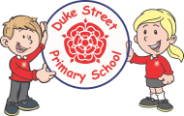 Duke Street EYFS Long Term Plan 2021/2022

 | Autumn 1  Me and My World (Where do I belong?) | Autumn 2  Sparkle and Shine | Spring 1  Snow and Ice  Cold! | Spring 2  Journeys  (Where are we going?) | Summer 1  How do Things grow?  (Life cycles and growth) | Summer 2  Ticket to ride… hot places.
Core Texts  A bank of familiar texts/ traditional tales will be read daily to the children at story time. This will enable them to orally re-tell popular texts and stories independently. | Shark in the park’ ‘Shark in the park on a windy day’ - Nick Sharratt/  Mrs Blackhat – Inkpen  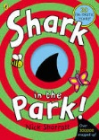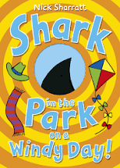  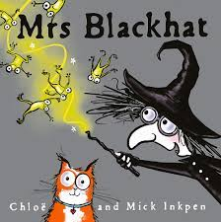 | Kipper’s party (ORT)  Kipper’s birthday – Mick Inkpen  The best birthday Present ever  The best Christmas present ever Mantle,  Penguin’s Christmas Book – Salina Yoon  Friendship week - books  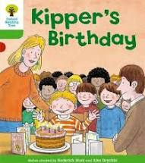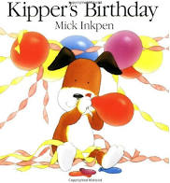  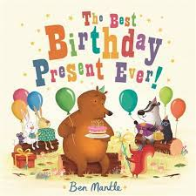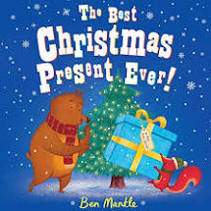  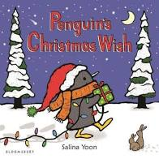 | Jack Frost – Kazuno Kohara  Snowballs – Louis Ehlert  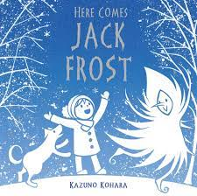  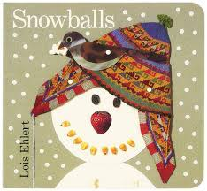 | The Gingerbread Man – Estelle Clarke Goldilocks and the Three Bears  The Naughty Bus  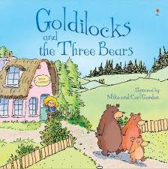  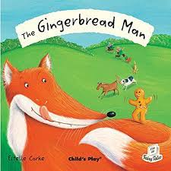  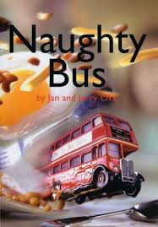 | Jack and the Beanstalk  The Very Hungry Caterpillar  The life cycle of a butterfly  Sunflower big book?  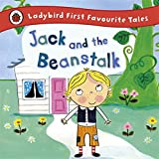  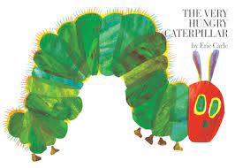 | Handa’s Surprise  Tinga Tinga Tales  (How the elephant got its trunk)  We all went on Safari – Laurie Krebs  We’re going on a lion hunt – David Axtell  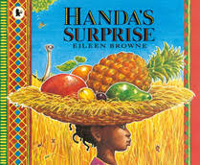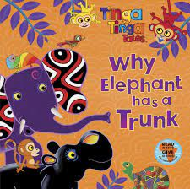  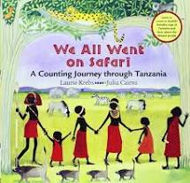  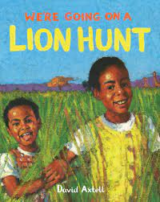
Extra Texts  To ensure a range of fiction non-fiction and poetry books throughout the school year | Fiction  Leaf man  Oxford Reading Tree (family links)  Percy The Park Keeper  Non-Fiction  Starting school  Welcome to my world  my world your world all kinds of families/colour  Poetry / Riddles | Fiction  There’s a house inside my tummy  Non-Fiction  Diwali  Welcome to our world  Poetry / Riddles  You were first? | Fiction  Non-Fiction  Poetry / Riddles  Goodbye Autumn, Hello Winter - JW Turner –  snowstorm,  Penguin on holiday Penguins big adventure  Once upon a snowstorm  The great race | Fiction  Non-Fiction  Poetry / Riddles  T  he Train Ride  Duck in a Truck  The Snail and the Whale  What the Ladybird Heard?  Rosie’s Walk  You Choose – Fairy Tales  Biscuit Bear | Fiction  Non-Fiction  Poetry / Riddles  Bean – Kirsty Holmes  Frog/butterfly life cycles – Grace Jones  Oi Frog  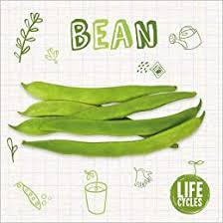  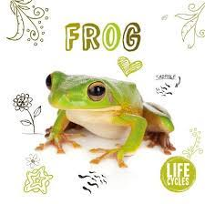 | Fiction  Non-Fiction  Poetry / Riddles  Penguin on Holiday  Handa’s Hen  Bringing the Rain to Kapiti Plain  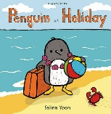
Duke Street needs (drivers) | Children can celebrate the special things and personal knowledge of themselves and their family that they come to Duke Street school with (e.g. birthdays)  Some start school with poor physical development.  Big focus on PSHE and well being due to effects of Covid and less time spent in nursery. | Exploring diversity and how special times are celebrated in different ways. | Exploring weathers, different parts of the world | Children may have limited experience of journeys/days out/holidays due to Covid 19 | Exploring different environments and building on their knowledge of forest school. | Exploring different cultures, different ways of life
PSHE links  Health and Well Being | All about me  Me and my Family  Who are my friends?  What foods do I like?  Harvest | How do I keep safe? (bonfire night) Anti-Bullying/Friendship Week  Road Safety(forest school) | Understanding and Respecting other cultures –  Chinese New Year | Easter Shrove Tuesday  Mother’s Day | Planting seeds/ bulbs Life cycles/ nurture and caring | Sports Day – team work  Similarities / differences  Transition – stay & play, move up day
Lines of Enquiry | Who am I?  Ourselves  Discussions about family members.  Past and present – do you remember being a baby? What about now?  Map work – tracking back from a walk to the park  Past and present experiences  Changes in seasons – noticing signs of Autumn  *Family photo album | Sparkle and Shine (celebrations and festivals)  Exploring different celebrations and cultures. Diwali, Christmas/ Eid/ Weddings/ Birthdays etc.  Other celebrations – different cultures Bonfire night –keeping safe  The Christmas Story Weddings  Eid  Link pieces of music to a celebration.  Create a dance/ song | Science exploration hot and cold countries.  Explore changes of state – melting and freezing.  Explore weather and seasonal change. Weather/Seasons  Hot and Cold Countries  Chinese New Year - taste Chinese Food  Penguins  Freezing & Melting Ice  Other cultures and different faiths.  Snowdrop walk/mapping where they are in FS. Snowflake dance Colour mixing cold colours  Winter art – using wax crayons and watercolours  Making characters from core text using recycled materials/ - how can the penguin travel?  Make boats/ planes etc using cardboard/ recycled materials etc Winter collages Chinese role-play Chinese dragon dance/song  Chinese music and sounds | Explore map work. D+T focus – making different modes of transport using Reggio materials/ different joining materials. Evaluate and improve designs.  Junk modelling and design areas. Deconstruct your role play  Ramadan - Crescent Moons and pointed minarets  DT focus – plan and evaluate – recreate baby bears chair – design and evaluate • Dance/ drama based on traditional tales  Mother’s Day - Mother’s Day cards | How do things grow? Planting seeds and taking care of them. Plant seeds and watch them grow to enhance the outdoor area  Map work – tracking back from a walk to the park  Past and present experiences Changes in seasons – noticing signs of Spring/Summer  Other celebrations – different cultures Dance/ drama based on traditional tales  Farm visit  Shadow art work – link to UW  Using different materials and media for lifecycles  Dance/ drama based on germinating plant Butterfly paintings Using natural materials to create pictures.  Making beanstalks – DT focus – plan and evaluate | Where is Kenya?  What is it like to live there? (houses, clothes, food, past times, school etc)  Animals in hot countries  Fruit in hot countries  Map work – Africa  Google maps
Knowledge and Concepts | Baseline  Sense of belonging Routines and relationships  Personal attributes Families Understanding own culture in immediate environment | Diwali – link to dance/ music  EAD Birthdays – link to music  Link all celebrations topic to pieces of music – dance Christmas songs  Using role-play to act out different scenes. Past and present – birthdays – what could you do as a baby? What can you do now? | Notice changes in seasons and signs of Winter  EAD – winter art, mixing colours/ice cubes etc (vocab) Melting and Freezing experiments  Looking at polar animals/ animals in hotter climates Looking after animals in winter (bird feeders) | Park visit – mapping our route  Easter - link to Easter story – Christianity Growing – planting seeds ready for the Summer term.  Notice seasonal change – Spring to Summer | Notice seasonal change – Spring to Summer  Life cycles: bees, butterflies, frogs.  Planting seeds and observational drawings/ painting of plants/ flowers  Junk model animals  Growth songs – ‘a tiny seed was sleeping’ etc Number songs  Using instruments to create sounds  Sand and Water/Wet and Dry Mud Kitchen Animal sounds Farm songs and dances
Cultural capital?
Prime Areas of Development
Physical Dev | Basic skills  Gross Motor – Basic skills  Experiments with different ways of moving.  Revise and refine the fundamental movement skills they have already acquired: - rolling - crawling - walking - jumping - running - hopping - skipping – climbing  Further develop and refine a range of ball skills including: throwing, catching, kicking, passing, batting, and aiming.  Use their core muscle strength to achieve a good posture when sitting at a table or sitting on the floor.  Fine Motor – -Develop their small motor skills so that they can use a range of tools competently, safely and confidently. Suggested tools: pencils for drawing and writing | Basic skills  Gross Motor – Basic skills  Experiments with different ways of moving.  Revise and refine the fundamental movement skills they have already acquired: - rolling - crawling - walking - jumping - running - hopping - skipping – climbing  Further develop and refine a range of ball skills including: throwing, catching, kicking, passing, batting, and aiming.  Use their core muscle strength to achieve a good posture when sitting at a table or sitting on the floor.  Fine Motor – -Develop their small motor skills so that they can use a range of tools competently, safely and confidently. Suggested tools: pencils for drawing and writing | Gymnastics using apparatus  Gross Motor  Confidently and safely use a range of large and small apparatus indoors and outside, alone and in a group.  Develop overall body-strength, balance, co-ordination and agility  Fine Motor –  Continue to: -  Develop their small motor skills so that they can use a range of tools competently, safely and confidently. Suggested tools: pencils for drawing and writing  ELG emerging Fine Motor- Hold a pencil effectively in preparation for fluent writing – using the tripod grip in almost all cases; | Movement in response to stimuli (dance)  Gross Motor –  Progress towards a more fluent style of moving, with developing control and grace  Develop the overall body strength, co-ordination, balance and agility needed to engage successfully with future physical education sessions and other physical disciplines including dance, gymnastics, sport and swimming  Fine Motor - . -Develop their small motor skills so that they can use a range of tools competently, safely and confidently. Suggested tools: pencils for drawing and writing, paintbrushes, scissors, knives, forks and spoons  Develop the foundations of a handwriting style which is fast, accurate and efficient.  ELG 6. Gross Motor Skills ELG  Children at the expected level of development will: Negotiate space and obstacles safely, with consideration for themselves and others; Demonstrate strength, balance and coordination when playing; Move energetically, such as running, jumping, dancing, hopping, skipping and climbing.  ELG 7. Fine Motor Skills ELG  Children at the expected level of development will: Hold a pencil effectively in preparation for fluent writing – using the tripod grip in almost all cases; Use a range of small tools, including scissors, paint brushes and cutlery; Begin to show accuracy and care when drawing. | Athletics & Sports Day  Gross Motor  Revise and refine the fundamental movement skills they have already acquired: - rolling - crawling - walking - jumping - running - hopping - skipping – climbing  Further develop and refine a range of ball skills including: throwing, catching, kicking, passing, batting, and aiming.  Develop confidence, competence, precision and accuracy when engaging in activities that involve a ball.  Fine Motor -Develop their small motor skills so that they can use a range of tools competently, safely and confidently. Suggested tools: pencils for drawing and writing, paintbrushes, scissors, knives, forks and spoons - Develop the foundations of a handwriting style which is fast, accurate and efficient.  ELG 6. Gross Motor Skills ELG  Children at the expected level of development will: Negotiate space and obstacles safely, with consideration for themselves and others; Demonstrate strength, balance and coordination when playing; Move energetically, such as running, jumping, dancing, hopping, skipping and climbing.  ELG 7. Fine Motor Skills ELG  Children at the expected level of development will: Hold a pencil effectively in preparation for fluent writing – using the tripod grip in almost all cases; Use a range of small tools, including scissors, paint brushes and cutlery; Begin to show accuracy and care when drawing | Games  Gross Motor  ELG 6. Gross Motor Skills ELG  Children at the expected level of development will:  Negotiate space and obstacles safely, with consideration for themselves and others;  Demonstrate strength, balance and coordination when playing;  Move energetically, such as running, jumping, dancing, hopping, skipping and climbing  ELG 7. Fine Motor Skills ELG  Children at the expected level of development will:  Hold a pencil effectively in preparation for fluent writing – using the tripod grip in almost all cases;  Use a range of small tools, including scissors, paint brushes and cutlery;  Begin to show accuracy and care when drawing.
Ongoing throughout the year - Know and talk about the different factors that support - their overall health and wellbeing:- regular physical activity- healthy eating- tooth brushing- sensible amounts of ‘screen time’- having a good sleep routine - being a safe pedestrian -Further develop the skills they need to manage the school day successfully: - lining up and queuing – mealtimes - personal hygiene
PSED | PSED is not specifically planned for across the year, however PSED Principles underpin daily classroom practice which ensures all aspects of developing PSED are covered. Observations and next steps are central to supporting children in making relationships, developing self-confidence and having an awareness and managing feelings and behaviour.  Self Regulation  See themselves as a valuable individual.  Identify and moderate their own feelings socially and emotionally.  ELG 3  3. Self-Regulation ELG Children at the expected level of development will:  Show an understanding of their own feelings and those of others, and begin to regulate their behaviour accordingly;  Set and work towards simple goals, being able to wait for what they want and control their immediate impulses when appropriate;  Give focused attention to what the teacher says, responding appropriately even when engaged in activity, and show an ability to follow instructions involving several ideas or actions  Managing Self  Manage their own needs. –  Express their feelings and consider the feelings of others –  Show resilience and perseverance in the face of challenge  ELG 4  4. Managing Self ELG Children at the expected level of development will:  Be confident to try new activities and show independence, resilience and perseverance in the face of challenge;  Explain the reasons for rules, know right from wrong and try to behave accordingly;  Manage their own basic hygiene and personal needs, including dressing, going to the toilet and understanding the importance of healthy food choices  Building Relationships –  Build constructive and respectful relationships. –  Think about the perspectives of others  ELG 5  5. Building Relationships ELG Children at the expected level of development will:  Work and play cooperatively and take turns with others; Form positive attachments to adults and friendships with peers;  Show sensitivity to their own and to others’ needs
 | Emotional Health and Well Being.  School Rules: routines and boundaries  Forming positive relationships | Being Different  Anti-Bullying Week Friendships  Playing together and taking turns.  Know where to find resources and equipment. | Economic Well Being Good to be Me Working within a group  Being proud of their achievements  Talk about their ideas | Keeping Safe  Road Safety  Know how to keep safe  Share ideas and listen to others  Understand consequences of behaviour | Show care and concern for living things  Sequence ideas together  Understand consequences of behaviour | Relationships Health Resolve conflict without an adult. Adapt to changes in routine/ transition.
Communication and Language | C&L is not specifically planned for across the year. All aspects of developing CLL is considered throughout daily classroom practice, continuous provision, group time and weekly focus learning all have a weighty focus on CLL. Observations next steps and target setting support the development of individuals. Intervention programmes such as talk boost, NELI, WellComm and differentiated group times are designed to support children who are not making the expected progress.  Listening, Attention and Understanding:  Understand how to listen carefully and why listening is important.  Learn new vocabulary. –  Ask questions to find out more and to check they understand what has been said to them –  Connect one idea or action to another using a range of connectives. –  Engage in storytimes -Listen to and talk about stories to build familiarity and understanding. –  Retell the story, once they have developed a deep familiarity with the text; some as exact repetition and some in their own words. –  Listen carefully to rhymes and songs, paying attention to how they sound. –  Learn rhymes, poems and songs. –  Engage in non-fiction books. –  ELG 1  Communication and Language  Listening, Attention and Understanding ELG Children at the expected level of development will:  Listen attentively and respond to what they hear with relevant questions, comments and actions when being read to and during whole class discussions and small group interactions;  Make comments about what they have heard and ask questions to clarify their understanding;  Hold conversation when engaged in back-and-forth exchanges with their teacher and peers  Listen to and talk about selected non-fiction to develop a deep familiarity with new knowledge and vocabulary  Speaking –  Learn new vocabulary  Use new vocabulary through the day  -Articulate their ideas and thoughts in well-formed sentences. –  Describe events in some detail. –  Use talk to help work out problems and organise thinking and activities, and to explain how things work and why they might happen. –  Develop social phrases –  Use new vocabulary in different contexts  ELG 2  Speaking ELG  Children at the expected level of development will:  Participate in small group, class and one-to-one discussions, offering their own ideas, using recently introduced vocabulary;  Offer explanations for why things might happen, making use of recently introduced vocabulary from stories, non-fiction, rhymes and poems when appropriate;  Express their ideas and feelings about their experiences using full sentences, including use of past, present and future tenses and making use of conjunctions, with modelling and support from their teacher
 | Talk about their likes/dislikes.  Talk about themselves and their family  Speak in a full sentence  Listening and Attention  Focus on an activity for a short period of time | Speaking skills.  Use language to communicate and explain how they are feeling and what they want to do.  Talk about who helps us in a simple sentence. | Listen and respond to stories with increasing attention. | Following instructions and recalling instructions given. Listen and respond to peers and adults. | Speaking skills. Organise talk and sequence ideas together to express opinions about their interests | Answering ‘how’ and ‘why’ questions.  Listen to others' opinions.
Other areas of learning
Forest School | Books:  Leaf Man  Gruffalo  Basic rules and routines  Being a safe pedestrian (PSED)  Gruffalo  Watching Duke on the ‘hedgehog cam’  Making wind chimes for outdoor area  Collecting leaves and making ‘Leaf Man’  Leaf rubbings | Books:  Percy the Park Keeper  Hibernation – Duke  Nettle soup (DT)  Presents for the woodland animals … clues ‘Who would like this gift?’  Collect twigs to wrap around candles for Diwali lanterns  Make stick fire works using curly ribbons  Forest circle fire – make toffee apple slices to toast  Christmas decorations from wooden discs | Books:  Jack Frost  Gruffalo’s Child  Waterproof materials – forest school  Make ice hanging decorations for trees  Leaf rubbings  Leaf/flower prints on calico (Mothers Day) | Books:  Stick Man  Act out stories/role play using masks  Make a chair – splitting a log | Books:  Non fiction  Frog spawn / frogs  Make a beanstalk using willow and wrapping around wooden poles  Caterpillar hunt  Nettles info  Make willow crowns and decorate in class | Camouflage  Ongoing forest school observations
RE | Why do we celebrate?  *What times are special for different people and why?  -Introduce persona doll  Harvest  Christmas  Diwali  Eid |  | What is special about our world?  -Persona doll  *Chinese New Year (party)  *Easter Church Visit  Christianity/Judaism  Islam |  | Which places are special for different people and why?  -Persona doll  -Special Places  Christianity  Islam  Hinduism
Phonics (Letters and sounds) | Phase 2  Recognising letters and the sounds they make. Segmenting and blending simple CVC words. Recognising HFW  *Part time week of 6/9/21 - Phase 1  *Then 13/9/21  -s,a  -t,p (I)  -i,n (no, go)  -m,d (to, into)  -g,o (the) | Phase 2/ Phase 3 for HA  Segmenting and blending CVC and CCVC words.  Spelling simple VC, CVC and CCVC words using phonics knowledge. Recognising and spelling HFW.  -c,k,ck  -e,u  -r,h  -b,f  -ff,l  -ll,ss  -phase 2 assessments week of 13/12/21 | Phase 3  Learning graphemes. Segmenting and blending phase 3 words using phonic knowledge.  Read simple sentences. Recognising and spelling key HFW.  -j,v (he, she)  -w,x (we, me)  -y,z (be)  -zz,qu (was)  -ch,sh (you)  -th,ng (they) | Phase 3  Reading sentences using letters and sounds to decode unfamiliar words. Recording sentences with key HFW and use of phonic knowledge  -ai,ee (all)  -igh,oa (are)  -oo,oo (my)  -ar,or (her)  -ur,ow  -oi,er | Phase 3 Consolidation Re-capping what has been taught.  Using and applying strategies through reading and writing.  -ure,ear,air  -Phase 3 recap  -Phase 3 assessment  -Phase 3 consolidation  -Phase 3 consolidation  -Phase 3 consolidation | Phase 4  Move onto phase 4 to consolidate phase 3, using and applying strategies.  -Phase 4  -Phase 4  -Phase 4  -Phase 4  -Phase 4  -Phase 4  (Possible Phase 5 group for any children ready?)
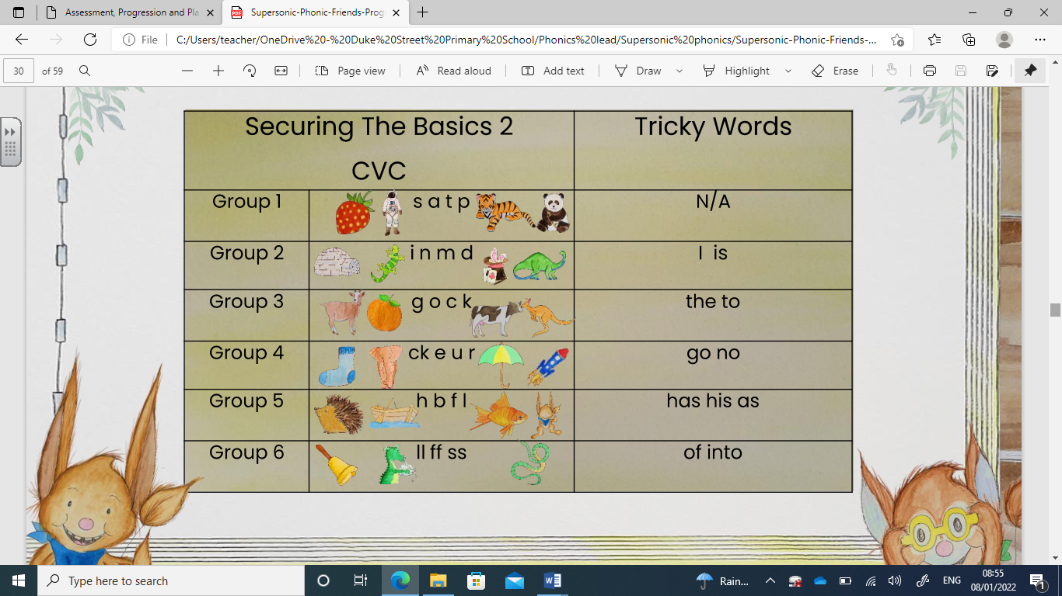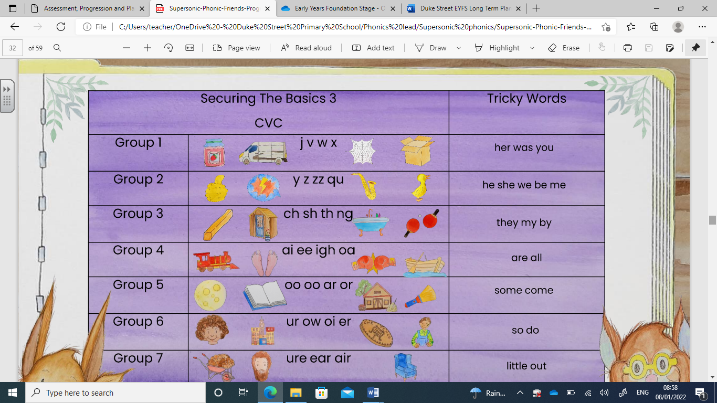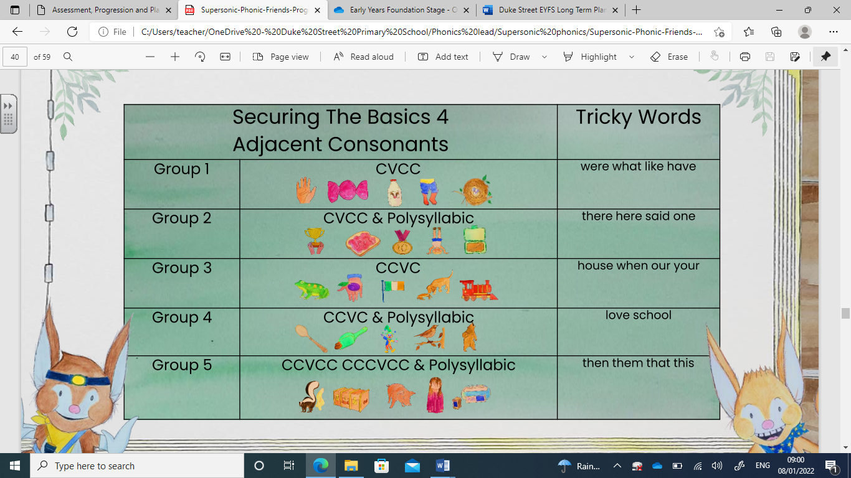
Specific areas of development
Literacy | Throughout the year the skills taught will include:  Comprehension focus:  -Re-read books to build up their confidence in word reading, their fluency and their understanding and enjoyment.  ELG 8 Comprehension ELG  Children at the expected level of development will:  Demonstrate understanding of what has been read to them by retelling stories and narratives using their own words and recently introduced vocabulary;  Anticipate – where appropriate – key events in stories;  Use and understand recently introduced vocabulary during discussions about stories, non-fiction, rhymes and poems and during role-play  Word Reading focus:  -Read individual letters by saying the sounds for them.  -Blend sounds into words, so that they can read short words made up of known letter–sound correspondences.  -Read some letter groups that each represent one sound and say sounds for them.  (Help children to become familiar with letter groups,  such as ‘th’, ‘sh’, ‘ch’, ‘ee’ ‘or’ ‘igh’)  -Read a few common exception words matched to the school’s phonic programme.  -Read simple phrases and sentences made up of words with known letter–sound correspondences and, where necessary, a few exception words.  -Re-read what they have written to check that it makes sense.  ELG 9 Word Reading ELG  Children at the expected level of development will:  Say a sound for each letter in the alphabet and at least 10 digraphs;  Read words consistent with their phonic knowledge by sound-blending;  Read aloud simple sentences and books that are consistent with their phonic knowledge, including some common exception words.  Writing Focus:  -Form lower-case and capital letters correctly.  -Spell words by identifying the sounds and then writing the sound with letter/s.  -Write short sentences with words with known sound-letter correspondences using a capital letter and full stop.  ELG 10 Writing ELG  Children at the expected level of development will:  Write recognisable letters, most of which are correctly formed;  Spell words by identifying sounds in them and representing the sounds with a letter or letters;  Write simple phrases and sentences that can be read by others
Literacy Skills | Comprehension  Re-read books to build up their confidence in word reading, their fluency and their understanding and enjoyment.  Reading  Recognise some initial letters Read some simple VC and CVC words.  Hears and says the initial sound in words. Can segment the sounds in simple words and blend them together and knows which letters represent some of them.  Retell favourite stories using some story language.  Send home reading books.  Identify daily target readers for lowest 20%.  Writing  Write own name. Write some initial sounds.  Write simple words.  During autumn 1 to complete writing steps 1, 2, 3 & 4.  Phonics -Oral blending and segmenting.  Phase 2 initial sounds.  Introduce tricky words I, go, no.  Label pictures.  Phase 2  Recognising letters and the sounds they make.  Segmenting and blending simple CVC words. Recognising HFW. | Comprehension  -Re-read books to build up their confidence in word reading, their fluency and their understanding and enjoyment.  Reading  Recognise and read key HFW.  Read some simple VC and CVC words and sentences.  Hears and says the sounds in words using phoneme frames. Continue with home-readers and daily target readers. Introduce guided reading.  Applying phonic knowledge to reading. Can segment the sounds in simple words and blend them together and knows which letters represent some of them.  Send home reading books.  Identify daily target readers for lowest 20%.  Writing  - Write own name. Write some initial sounds.  Write simple words. Begin to record simple captions and labels using dominant sounds.  To write 4 or more words in a simple sentence.  To complete writing step 5 by the end of December.  Phonics  To introduce tricky words I, go, no, the into, to  Phase 2/ Phase 3 for HA  Segmenting and blending CVC and CCVC words.  Spelling simple VC, CVC and CCVC words using phonics knowledge. Recognising and spelling  HFW.Phonics -Oral blending and segmenting  Phase 2 initial sounds | Comprehension  -Re-read books to build up their confidence in word reading, their fluency and their understanding and enjoyment –  Children to be able to retell at least two familiar texts.  Reading  Continue to recognise and read key HFW. Read CVC sentences. Use phoneme frames to write words and sentences with phase 2/3 sounds in them. Use phonic knowledge to retell a story in simple sentences. Continue with home-readers, daily target readers and guided reading.  Use and apply phonic knowledge when reading to recognise and read key HFW. When writing use Phase 2/3 letters and sounds to support what is being written. Retell favourite stories using story language and time connectives e.g “First, Next, Then, After that, Finally”  Continue with home-readers and daily target readers Continue guided reading.  Writing  - Write own name. Write some initial sounds.  Write simple sentences using VC and CVC words.  To write 5 or more words in a sentence.  Start to use capital letter for ‘I’.  To incorporate / copy tricky words into writing.  Record simple captions and labels using phase 2/3 sounds.  Begin to write for a purpose, sequencing ideas together and recognising key features that need to be included such as finger spaces – instructional writing/ letter writing/ diary entries etc.  To ensure writing steps 1-6 are completed by February half term.  Phonics  Phase 3 Learning graphemes. Segmenting and blending phase 3 words using phonic knowledge.  Read simple sentences. Recognising and spelling key HFW.  Oral blending and segmenting.  Phase 2 and Phase 3 sounds.  Use phoneme frames to write words using phase 3 sounds.  Use phonic knowledge to retell stories – Goldilocks  Word Reading focus:  -Read individual letters by saying the sounds for them.  -Blend sounds into words, so that they can read short words made up of known letter–sound correspondences.  -Read some letter groups that each represent one sound and say sounds for them.  (Help children to become familiar with letter groups, such as ‘th’, ‘sh’, ‘ch’, ‘ee’ ‘or’ ‘igh’)  -Read a few common exception words matched to the school’s phonic programme.  Read simple phrases and sentences made up of words with known letter–sound correspondences and, where necessary, a few exception words. -Re-read what they have written to check that it makes sense. | Comprehension  Re-read books to build up their confidence in word reading, their fluency and their understanding and enjoyment.  Children to be able to retell at least 3 familiar texts.  Reading  Continue to recognise and read key HFW. Read CVC/ CVCC sentences.  Use phoneme frames to write words and sentences with phase 3 sounds in them.  Use phonic knowledge to retell a story in simple sentences. Continue with home-readers, daily target readers and guided reading.  Use and apply phonic knowledge when reading to recognise and read key HFW. Continue with home-readers and daily target readers Continue guided reading.  Writing  - When writing use Phase 3 letters and sounds to support what is being written.  Retell favourite stories using story language and time connectives e.g “First, Next, Then, After that, Finally”  To complete writing step 7 by April with a particular focus on writing stamina.  CL to start a sentence and FS at the end – to use independently.  Phonics  Phase 3  Reading sentences using letters and sounds to decode unfamiliar words. Recording sentences with key HFW and use of phonic knowledge.  Oral blending and segmenting.  Phase 3 sounds.  Use phoneme frames to write words using phase 3 sounds.  Use phonic knowledge to retell stories – Naughty Bus using time connectives “Then, After that, Next” etc.  Word Reading focus  -Read individual letters by saying the sounds for them.  -Blend sounds into words, so that they can read short words made up of known letter–sound correspondences.  -Read some letter groups that each represent one sound and say sounds for them.  (Help children to become familiar with letter groups, such as ‘th’, ‘sh’, ‘ch’, ‘ee’ ‘or’ ‘igh’)  -Read a few common exception words matched to the school’s phonic programme.  Read simple phrases and sentences made up of words with known letter–sound correspondences and, where necessary, a few exception words. -Re-read what they have written to check that it makes sense. | Reading  Continue to recognise and read key HFW. Read CVC/ CVCC sentences.  Use phoneme frames to write words and sentences with phase 3/4 sounds in them. Introduce Phase 5 for HA children.  Use phonic knowledge to retell a story using complex sentences – Jack and the Beanstalk.  Continue with home-readers, daily target readers and guided reading.  Use and apply phonic knowledge when reading to recognise and read key HFW.  Writing - When writing use Phase 3/4 letters and sounds to support what is being written.  Retell favourite stories using story language and time connectives e.g “First, Next, Then, After that, Finally” – Jack and the Beanstalk.  To complete writing step 8 by June.  Tricky words from phase 2 & 3 used consistently in writing and some from phase 4 &5.  CL to start a sentence and FS at the end – to use independently.  Phonics – Phase 3 Consolidation  Re-capping what has been taught.  Using and applying strategies through reading and writing. Oral blending and segmenting Phase 3/4 sounds.  Use phoneme frames to write words using phase 3/4 sounds.  Use phonic knowledge to retell stories – Jack and the Beanstalk using time connectives “Then, After that, Next” etc.  9. Word Reading ELG Children at the expected level of development will:  Say a sound for each letter in the alphabet and at least 10 digraphs;  Read words consistent with their phonic knowledge by sound blending;  Read aloud simple sentences and books that are consistent with their phonic knowledge, including some common exception words.  10. Writing ELG Children at the expected level of development will:  Write recognisable letters, most of which are correctly formed;  Spell words by identifying sounds in them and representing the sounds with a letter or letters;  Write simple phrases and sentences that can be read by others | Consolidating what has been taught to ensure children have the confidence and stamina to write at length.  Children begin to include detail in what they write and can read what they have recorded unaided. Children to be able to re-tell at least 3-5 familiar texts  8. Comprehension ELG  Children at the expected level of development will:  Demonstrate understanding of what has been read to them by retelling stories and narratives using their own words and recently introduced vocabulary;  Anticipate – where appropriate – key events in stories;  Use and understand recently introduced vocabulary during discussions about stories, non-fiction, rhymes and poems and during role-play.  Phase 4  Move onto phase 4 to consolidate phase 3, using and applying strategies.  9. Word Reading ELG Children at the expected level of development will:  Say a sound for each letter in the alphabet and at least 10 digraphs;  Read words consistent with their phonic knowledge by sound blending;  Read aloud simple sentences and books that are consistent with their phonic knowledge, including some common exception words  10. Writing ELG Children at the expected level of development will:  Write recognisable letters, most of which are correctly formed;  Spell words by identifying sounds in them and representing the sounds with a letter or letters;  Write simple phrases and sentences that can be read by others
Mathematics | Throughout the year the skills taught will include:  Number focus: 0-20 and beyond. Recognition/composition/subitising/counting/ordering/one to one correspondence/recording numbers, number bonds to 10, counting in 10’s and 2’s, addition/subtraction, doubling & halving, sharing, recognising money and its uses, solving simple number problems, guided reasoning.  Leading towards ELG: Number  Children at the expected level of development will:  - Have a deep understanding of number to 10, including the composition of each number;  - Subitise (recognise quantities without counting) up to 5;  - Automatically recall (without reference to rhymes, counting or other aids) number bonds up to 5 (including subtraction facts) and some number bonds to 10, including double facts.  ELG: Numerical Patterns  Children at the expected level of development will:  - Verbally count beyond 20, recognising the pattern of the counting system;  - Compare quantities up to 10 in different contexts, recognising when one quantity is greater than, less than or the same as the other quantity;  - Explore and represent patterns within numbers up to 10, including evens and odds, double facts and how quantities can be distributed equally.  Shape,Space and Measures focus: Explore, manipulate and describe jigsaws, 2d & 3d shapes, pattern blocks, weight, length, capacity. Use informal language, signs and strategies when working out mathematical problems, creating maps, giving instructions and logging data.
Math Skills (Number) | Introducing numbers to 4  Comparison  - Compare numbers 1234  - More than and less than, to 4  - Estimates the number of items before counting  Counting  - Practice counting to 10 and beyond saying the number names in the correct order (stable order)  - Count objects, actions and sounds  - Use 1:1 correspondence when counting  - Order number to 4 and beyond  - Cardinality  - Introduce numbers 1-4  - Represent numbers 1-4 using objects  - Write numerals 1-4  - Match numerals 1-4 to quantity.  - Count out up to 4 objects from a larger group  - Recognise the last number in the count as the group size.  - Composition  - Introduce partitioning of numbers 1-4 (part-part-whole)  - Subitising numbers to 4 | Securing Numbers to 5  Comparison  - Compare numbers 12345  - More than and less than, to 5  - Estimates the number of items before counting  Counting  - Practice counting to 10 and beyond saying the number names in the correct order (stable order)  - Count objects, actions and sounds  - Use 1:1 correspondence when counting  - Order number to 5 and beyond  - Cardinality  - Introduce numbers 1-5  - Represent numbers 1-5 using objects  - Write numerals 1-5  - Match numerals 1-5 to quantity.  - Count out up to 5 objects from a larger group  - Recognise the last number in the count as the group size.  - Composition  - Introduce partitioning of numbers 1-5 (part-part-whole)  - Subitising numbers to 5  Calculation  - Addition and subtraction of 1 to 5  - Numberbonds to 5  - Conservation of number (a number can be partitioned but the whole (total) remains the same | Securing Numbers to 7 Comparison  - Compare numbers 1-7  - More than and less than, to 7  - Estimates the number of items before counting  Counting  - Practice counting to 20 and beyond saying the number names in the correct order (stable order)  - Practice counting down from 10  - Count objects, actions and sounds  - Use 1:1 correspondence when counting  - Order number to 7 and beyond  - Cardinality  - Introduce numbers 1-7  - Represent numbers 1-7 using objects  - Write numerals 1-7  - Match numerals 1-7 to quantity.  - Count out up to 7 objects from a larger group  - Recognise the last number in the count as the group size.  - Composition  - Introduce partitioning of numbers 1-7 (part-part-whole)  - Subitising numbers to 7  - Subitising larger numbers by subitising smaller groups within the number – dice patterns and irregular arrangements  - 10 ones are equivalent to 1 ten  Calculation  - Addition and subtraction of 1 to 7  - Numberbonds to 7  - Conservation of number (a number can be partitioned but the whole (total) remains the same | Securing Numbers to 10 Comparison  - Compare numbers 1-10  - More than and less than, to 10  - Estimates the number of items before counting  Counting  - Practice counting to 20 and beyond saying the number names in the correct order (stable order)  - Practice counting down from 10  - Count objects, actions and sounds  - Use 1:1 correspondence when counting  - Order number to 7 and beyond  - Cardinality  - Introduce numbers 1-10  - Represent numbers 1-10 using objects  - Write numerals 1-10  - Match numerals 1-10 to quantity.  - Count out up to 10 objects from a larger group  - Recognise the last number in the count as the group size.  - Composition  - Introduce partitioning and combining numbers 1-10 (part-part-whole)  - Subitising numbers to 10  - Subitising larger numbers by subitising smaller groups within the number – dice patterns and irregular arrangements  - 10 ones are equivalent to 1 ten  - Work out mathematical problems using signs and strategies of their own choice (Standard numerals, tallies and ‘+’ or ‘-‘  Calculation  - Addition and subtraction of 1 with number to 10  - Numberbonds to 10  - Conservation of number (a number can be partitioned but the whole (total) remains the same | Deepening Understanding of Numbers to 10 and introducing larger numbers  - Automatically recall numberbonds to 5 without reference to rhymes, counting or aids.  - Verbally count beyond 20 recognising patterns in the counting system – odd and evens, teens,  - Use the language greater than, less than or the same as when comparing quantities  Explore and represent patterns within numbers to 10 – odd and even, double facts, how quantities can be distributed equally. | ELG: Number  Children at the expected level of development will:  - Have a deep understanding of number to 10, including the composition of each number;  - Subitise (recognise quantities without counting) up to 5;  - Automatically recall (without reference to rhymes, counting or other aids) number bonds up to 5 (including subtraction facts) and some number bonds to 10, including double facts.  ELG: Numerical Patterns  Children at the expected level of development will:  - Verbally count beyond 20, recognising the pattern of the counting system;  - Compare quantities up to 10 in different contexts, recognising when one quantity is greater than, less than or the same as the other quantity;  - Explore and represent patterns within numbers up to 10, including evens and odds, double facts and how quantities can be distributed equally.
Math Skills (SSM) | - Solve a range of jigsaws with increasing challenge.  Use informal language to describe shapes within the environment. | - 2d Shape Select, rotate and manipulate shapes in order to develop spatial reasoning skills. (2d pattern blocks)  Create patterns with varying rules (AB ABB ABBC) Xmas paper chains | 2d shape – use mathematical language to describe shapes.  Capacity | Weight  Tallies  Work out mathematical problems using signs and strategies of their own choice (Standard numerals, tallies and ‘+’ or | Length  3d shape  Follow and give instructions, using relative terms and describing what they see from other viewpoints.
Understanding of the World (UTW) | Past and Present –  Seasonal changes –  exploring Autumn time  Eid  People and Communities – Talk about members of their immediate family and community.  Name and describe people who are familiar to them.  The Natural World  Describe what they see, hear and feel whilst outside.  Class rules, boundaries and routines.  Other faiths and culture. Understanding about what is happening in the world around them.  Talking about themselves, their home and their family. Past and present experiences.  Accessing I-pads  Phonics games  Maths games  Using the IWB  Understanding how to work technological equipment. | Past and Present - Comment on images of familiar situations in the past. –  Compare and contrast characters from stories, including figures from the past.  People and Communities Understand that some places are special to members of their community  Recognise that people have different beliefs and celebrate special times in different ways  The Natural World Describe what they see, hear and feel whilst outside  Light and dark  Bonfire night – keeping safe  The Christmas Story Birthdays  Weddings  Diwali  Eid  Light and dark Expresso  Purple Mash – fireworks pictures | Past and Present Compare and contrast characters from stories, including figures from the past.  People and Communities Recognise some similarities and differences between life in this country and life in other countries.  The Natural World  Describe what they see, hear and feel whilst outside. Understand the effect of changing seasons on the natural world around them.  Explore the natural world around them. (Observe and interact with natural processes, such as ice melting, a sound causing a vibration, light travelling through transparent material, an object casting a shadow, a magnet attracting an object and a boat floating on water.) - Recognise some environments that are different to the one in which they live. | Past and Present Compare and contrast characters from stories, including figures from the past.  People and Communities  Draw information from a simple map.  The natural World Describe what they see, hear and feel whilst outside. Understand the effect of changing seasons on the natural world around them. -Explore the natural world around them. (Observe and interact with natural processes, such as ice melting, a sound causing a vibration, light travelling through transparent material, an object casting a shadow, a magnet attracting an object and a boat floating on water.) - Recognise some environments that are different to the one in which they live. - Understand the effect of changing seasons on the natural world around them.  Park visit – mapping our route  Easter Teachers link to Easter story – Christianity  Growing – planting seeds ready for the Summer term. Maths games Phonic games Paint program | ELG 13. Past and Present ELG  Children at the expected level of development will:  Talk about the lives of the people around them and their roles in society;  Know some similarities and differences between things in the past and now, drawing on their experiences and what has been read in class;  Understand the past through settings, characters and events encountered in books read in class and storytelling;  ELG 14. People Culture and Communities ELG Children at the expected level of development will: Describe their immediate environment using knowledge from observation, discussion, stories, non-fiction texts and maps;  Know some similarities and differences between different religious and cultural communities in this country, drawing on their experiences and what has been read in class;  Explain some similarities and differences between life in this country and life in other countries, drawing on knowledge from stories, non-fiction texts and – when appropriate – maps  ELG 15 The Natural World ELG  Children at the expected level of development will: Explore the natural world around them, making observations and drawing pictures of animals and plants; Know some similarities and differences between the natural world around them and contrasting environments, drawing on their experiences and what has been read in class; Understand some important processes and changes in the natural world around them, including the seasons and changing states of matter.  Growing and planting Caring for plants Weather chart Life cycles: bees, butterflies, frogs. Growing Programmable toys | ELG 13. Past and Present ELG  Children at the expected level of development will:  Talk about the lives of the people around them and their roles in society;  Know some similarities and differences between things in the past and now, drawing on their experiences and what has been read in class; Understand the past through settings, characters and events encountered in books read in class and storytelling;  ELG 14. People Culture and Communities ELG Children at the expected level of development will: Describe their immediate environment using knowledge from observation, discussion, stories, non-fiction texts and maps;  Know some similarities and differences between different religious and cultural communities in this country, drawing on their experiences and what has been read in class;  Explain some similarities and differences between life in this country and life in other countries, drawing on knowledge from stories, non-fiction texts and – when appropriate – maps.  ELG 15 The Natural World ELG  Children at the expected level of development will: Explore the natural world around them, making observations and drawing pictures of animals and plants; Know some similarities and differences between the natural world around them and contrasting environments, drawing on their experiences and what has been read in class; Understand some important processes and changes in the natural world around them, including the seasons and changing states of matter.  Growing and planting Keeping Healthy Changes in weather Changes in the environment. Similarities and differences.
Expressive Arts and Design (EAD) | Art  Drawing  PD – fine motor begin to show accurcy  EAD – creating with material safely use and explore...  - Share their creation  Creating with materials -Create collaboratively, sharing ideas, resources and skills.  Being Imaginative and Expressive  Listen attentively, move to and talk about music, expressing their feelings and responses.  Develop storylines in their pretend play.  Exploring the patterns in Bridget Riley’s Work – lines, spirals etc. textures, chalks, paints.  Drawing pictures of families/ themselves  Autumnal painting – colour mixing  Singing lots of songs and familiarising children with regular singing.  Sand and Water  Mud Kitchen  BI  Nursery rhymes Deconstructed role play  Artist ideas – Vincent Van Gogh, Georges Seurat, Bridget Riley,  Barbara Hepworth | DT  Prepping fruit and veg  PD – fine motor  use a range of small tools, including scissors, paint brushes, and cutlery  (make fruit kebabs)  Vegetable soup / pumpkin soup – forest school)  Being Imaginative – Music focus  Listen attentively, move to and talk about music, expressing their feelings and responses.  Explore, use and refine a variety of artistic effects to express their ideas and feelings. –  Watch and talk about dance and performance art, expressing their feelings and responses. –  Sing in a group or on their own, increasingly matching the pitch and following the melody - Develop storylines in their pretend play.  Explore and engage in music making and dance, performing solo or in groups Bonfire night paints and textures. Christmas cards Calendars  Making stickman puppets.  Christmas craft, cards and decorations.  BI  Firework sounds  Link celebrations topic to pieces of music - dance  Christmas songs  Using role-play to act out different scenes. | Art  Textiles/collage  Creating with Materials  Safely use and explore a variety...  (weaving/hole punch cardboard  Thread needles)  Being Imaginative – use other cultures / hot and cold to explore, use and refine a variety of artistic effects to express their ideas and feelings. –  Watch and talk about dance and performance art, expressing their feelings and responses.  Sing in a group or on their own, increasingly matching the pitch and following the melody - Develop storylines in their pretend play. - Explore and engage in music making and dance, performing solo or in groups. (Play music with a pulse for children to move in time with and encourage them to respond to changes: they could jump when the music suddenly becomes louder, for example.)  Colour mixing cold colours / Winter art – using wax crayons and watercolours  Making characters from core text using recycled materials/ - how can the penguin travel?  Make boats/ planes etc using cardboard/ recycled materials etc Winter collages  Story characters Malleable materials Mother’s Day cards  BI  Steve Brown unit of work – forte/ tempo/ piano  Chinese role-play Chinese dragon dance Chinese dragon song Chinese music and sound | DT  Sliders and Lever OR templates and joining  Creating with Materials  Return to and build on their previous learning, refining ideas and developing their ability to represent them. (Teach children different techniques for joining materials, such as how to use adhesive tape and different sorts of glue).  Making vehicles using recycled materials – going on a journey Easter craft  Easter story paintings Playdough  Take your paintbrush for a walk – focus on travel  BI  Wheels on the bus/ travel songs  Sand and Water  Mud Kitchen  Lots of map work – drawing maps – retracing steps on journey from the park back to school | Art  Printing  ELG 16. Creating with Materials ELG Children at the expected level of development will: Safely use and explore a variety of materials, tools and techniques, experimenting with colour, design, texture, form and function;  Share their creations, explaining the process they have used;  Make use of props and materials when role playing characters in narratives and stories.  ELG 17. Being Imaginative and Expressive ELG  Children at the expected level of development will: Invent, adapt and recount narratives and stories with peers and their teacher; Sing a range of well-known nursery rhymes and songs; Perform songs, rhymes, poems and stories with others, and – when appropriate – try to move in time with music.  Planting seeds and observational drawings/ painting of plants/ flowers  Junk model animals Farmyard collage Using different materials and media for chicks  Butterfly paintings Using natural materials to create pictures.  Making beanstalks. Story characters. Exploring media and materials  BI  Growth songs – ‘a tiny seed was sleeping’ etc Number songs  Using instruments to create sounds  Sand and Water/Wet and Dry  Mud Kitchen  Animal sounds  Farm songs and dances | Dt  Wheels and axels  ELG 16. Creating with Materials ELG Children at the expected level of development will: Safely use and explore a variety of materials, tools and techniques, experimenting with colour, design, texture, form and function;  Share their creations, explaining the process they have used;  Make use of props and materials when role playing characters in narratives and stories.  ELG 17. Being Imaginative and Expressive ELG  Children at the expected level of development will: Invent, adapt and recount narratives and stories with peers and their teacher; Sing a range of well-known nursery rhymes and songs; Perform songs, rhymes, poems and stories with others, and – when appropriate – try to move in time with music.  Focus on art skills and displaying/ documenting the skills learned throughout the year for whole school corridors display  BI  Whole School Project performance – acting/ singing/ performing to parents.
Extra Curricular activities | Park visit  Autumn Walk  Duke Street Bedtime Hour | Christmas party  Reindeer visit  West Midland Theatre (Panto) | Chinese dragon dancing  Chinese drumming | Visit to the park/Birkacre - mapwork | Visit to ES farm  Platinum Jubilee celebration | Seaside visit  Zoo/safari park visit
Parental engagement | Sending in photos of family | Parents phonics workshop / reading meeting  Invite parents to send in wedding photos for discussion  Festival of Light assembly  Parent consultations |  | Sending in photos/memories of journeys or days out
Assessment | Baseline  Gap report  EY predictions | EY tracker  Gap report  Pupil progress meeting  Moderation  Floor book moderation  End of Phase 2 phonics assessment | EY tracker  Gap report | EY tracker  Gap report  Pupil progress meeting  Moderation  Floor book moderation | EYFS profile  End of Phase 3 phonics assessments | Transition reports/Y1  Reports to parents

