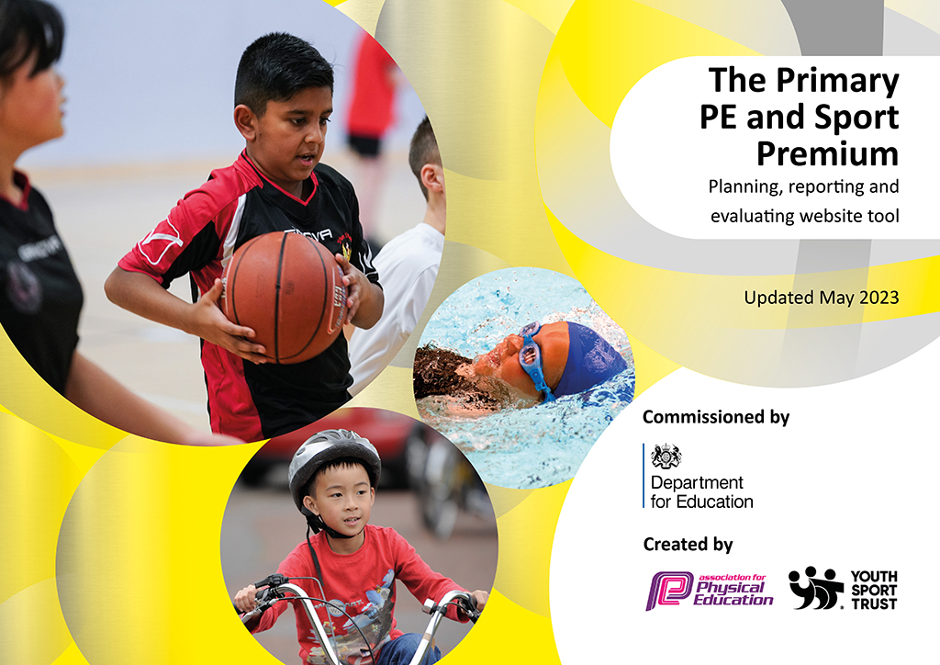
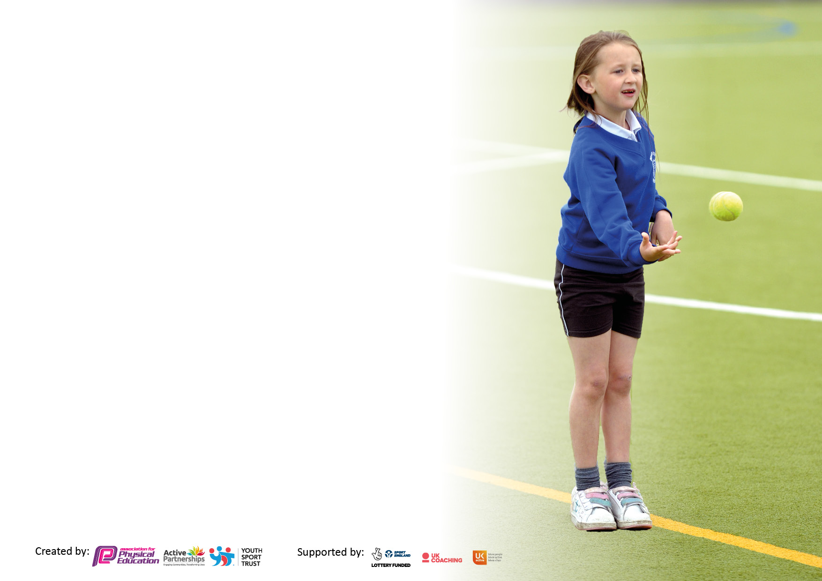

It is important that your grant is used effectively and based on school need. The Education Inspection Framework makes clear there will be a focus on ‘whether leaders and those responsible for governors all understand their respective roles and perform these in a way that enhances the effectiveness of the school’.

Under the Quality of Education Ofsted inspectors consider:
Intent - Curriculum design, coverage and appropriateness
Implementation - Curriculum delivery, Teaching (pedagogy) and Assessment
Impact - Attainment and progress

To assist schools with common transferable language this template has been developed to utilise the same three headings which should make your plans easily transferable between working documents.

Schools must use the funding to make additional and sustainable improvements to the quality of Physical Education, School Sport and Physical Activity (PESSPA) they offer. This means that you should use the Primary PE and sport premium to:

- Develop or add to the PESSPA activities that your school already offer.
- Build capacity and capability within the school to ensure that improvements made now will benefit pupils joining the school in future years.
- The Primary PE and sport premium should not be used to fund capital spend projects; the school’s budget should fund these.

Pleasevisitgov.ukfortherevisedDfEguidanceincludingthe5keyindicatorsacrosswhichschoolsshoulddemonstrate animprovement.Thisdocumentwillhelpyoutoreviewyourprovisionandtoreportyourspend.DfEencouragesschools to use this template as an effective way of meeting the reporting requirements of the Primary PE and Sport Premium.

We recommend you start by reflecting on the impact of current provision and reviewing the previous spend.

Schools are required to publish details of how they spend this funding, including any under-spend from 2021/2022, as well as on the impact it has on pupils’ PE and sport participation and attainment. All funding must be spent by 31st July 2023.

We recommend regularly updating the table and publishing it on your website throughout the year. This evidences your ongoing self-evaluation of how you are using the funding to secure maximum, sustainable impact. Final copy must be posted on your website by the end of the academic year and no later than the 31st July 2023. To see an example of how to complete the table please click HERE.

Details with regard to funding
Please complete the table below.

Total amount carried over from 2021/22 | £7618.42
Total amount allocated for 2021/22 | £18,850
How much (if any) do you intend to carry over from this total fund into 2022/23? | £0
Total amount allocated for 2022/23 | £18,820
Total amount of funding for 2023/23. To be spent and reported on by 31st July 2023. | £ 0
Swimming Data
Please report on your Swimming Data below.

Meeting national curriculum requirements for swimming and water safety.

N.B. Complete this section to your best ability. For example you might have practised safe self-rescue techniques on dry land which you can then transfer to the pool when school swimming restarts.
Due to exceptional circumstances priority should be given to ensuring that pupils can perform safe self-rescue even if they do not fully meet the first two requirements of the NC programme of study
What percentage of your current Year 6 cohort swim competently, confidently and proficiently over a distance of at least 25 metres?  N.B. Even though your pupils may swim in another year please report on their attainment on leaving primary school at the end of the summer term 2022.  Please see note above | 36%
What percentage of your current Year 6 cohort use a range of strokes effectively [for example, front crawl, backstroke and breaststroke]?  Please see note above | 90%
What percentage of your current Year 6 cohort perform safe self-rescue in different water-based situations? | 100%
Schools can choose to use the Primary PE and sport premium to provide additional provision for swimming but this must be for activity over and above the national curriculum requirements. Have you used it in this way? | Yes £2896.40

Action Plan and Budget Tracking
Capture your intended annual spend against the 5 key indicators. Clarify the success criteria and evidence of impact that you intend to measure to evaluate for pupils today and for the future.

Academic Year: 2022/23 | Total fund allocated:£18,820 | Date Updated:10th July 2023
Key indicator 1: The engagement of all pupils in regular physical activity – Chief Medical Officers guidelines recommend that primary school pupils undertake at least 30 minutes of physical activity a day in school |  |  |  | Percentage of total allocation:
 |  |  |  | 9%
Intent | Implementation |  | Impact
Your school focus should be clear what you want the pupils to know and be able to do and about  what they need to learn and to  consolidate through practice: | Make sure your actions to achieve are linked to your intentions: | Funding allocated: | Evidence of impact: what do pupils now know and what can they now do? What has changed?: | Sustainability and suggested next steps:
Physical activity is very important to all pupils. We recognise this at Duke Street and have seen the benefits, pre Covid. Unfortunately, due to mixing bubbles and high cases in our area, we have not been able to carry out as many activities to promote active break times and lunch times as usual. Our intent is to look at developing the opportunities that we already have to engage pupils in daily physical activity and expand this offer further. We will do this through training “Buddies” and “Play leaders” to promote physical activity at lunch times. | - Observe playground behavior and activity levels.  - Consult with EYFS and Y6 for “Buddies” training and provision.  - Select and train Y5 pupils to be lunch time play leaders.  - Purchase equipment to promote physical activity at lunch times.  - Consult with welfare staff.  - Monitor participation at lunch times and the impact of “Buddies” and “Play leaders” | Play leader and Buddies training included in ESPE KI3.  £382.86 Play leader equipment | As Covid restrictions are no longer in force, it has been the first “normal” year in school.  “Buddies” training was delivered to our Y6 pupils on 9th September by ES. Y6 “Buddies” will support our EYFS pupils at lunchtimes. The training was a little different to play leader training as there was a big focus on nurture and support for our new pupils. The Y6 pupils responded well to the training and are well prepared to support EYFS, especially in playing games, being a good role model and being active. ES worked with LP to consider how to promote this further through PSHE lessons. Y5 Play Leader training took place on Friday 16th September by ES. The Y5 Play Leaders work with the welfare staff to promote activity and play at lunchtimes.  Buddies have worked well with reception. Year 6 spend lunchtimes once a week with their reception buddy eating lunch with them and playing games for the remainder of lunch. Many pupils seek out their buddy and play with them at break times when they are out at the same time. Play leaders has not been as successful this year and there has been a lot of confusion. | Sustainability  The equipment purchased will be available in future years. The welfare staff are becoming more confident in supporting pupils. They will continue to do this throughout their employment at Duke Street.  LS and RA also attended the training and therefore can lead the training in the future if required.  Next steps  Consider how to develop the buddy system further. Look at opportunities to improve the play leaders.
The benefits of “brain breaks” during lessons has been well documented. As our morning sessions have lengthened we would like to introduce “brain break” activities to encourage movement throughout the day. Our staff have indicated that this is an area that they would like support with and so we will look to develop this area with staff in Key Stage 1 and Key Stage 2. | - Consider the current timetable and when to include active breaks.  - Consult staff on current provision and barriers.  - Train staff in effective brain breaks that can be done in a classroom.  - Subscribe to Imoves to support planning and delivery of daily physical activity.  - Consider a competition between classes to promote active breaks. | £997 Imoves  £469.55 Active minute prizes | Following consultation with staff the biggest barriers to brain breaks was when to fit it in to an already busy school day and also coming up with engaging ideas to carry out brain breaks in the classroom.  To support staff, we carried out a staff training session with ES on 8th March 2023. All staff from EYFS, KS1 and KS2 attended. During the session ES highlighted the importance of brain breaks, used lots of practical examples and shared ideas with staff. Following this ES visited each class every Friday morning for a half term and completed a brain break with the whole class, sharing a range of ideas with staff and pupils. The classes were then tasked with completing the brain breaks every day the following week until they got a new activity. This continued for six weeks giving staff a range of ideas to draw from when delivering brain breaks. These included – KS1 action stories such as “We’re going on a Bear Hunt”, A Pirates Treasure game and Yoga. For KS2 activities included the Dodgeball game, Rock, Paper Scissors, Active Times tables, Chair strength exercises and classroom cardio.  Feedback from staff was very positive and the pupils looked forward to their new challenge each week. LS (KS1) commented that “the children are so excited to see you each week and look forward to our new challenge”. LP (UKS2) stated that not only did the pupils enjoy the active times tables, but their times tables knowledge also improved. LP shared that they struggled to co-ordinate the actions and times tables whilst performing the two times tables at the start, but now they can do them all, with more complex actions too.  Staff also have access to Imoves which also has a range of active challenges on.  To motivate staff and pupils and to ensure that the active minutes continued, RA created a simple monitoring system. Once classes had completed their active minutes, they had a smiley face to stick on their classroom doors. The active monitors went around the school daily to record participation. At the end of the week RA shared the results through a leaderboard in the hall, in assembly and through school DoJo and Facebook/Twitter to keep parents informed. The winning class for each half term also won a prize, which was being able to choose a prize from the Active Minutes Prize Box. | Sustainability  Class teachers now understand the importance of active minutes and why it should be included in the school day. There are still some challenges, but through making the active minuets competitive has significantly improved participation. Staff now have a bank of activities that they can quickly draw on when they want to deliver their active minutes.  Pupils have a positive attitude to the brain breaks.  Next steps  Continue to promote active minutes, share good practice and support staff as needed. Consider how to engage parents in supporting a further 30 minutes of daily physical activity. Carry out a survey to establish current activity levels outside school and parents’ opinions. Examples could include “Walk to school Wednesday”.
Key indicator 2: The profile of PESSPA being raised across the school as a tool for whole school improvement |  |  |  | Percentage of total allocation:
 |  |  |  | 29%
Intent | Implementation |  | Impact
Your school focus should be clear what you want the pupils to know and be able to do and about.  what they need to learn and to  consolidate through practice: | Make sure your actions to achieve are linked to your intentions: | Funding allocated: | Evidence of impact: what do pupils now know and what can they now do? What has changed?: | Sustainability and suggested next steps:
Continue to support the PE subject leader, especially in supporting staff in delivering active minutes and daily physical activity. PE remains a focus in school and needs to be driven by the subject leader. | - ES and RA to meet regularly to plan action points.  - Update the curriculum map and keep informed of national updates.  - Observation of staff and quality assure visiting staff.  - Audit school staff and consider needs.  - Set up pupil voice.  - Attend PLT and cluster meetings with the Sports Partnership  - Ensure that PESS premium is reported and spent wisely. | Included in ESPE KI3  £90 additional meeting 18th April  £200 additional meeting 11th July  £1000 CSSP membership  Subject leader resources £46.64  RA subject leader time – last year it was £5000. | ES and RA meet regularly to plan action points to develop PE across the school. RA has developed his subject leader knowledge and was confident and well prepared during subject discussions (shallow dive) during an Ofsted inspection earlier this year. RA has said that he felt confident that he had sufficient knowledge and evidence on PE passport as well as the support from ES.  RA made the decision at the start of the academic year to change the scheme of work followed within the school and as a result has created a new curriculum map offering a much broader range of activities and more engaging lessons. Staff have been happy with this change, and several have reported that they enjoy teaching PE more as a result. Others have reported that the lessons are much more engaging for the pupils. From a subject leader’s perspective there is also a lot more opportunity for progression in the new scheme as units do not need to be repeated as was the case with the old scheme.  RA conducted pupil voice with our KS2 pupils, which showed that all pupils enjoy PE and understand that PE is important. Pupils strongly agreed that they know what they were learning in PE and agree that they know how to improve. Pupils also feel confident and safe in PE. A few pupils stated that they do not enjoy extracurricular clubs, however some strongly agreed that they enjoy attending the clubs.  RA has also sought opportunities to network with other PE leaders. On a local level, RA has attended the CHIP cluster subject leader meeting to develop links with PE leads in the immediate area. This was beneficial to share good practice and also to link with staff to arrange friendly fixtures. RA has attended the CSSP PLT day and Health Conference in which the Sports Partnership deliver sessions on a variety of areas and provide a networking opportunity for subject leaders from across Chorley.  RA has also attended the Lancashire PE subject leader’s day, which again provided opportunities to attend a range of sessions and network on a much wider scale. | Sustainability  RA continues to develop his subject leadership to support staff in continuing to develop and lead PE across the school. Staff and pupils have benefited from his enthusiasm and dedication as well as his confidence in making decisions as shown in changing the scheme of work.  Next steps  Continue to support RA in the observation of staff and developing the curriculum further.  Following the pupil voice, we need to look at clubs to engage those pupils who do not enjoy clubs.
At the end of the last academic year, we subscribed to and introduced a cross curricular scheme of work to promote active learning in a range of subjects. As this was introduced in the summer term we need to develop this further to make the most of the resource. We started with learning to orienteer as a whole school theme within our PE lessons, this year we need to make use of the cross curricular aspect of the resource. | - Plan PE curriculum map to re-visit the orienteering parts of the course.  - Consider how to introduce the cross curricular sections.  - Liaise with staff and timetable as appropriate. | No cost as we paid for a three-year subscription last year. | All staff started the year teaching the OAA unit of work to consolidate the learning and promote the use of the resources. This has also allowed staff to become more confident in using the lesson plans and resources available. As this scheme was introduced in the summer term of last year it has been beneficial to give staff the opportunity to teach it again early in the year. It also allowed pupils to really develop their understanding of the Orienteering unit of work. | Sustainability  The resources are all stored in boxes and are ready to go for each lesson. These are stored in the staff room and are available and ready for all staff to use. These will be available for years to come. The knowledge of staff and pupils of orienteering has improved, and this experience will develop their understanding over time.  Next steps  Consider how to encourage staff to use the cross curricular units within the scheme.

Key indicator 3: Increased confidence, knowledge and skills of all staff in teaching PE and sport |  |  |  | Percentage of total allocation:
 |  |  |  | 39%
Intent | Implementation |  | Impact
Your school focus should be clear | Make sure your actions to | Funding | Evidence of impact: what do | Sustainability and suggested
what you want the pupils to know | achieve are linked to your | allocated: | pupils now know and what | next steps:
and be able to do and about | intentions: |  | can they now do? What has
what they need to learn and to |  |  | changed?:
consolidate through practice:
Due to changes within the staffing team, we need to continue to audit staff and support all staff members in the delivery of high-quality PE and physical activity. We have subscribed to a new version of PE passport; we need to ensure that we use PE passport and data to ensure that as a school we continue to raise attainment in PE. The SL will choose six pupils from EYFS and six pupils from Y3 to track their progress through school to year 6 using a detailed approach. | - Complete staff audit to consider current confidence levels in teaching PE.  - Evaluate staff audit and plan support as appropriate.  - Purchase PE passport to support teaching, learning and assessment.  - Ensure that all staff are confident in accessing and using PE passport.  - Observe staff and quality assure outside providers.  - Review the support given over the year and how it was effective/could be improved. | £3208.33 ESPE support  PE passport cost  £2870.91 RA staff support  £317.42 – basketball hoops and balls to introduce to the curriculum.  £954.09 Tri Golf and Lacrosse equipment | As discussed in KI2 the PE subject leader has chosen to change the scheme of work used in school to support PE planning and assessment. Staff have regularly shared how much this has helped their planning, teaching and assessment of PE as well as providing more engaging lessons for pupils. As a result of this we will continue to subscribe to this scheme in the new academic year.  RA has continued to support staff over the school year and staff are consistently developing their confidence and competence in teaching PE. RA regularly supports staff by going through planning with them, setting up equipment before the lesson and supporting where necessary.  After looking at the curriculum map we decided that we need to purchase equipment to be able to introduce new activities to our curriculum. We bought equipment to introduce basketball, lacrosse and Tri Golf to the curriculum.  Staff have more consistent in teaching two hours of Curriculum PE as a result of support from RA and SLT as well as the new scheme of work. The has been a benefit to the pupils as the cast majority of our pupils enjoy PE and look forward to lessons.  ES has supported staff in Acorn class (SEN) and RA in teaching activities more suitable to the pupils in this class. RA initially found it difficult to pace and direct the lesson at a suitable level for the pupils in this class as the needs are so diverse. ES supported this and as a result RA and support staff feel more confident in teaching PE. ES also gained a valuable insight into effective behaviour management strategies and how to support pupils in the class. Pupils really benefitted from having the large apparatus out. Add to | Sustainability  Staff have developed their knowledge and confidence in teaching activities across the curriculum. This will continue to support them throughout their career. Pupils have had access to a wider range of activities to develop their skills, knowledge and understanding to support future participation.  The equipment will be available for future use within the curriculum.  Next steps  Continue to subscribe to PE passport. Consider how to support staff in the activities provided in the scheme. Audit staff to ensure that staff receive appropriate support. Ensure that all staff consistently teach two hours of PE.
Key indicator 4: Broader experience of a range of sports and activities offered to all pupils |  |  |  | Percentage of total allocation:
 |  |  |  | 2%
Intent | Implementation |  | Impact
Your school focus should be clear | Make sure your actions to | Funding | Evidence of impact: what do | Sustainability and suggested
what you want the pupils to know | achieve are linked to your | allocated: | pupils now know and what | next steps:
and be able to do and about | intentions: |  | can they now do? What has
what they need to learn and to |  |  | changed?:
consolidate through practice:
Consider opportunities to introduce a wider range of extracurricular clubs. Our pupils enjoy clubs and benefit from activities outside the school day. We will also look to signpost pupils to clubs within the community for further development. | - RA to plan a range of clubs and timetable.  - Use the CSSP competition calendar to plan clubs in preparation for competitions.  - Source outside providers to deliver clubs where appropriate.  - Consider the needs of pupils when planning clubs.  - Logistics in providing clubs, such as informing staff, parental consent, booking providers etc.  - RA to build links with local clubs. | £300 Nippon UK club | RA introduced a Parent & Child fitness club this was to celebrate national sports week. This was attended by 8 families.  We have Y3/4 Martial Arts Club; this ran for four weeks and was attended by 24 pupils.  Y1/2 multi sport club ran in Autumn 2 and had 20 pupils attend.  We have Chorley football club that do an after-school session for Year 4/5/6 for 15 pupils for 5 weeks. We held a TriKidz Ironman Challenge, it was a little bit different this year as all the children only took part in a longer bike ride and running distance, all the children gave 100%.  PASTA club was run by the CSSSP and was for targeted families to come and learn about healthy eating and how to be active.  Ofsted report (2022) states that “pupils benefit from a wide range of clubs”.  We have good club links with Chorley Dojo, Chorley Marlins and Chorley FA.  We achieved gold for the school games mark. | Sustainability  By introducing pupils to new activities, pupils have more experiences to promote future participation. Good links with clubs also promotes future participation.  PASTA club has promoted healthier eating options and ideas for physical activity. This knowledge will stay with those families who attended.  Next steps  Provide more extracurricular clubs, consider opportunities to do this. Aim for gold school games mark again next year.
Provide opportunities to promote gross motor skills through balance bikes in Acorn class (SEN) and Bikeability in Y6. This will also promote cycling outside of school as a physical activity and provide a life skill for our pupils | - Book sessions for balance bikes and Bikeability.  - Inform parents and class teachers.  - Gain parental consent.  - Delivery of the sessions.  - Consider if any pupils need to complete the Learn to ride sessions before the Bikeability course.  - Logistics – arrange bikes and helmets for those without in Y6. |  | All of our Y6 pupils completed the Bikeability Level 1 and Level 2 and they all passed. The children were awarded certificates which were presented in assembly.  Three pupils completed the Learn 2 ride prior to the Bikeability and we were pleased that they also achieved Level 1 and 2.  The HLTA who attended balance bike training last year regularly teaches balance bikes to Acorn class. This has noticeably developed their gross motor skills and pupil enjoy the sessions. | Sustainability  Once pupils have learnt to ride a bike it is a skill that will remain with them for the rest of their lives. Bikeability is an important part of Y6 for our pupils and is always on the school calendar. Balance bike sessions are a great way to develop gross motor skills and also to prepare pupils for riding a pedal bike. We have our own balance bikes in school which we use with the pupils. These are available for future use. Having a member of staff trained allows us to deliver this regularly in school.  Next steps  Book sessions for next year, include EYFS sessions.  Consider how to make better use of the balance bikes in school.

Key indicator 5: Increased participation in competitive sport |  |  |  | Percentage of total allocation:
 |  |  |  | 5%
Intent | Implementation |  | Impact
Your school focus should be clear | Make sure your actions to | Funding | Evidence of impact: what do | Sustainability and suggested
what you want the pupils to know | achieve are linked to your | allocated: | pupils now know and what | next steps:
and be able to do and about | intentions: |  | can they now do? What has
what they need to learn and to |  |  | changed?:
consolidate through practice:
Promote national sports events to inspire and engage our pupils, especially in our sports day and inter school competitive events. Our pupils have little understanding of the world outside Chorley so we will use events, such as the World Cup to extend their understanding. | - Create a calendar of sporting events over the year to engage staff and pupils.  - RA to plan activities and promote to staff.  - Inform pupils and parents of key National Sports events | £200 Sports day support  £361.80 sports day medals | Sports day was a huge success with pupil’s staff and parents having a great day. Our sports day theme was ‘Celebration of Sports’ the activities were based around all the major sporting events around the world. All pupils participated in the day. Several Y6 pupils also helped as leaders for the KS1 sports day. All the pupils received a medal for taking part which were engraved with year 2023, which is a nice keepsake for pupils. Many pupils wore the medals for days after the sports day.  Virtual competitions - | Sustainability  Our pupils enjoy whole school events and have great pride when taking part in competitions and receiving their medals and certificates. This will be a lasting memory for the pupils and may inspire some of them.  Next steps  Next year is a busy sporting year. Continue to use national events to inspire competition at Sports Day and link this across the curriculum.
Our pupils enjoy competitions against other schools, and it is character building to go to other schools to compete. It also encourages fair play, teamwork and pride in representing our school. To facilitate this, we will engage with our local School Sports Partnership to increase opportunities to compete against other schools. We will also look at opportunities for friendly fixtures against local primary schools. | - Liaise with the CSSP to enter competitions.  - Plan competitions and include in the school diary using the CSSP competition calendar.  Logistics in attending competitions e.g., transport, parental consent, informing staff etc. | £125 Coach for Sportshall Athletics comp. | We competed in the Y3/4 Sports hall Competition at Holy Cross High School. We also have regular football matches against other schools.  The whole school also competed in interhouse virtual competitions. The children really enjoyed having the opportunity to compete in school. | Sustainability  Success at competitions brings about more confidence and enthusiasm for more competition. By celebrating success across the school encourages more pupils to take part.  Next steps  Liaise with the Sports Partnership to enter more competitions next year. Continue to arrange fixtures with local primary schools.

Signed off by
Head Teacher: | Mr A.KIdd
Date: | 02/08/23
Subject Leader: | Mr Allen
Date: | 17/07/23
Governor: | Mrs K.Parkinson
Date: | 02.08/23

