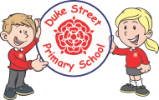
French Club

Miss Sharman will be starting a French Club for children in Years 3 and 4, in Spruce Class on Tuesdays from 3:15 to 4:15. The children will have the opportunity to practice their French skills whilst playing games, trying traditional French food and creating French inspired art work.
If you would like your child to attend please complete the slip and return to school by Friday 24th January. This will be on a first come first serve basis as numbers are limited.
__________________________________________________________
I would like my child ____________________ in _____________ class to attend the after school French club on Tuesdays from 3:15 to 4:15.
I will collect my child from the school office at 4:15.
Signed : _________________________

