Duke Street Primary School

Geography Policy
2021/22

Introduction

This policy outlines the teaching, organisation and management of Geography taught and learnt at Duke Street Primary School.

The policy has been drawn up as a result of staff discussion and has the agreement of the Governing Body. The implementation of this policy is the responsibility of all teaching staff. The responsibility for monitoring and reviewing the content within this subject area is to be reviewed by the Geography subject leader Sue Robinson.

Aims and objectives
The aim of Geography teaching at Duke Street Primary School is to stimulate the children’s interest and understanding of places and environments. Through their work in geography, children learn about their local area and compare their life in this area with that in other regions in the United Kingdom and in the rest of the world. They learn how to draw and interpret maps and they develop their skills of research, investigation, analysis and problem-solving. Through their growing knowledge and understanding of human geography, children gain an appreciation of life in other cultures. Geography teaching also motivates children to find out about the physical world and enables them to recognise the importance of sustainable development for the future of mankind.
The aims of geography are:
•to enable children to gain knowledge & understanding of places in the world and of how places can change;
•to increase children’s knowledge of other cultures and, in so doing, teach a respect and understanding of what it means to be a positive citizen in a multi-cultural country;
•to allow children to learn graphic skills, including how to use, draw and interpret maps;
•to enable children to know and understand environmental problems at a local, regional and global level;
•to encourage in children a commitment to sustainable development and an appreciation of what ‘global citizenship’ means;
•to develop a variety of other skills, including those of enquiry, problem solving, ICT, investigation and how to present their conclusions in the most appropriate way.
Duke Street Primary School aims to:
- Provide pupils with a secure, caring and stimulating learning environment –
- Promote self-discipline, moral values and self-esteem –
- Set challenging yet realistic goals in order to allow each child and member of staff to reach his or her full potential –
- Encourage an enthusiastic attitude to teaching and learning through a well-balanced and varied curriculum –
- Work in partnership with parents to provide the best for each child in order to get the best from each child –
- Learn from each other, learn with each other and learn on behalf of each other as part of a networked learning community –
- Offer colleagues an enjoyable, positive and welcoming environment in which to work, fostering both team commitment and the well-being of everyone within our school community –

National Curriculum (2014) aims and objectives:
Purpose of study

A high-quality geography education should inspire in pupils a curiosity and fascination about the world and its people that will remain with them for the rest of their lives. Teaching should equip pupils with knowledge about diverse places, people, resources and natural and human environments, together with a deep understanding of the Earth’s key physical and human processes. As pupils progress, their growing knowledge about the world should help them to deepen their understanding of the interaction between physical and human processes, and of the formation and use of landscapes and environments. Geographical knowledge, understanding and skills provide the frameworks and approaches that explain how the Earth’s features at different scales are shaped, interconnected and change over time.
National Curriculum 2014 Aims

The national curriculum for geography aims to ensure that all pupils:
▪ develop contextual knowledge of the location of globally significant places – both terrestrial and marine – including their defining physical and human characteristics and how these provide a geographical context for understanding the actions of processes
▪ understand the processes that give rise to key physical and human geographical features of the world, how these are interdependent and how they bring about spatial variation and change over time
▪ are competent in the geographical skills needed to:
▪ collect, analyse and communicate with a range of data gathered through experiences of fieldwork that deepen their understanding of geographical processes
▪ interpret a range of sources of geographical information, including maps, diagrams, globes, aerial photographs and Geographical Information Systems (GIS)
▪ communicate geographical information in a variety of ways, including through maps, numerical and quantitative skills and writing at length.
Teaching and Learning
Content:
Duke Street Primary School is developing a skills based curriculum taking support from the Lancashire KLIPs planning documents (Key Learning Indicators of Performance).
Classes follow a ‘Creative Hook’ to start the learning of a theme and plan for progression taking into account children’s individual learning styles. This approach enables children to take responsibility for their own learning by suggesting the path we, the teachers’, take when planning our topic based curriculum. Prior to a topic, teachers may ask children to complete some independent research (preview learning) to help to engage them and others in the topic. Children are also asked to think of questions that help to shape and personalise the planning of topics.

Underpinning all teaching and learning in Geography is capturing the children’s imagination and curiosity to learn. Many of our topics include access to visits or visitors to engage the children and give them a purpose for learning and an enthusiasm to find out more.

The children’s skills are revisited and embedded over time (sticky learning) to enable them to gain a deeper understanding of geography throughout each key stage. This is supported by the Lancashire KLIPS documents as mentioned above.

Geography topics are organised in a two-year cycle for each key stage and are personalised to the needs of children here at Duke Street. Each key stage teaches three topics per year for a half term each topic. Some of our topics are linked to history and science to provide further understanding and cohesion throughout the curriculum.

EYFS
The EYFS framework is structured very differently to the national curriculum as it is organised across seven areas of learning rather than subject areas. Our EYFS team develop a long term plan taking into account all the areas of learning. This is taught through themes that link to stories and texts that are read.
Below demonstrate which statements from the 2020 Development Matters are prerequisite skills for geography within the national curriculum. The table below outlines the most relevant statements taken from the Early Learning Goals in the EYFS statutory framework and the Development Matters age ranges for Three and
Four-Year-Olds and Reception to match the programme of study for geography.
The most relevant statements for geography are taken from the following areas of learning:
• Mathematics
• Understanding the World
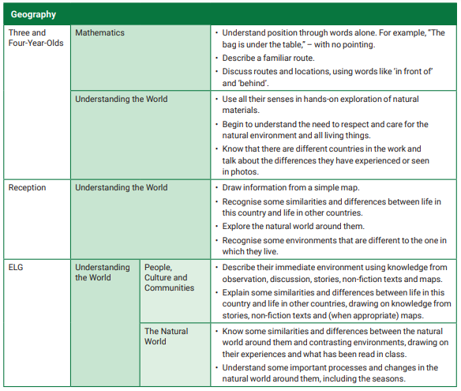
Key Stage 1 topics:
Cycle A
UK countries and capital cities
Small areas of a non-European country (North America)
Fieldwork and mapping of the school grounds
Cycle B
Small area in the UK, weather and fieldwork
Hot and cold places, continents and oceans
Fieldwork and mapping

Our Key Learning Indicators of performance for Geography in KS1 are:
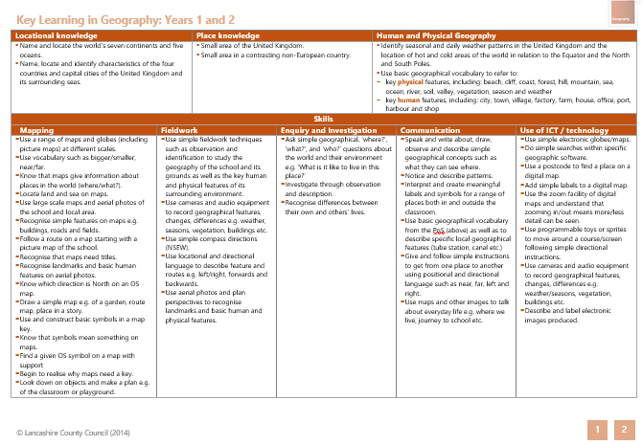

Lower Key Stage 2 topics:
Cycle A
Volcanoes and locational knowledge
Water cycles, rivers and fieldwork.
The Coast including physical and human aspects
Cycle B
Region in the UK, The Lake District
Europe, region in a European Country
Sustainability, local environment, fieldwork, recycling and energy

Our Key Learning Indicators of performance for Geography in LKS2 are:
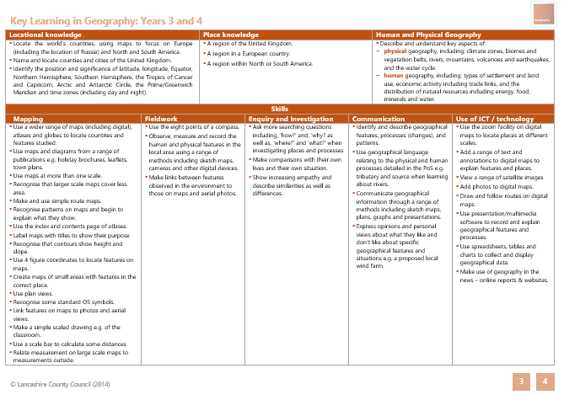

Upper Key Stage 2 topics:
Cycle A
Biomes and vegetation – where our food comes from
Geography of the UK and fieldwork
South America (region e.g. The Amazon Basin)
Cycle B
The worlds countries and key features, agriculture and trade
Global aspects of Human geography - economic. Antarctica and sustainability
North America

Our Key Learning Indicators of Performance for Geography in UKS2 are:
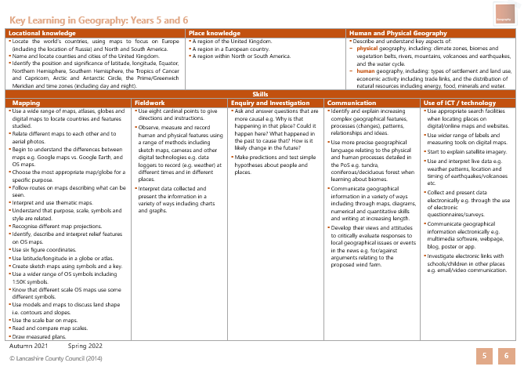
Planning, Assessing and Monitoring
Planning
We plan and teach Geography through a skills based approach using the Lancashire KLIPs documents as a basis, and ensure skills and objectives from the National Curriculum are also incorporated into our curriculum planning. Each topic is carefully chosen to engage our children and is personalised to Duke Street. We ensure that there are opportunities for children of all abilities to develop their skills and knowledge and we build progression into the schemes of work so that the children are increasingly challenged as they move up through the school, deepening their learning and understanding. Our medium-term plans give details of each unit of work for each term.
The subject leader provides teachers with the skills to be covered for each topic including suggested lessons, sticky learning opportunities, visits and visitors that may be used. Teachers plan using a medium term plan which incorporates these skills and a sequence of lessons for learning. The teacher writes an outline for each lesson (short-term plans). These list the specific learning objectives of each lesson. Plans are shared so that they can be monitored. Teachers feedback to the subject leader at the end of each topic which enables the subject leader to make any necessary amendments to future planning. Because we have some mixed-age classes, we carry out the medium-term planning on a two-year rotation cycle. By so doing, we ensure that children have complete coverage of the National Curriculum, but do not have to repeat topics.

Assessment
Children demonstrate their ability in geography in a variety of different ways. Younger children might, for example, dress up in costumes from different parts of the world, whilst older pupils might produce a PowerPoint presentation based on their investigations of different sources of energy. Teachers will assess children’s work by making informal judgements during lessons. On completion of a piece of work, the teacher assesses the work and uses this information to plan future learning. Written or verbal feedback in line with the school’s policy is given to the child to help guide his or her progress. Older children are encouraged to make their own judgements about how they can improve their work. Teachers weekly plans also include a deeper learning challenge to strengthen a child’s knowledge and understanding of the lesson.

At the end of each topic, teachers will reflect on the lessons that have been taught and complete an assessment form for the subject leader. Information on this form will include notes to inform future planning e.g. what worked well, what will need to be changed next time etc. It will also include an assessment for the children i.e. children below the expected level, at the expected level and exceeding the expected level. Children working below the expected level will be focus children for the following topic to ensure that every effort is made to help them to reach the expected level.

At the end of the year a summary judgement of the work of each pupil in relation to the National Curriculum levels of attainment is made. This information is then passed on to the child’s new teacher to inform future planning.
During the year, the subject leader will perform subject monitoring. This will consist of a book scrutiny and viewing of digital evidence in all year groups. The subject leader will look for coverage against the KLIPs and National Curriculum skills and ensure that there is consistency throughout a key stage. They will also look to see that the work produced by the children is of a standard expected for that age of child and that skills that cross key stages are built upon each time they are covered and are appropriately challenging. Work should also reflect the ability of individual children and should include appropriately scaffolded and differentiated work for those children that require additional support.
Other forms of assessment will include pupil conferencing to discuss what the children have learnt during their lessons.
Children with special educational needs
For children with special educational needs, provision will be made by teachers, through the planning process, to accommodate for specific needs so that all children can access and develop the skills necessary to progress through the curriculum. This may mean that teachers look to previous key stage skills, adapt teaching materials, add in additional steps to aid progression or provide adapted learning and recording material such as word mats and worksheets. Some children may benefit from pre-learning sessions. For children who are exceeding their expectations, additional challenges will be set through the planning process to ensure that these children broaden and deepen their knowledge and understanding of Geography.

Monitoring and review

The coordination and planning of the geography curriculum are the responsibility of the subject leader, who also:
- supports colleagues in their teaching, by keeping informed about current developments in geography and by providing a strategic lead and direction for this subject
- conducts yearly audits with staff to assess any training needs and support needed.
- provides the head teacher with an annual summary report for the strengths and weaknesses in geography which is evaluated and areas for further improvement indicated.
- uses specially allocated time to review evidence of the children’s work and to monitor and evaluate the progress made by children in geography across the school.

Resources

The resources for geography are kept in a central location. These will be maintained and updated and will be appropriate for the topics that are taught in geography. Library books will also be used as part of geography topic resources.

Fieldwork
Fieldwork is integral to good geography teaching, and we include as many opportunities as we can to involve children in practical geographical research and enquiry. This includes studies of the school grounds, the local environment and places further away from Chorley.

For health and safety issues regarding fieldwork, our school follows the guidance contained in its policies on Off-Site Visits and Health and Safety.
This policy will be reviewed at least every three years or sooner if necessary.
Policy updated 7.6.22
Mrs S Robinson ___________________________

