Duke Street Primary School
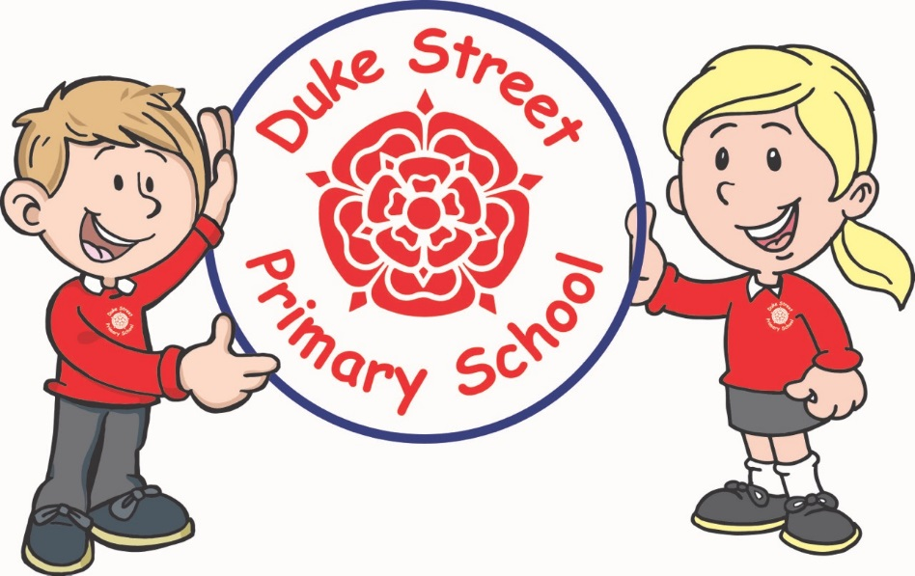

History Progression
 | EYFS | KS1  Year 2 |  | Lower KS2  Year 4 |  | Upper KS2  Year 6
Key area

Events, people and change | Shows interest in the lives of people who are familiar to them.  Recognises and describes special times or events for family or friends.  Shows interest in different occupations and ways of life.  Knows some of the things that make them unique, and can talk about some of the similarities and differences in relation to friends or family. | - To tell the difference between past and present in their own and other people’s lives by using and making simple comparisons to parts of stories, and features of events.  - Recognise that their own lives are different from the lives of people in the past by describing some of the topics, events and people that they have studied.  - Use simple stories and other sources to show that they know and understand key features of events. |  | Be able to describe some of the main events, people and periods they have studied by:  - Understanding some of the ways in which people's lives have shaped this nation.  - Describing how Britain has influenced and been influenced by the wider world.  - Understanding some significant aspects of history – nature of ancient civilisations; expansion of empires; characteristic features of non-European societies; achievements and follies of mankind. |  | Show their knowledge and understanding of local, national and international history by:  - Understanding significant aspects of history – nature of ancient civilisations; expansion and dissolution of empires; characteristic features of non-European societies; achievements and follies of mankind.  - Gaining historical perspective by placing their growing knowledge into different contexts...between cultural, economic,, military, political (CRIME) religious and social history.  - Establishing a narrative showing connections and trends within and across periods of study.  - Begin to recognise and describe the nature and extent of diversity, change and continuity and suggest relationships between causes.  - Presenting a clear narrative within and across periods that notes connections, contrasts and trends over time.
Enquiry, interpretation and using sources | They know about similarities and differences between themselves and others, and among families, communities and traditions. | - Use sources to answer simple questions about the past.  - Ask and answer questions about the past through observing and handling a range of sources, such as objects, pictures, people talking about their past, buildings, written sources.  - Identify some of the basic ways the past can be represented.  - To begin to understand the reasons why people in the past acted as they did from a range of sources (pictures, plays, films, written accounts, songs, museum displays, stories). |  | - Understand some of the methods of historical enquiry, and how evidence is used to make detailed observations, finding answers to questions about the past.  - Use some sources to start devising historically valid questions about change, cause, similarity and difference, and significance.  - Understand some of the methods of historical enquiry, how evidence is used to make historical claims.  - Use sources as a basis for research from which they will begin to use information as evidence to test hypotheses.  - Identify some of the different ways in which the past can be represented, and that different versions of the past such as an event may exist (artist’s pictures, museum displays, written sources).  - Understand how our knowledge of the past is constructed from a range of different sources and that different versions of past events may exist, giving some possible reasons for this. |  | - Understand the methods of historical enquiry, how evidence is used to make historical claims, and begin to discern how and why contrasting arguments and interpretations of the past have been constructed.  - Use sources as a basis for research from which they will begin to use information as evidence to test hypotheses.  - Begin to evaluate sources to make historical claims, and discern how and why contrasting arguments and interpretations of the past have been constructed, and establish evidence for particular enquiries.
Chronology | Remembers and talks about significant events in their own experience | Show their emerging knowledge and understanding of the past by:  - Recognising the distinction between past and present.  - Identifying some similarities and differences between their own present and aspects of the past.  - Place a few events and objects in order by using common phrases to show the passing of time (old, new/young, days and months).  Show their developing knowledge and understanding of the past by:  - Recognising the distinction between present and past in their own and other people's lives. PEOPLE – significant individuals  - Identifying some similarities and differences between ways of life in different periods.  - Know where some people and events fit into a chronological framework by using common words and phrases about the passing of time (before, after, a long time ago, past…). |  | Show their increasing knowledge and understanding of the past by:  - Using specialist dates and terms, and by placing topics studied into different periods (century, decade, Roman, Egyptian, BC, AD…).  - Making some links between and across periods, such as the differences between clothes, food, buildings or transport.  - Identifying where some periods studied fit into a chronological framework by noting connections, trends and contrasts over time. |  | Show their chronologically secure knowledge by:  - Sequencing events and periods through the use of appropriate terms relating to the passing of time (empire, civilisation, parliament, peasantry...).  - Identifying where periods studied fit into a chronological framework by noting connections, trends and contrasts over time.  - Know and understand the history of these islands as a coherent, chronological narrative, from the earliest times to the present day.  - In depth study of different periods, using appropriate vocabulary when describing the passing of time and historical concepts (propaganda, bias, primary source, secondary source, reliability...).  - Analyse connections, trends and contrasts over time.
Communication | Children talk about past and present events in their own lives and in the lives of family members. | - Understand and use simple historical concepts such as now/then and same/different.  - To show what they know and understand about the past in different ways (speaking, role-play, drawing and writing).  - Understand historical concepts and use them to make simple connections and draw contrasts. |  | - Construct informed responses that involve thoughtful selection and organisation of relevant historical information.  - When doing this they should use specialist terms like settlement, invasion and vocabulary linked to chronology.  - Produce structured work that makes some connections, draws some contrasts, frame historically-valid questions involving thoughtful selection and organisation of relevant historical information using appropriate dates and terms. |  | - Produce structured work that makes connections, draws contrasts, analyses trends, frames historically-valid questions involving thoughtful selection and organisation of relevant historical information using appropriate dates and terms.  - Produce detailed structured work to select and deploy information and make appropriate use of historical terminology and contrasting evidence.
Topics over a 2 year cycle |  | Cycle A  Fire of London  Events beyond living memory that are significant nationally or globally  Significant individual – Samuel Pepys  Explorers  The lives of significant individuals in the past who have contributed to inter/national achievements and used to compare aspects of life in different periods.  Seaside  Changes within living memory – to reveal changes to National Life  Robert Falcon Scott – (A significant individual to be researched during Geography Antarctica topic) | Cycle B  Castles  Events beyond living memory that are significant nationally or globally  Significant individual – Royal Family  My Place (Chorley)  Significant historical events, people and places in their own locality.  Changes within living memory – to reveal changes in national life.  Ancient China  Events beyond living memory that are significant nationally or globally. | Cycle A  Tomb Raiders – Egypt  The achievements of the earliest civilisations – an overview of where and when the earliest civilisations appeared and a depth study.  Rotten Romans  The Roman empire and its impact on Britain | Cycle B  Rock and Roll - Stone Age  Changes in Britain from the Stone Age to the Iron Age  Mexico – Mayan Civilisation  A non-European society that provides contrast with British history  No place like home (Local industry – canals, cotton and coal)  A study of an aspect of history since 1066 that is significant in the locality | Cycle A  Crime and Punishment  A study of an aspect or theme in British history that extends pupil’s chronological knowledge beyond 1066 – Crime and Punishment from Anglo Saxons to now.  Raids and Invasion – Vikings  The Viking and Anglo Saxon struggle for the Kingdom of England to the time of Edward the Confessor  (links with Rivington Pike and the Spanish Armada) | Cycle B  Inventors and Inventions – Ancient Greece  Ancient Greece 0 a study of Greek life and achievements and their influence on the Western World.)  A Kingdom United -Anglo Saxons  Britain’s settlement by Anglo Saxons and Scots
Remembrance Day will be celebrated each year
Visits take place
Workshops visit school for relevant topics

