icare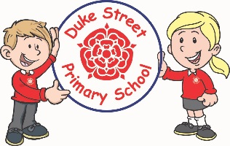

**Geography:**

Linking to the history topic of castles, the children will be looking locating castles on maps, they will use digital maps and atlases, to discuss the location of the castles, the human and physical features of the surroundings. We will also look at the United Kingdom locating the 4 countries.

**History:**

The children will be learning all about castles. We will explore why castles were built in the past, investigate different rooms in a castle and what they were used for and we will also learn what different jobs people had in the castles. We will also be exploring castles still standing in the UK.

**Computing:**

**Programming and algorithms:**

The children will be thinking about a set of clear instructions, and using the beebots to carry out some programming and algorithm tasks. They will be working on problem solving skills.

**Online safety:**

The children will also be learning about how they can keep safe online.

**Mathematics:** Daily mathematics lesson

(Y1 & Y2 National Curriculum Objectives)

This term we will focus heavily of place value, number, addition and subtraction. The children will continue to use our new maths characters to further develop their reasoning skills. Children will explore work with shape, space and measure also.

**Year 1 and 2 Curriculum Plans**

Autumn 2020 and 2022

**Topic:** Castles

Our Core Values

**English:** Daily English and phonics lesson

(Y1 & Y2 National Curriculum Objectives)

**Focused Text:** The way home for wolf, by Rachel Bright and Jim Field

**Fiction:** We will be exploring the text and building up to retelling and adapting the stories, using our own experiences.

**Non- Fiction:** We will be doing lots of research about wolves and creating facts files.

**Science:**

**Animals:** The children will be looking at common animals in the United Kingdom and they discuss the different structures of the animals. They will learn if these animals are carnivores, herbivores, omnivores and what this means.

**Habitats:** The children will explore the habitats of different mini-beasts. They will learn about the animals that live there and what they eat.

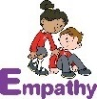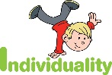 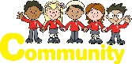 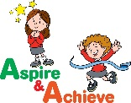 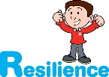

**Art:**

F**ocus**: Painting – The children will be looking at famous artist Claude Monet, and trying to emulate some of his water colour pictures.

**Artist:** Claude Monet

**Focus:** Printing – The children will explore printing with different materials and will create their own Christmas Wrapping paper using printing skills.

**Curriculum Drivers:**

* **Enterprise** – Develop collaborative learning within a group, class and whole school context.
* **Resilience** – Develop resilience when tackling challenging tasks.
* **Aspiration** – Complete your best work at all time.
* **Real Experiences** – Develop opportunities for outdoor learning.

**Music:**

We will be using Charanga programme to learn different songs and also explore the pulse of music and also look at the rhythm within different genres of songs. We will be singing the songs and we will learn to play some instruments along to songs.

**PE:**

**Athletics, FMS and dance:**

The children will develop skills in running, hopping, skipping, jumping, rolling a ball, throwing underarm, catching, throwing over arm, bouncing a ball and kicking a ball.

**RE:**

During R.E sessions we will explore and discuss beliefs and values of Christianity this term. There will be a key question for each unit.

**Christianity:** God – Why do Christians say that God is a father?

**Christianity:** Jesus– Why is Jesus special to Christians?

**DT:**

**Stew:** The children will use cutting, peeling and cooking skills to prepare a range of foods for a stew. The children will design and make a Pirate Stew.

**Skills:** Food

**Finished Product:** Design, make and evaluate a Stew

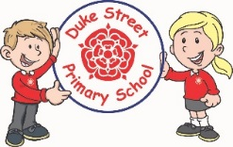

**Enrichment:**

**To be confirmed.**

**School Expectations**

* We are kind and helpful
* We listen
* We are honest
* We work hard and take pride in our work
* We look after property

**British Values:**

Our work throughout the curriculum will promote the British Values of:

* Democracy
* Rule of Law
* Mutual Respect
* Individual Liberty
* Tolerance & harmony
* Responsibility/positive contribution
* Public Institution

**PSHE:**

**Core Values:** Empathy

**Core Themes:** Me and my relationships

**Focus:**

* Conflict
* Feelings & Emotions
* Friendships
* Valuing difference
* Positive Mental Health

**School Aims:**

Duke Street Primary School aims to:

* provide a secure, caring and stimulating learning environment,
* promote self-discipline, moral values and self-esteem,
* set challenging yet realistic goals in order to allow each child and member of staff to reach his or her potential
* encourage an enthusiastic attitude to learning through a well-balanced and varied curriculum.
* work in partnership with parents to provide the best for each child in order to get the best from each child
* offer colleagues an enjoyable, positive environment in which to work, fostering both team commitment and the well-being of everyone within our school.