icare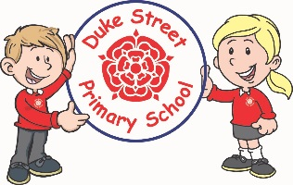

**Science:**

**Materials:** The children will explore different materials including hessian, felt, paper, plastic, carpet, wood, metal, plastic, glass, brick, rock, paper and cardboard

and their properties.

We will discuss these materials in relation to whether they are natural or man made.

**Geography:**

**Skills & Fieldwork:** The children will further develop their understanding of basic maps and atlases. They will learn about the locality of Chorley and where it is in the UK and the wider world. The children will look local landmarks and compare the physical and human features they spot.

**Computing:**

**Focus: Digital Painting**

The children will develop their understanding of a range of tools used for digital painting. They will create their own digital paintings from inspiration of other artist’s work.

**Focus: Technology around us**

Children will develop their understanding of technology and how it can help us. They will start to become familiar with the different components of a computer by developing their keyboard and mouse skills.

**Mathematics:** Daily mathematics lesson

(Y1 & Y2 National Curriculum Objectives)

This term we will be developing our abilities to reason in maths and strengthen our understanding of Maths through discussion and answering questions. We will be developing our mathematical thinking skills throughout all lessons. We will be covering aspects such as shape, time, measurement, place value, addition, subtraction and data handling.

**Year 1 and 2 Curriculum Plans**

Spring 2021

**Topic:** My Place - Chorley

Our Core Values

**English:** Daily English and phonics lesson

(Y1 & Y2 National Curriculum Objectives)

**Focused Texts:** Bob, The Man on the Moon.

**Fiction:** We will be exploring the texts and building up to retelling and adapting the stories, using our own experiences.

**Non- Fiction:** The children will be working on recounts and instruction writing.

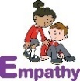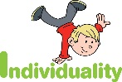  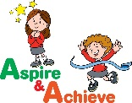 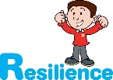

**History:**

The children will learn about the changes within Chorley and the history of local landmarks.

**Art:**

F**ocus**: Textiles and collage

The children will learn to identify different forms of textiles and have experience in colouring onto fabric. They will practice threading a needle, and learn a running stitch and cross stitch. The children will gain some experience in weaving. They will then use all of these new skills to create a fabric collage of a local landmark.

**Curriculum Drivers:**

* **Enterprise** – Develop collaborative learning within a group, class and whole school context.
* **Resilience** – Develop resilience when tackling challenging tasks.
* **Aspiration** – Complete your best work at all time.
* **Real Experiences** – Develop opportunities for outdoor learning.

**Music:**

This term we will be continuing to explore and experiment with pitch, pulse and rhythm. We will also look at keeping in time to music by playing a glockenspiel. We will respond appropriately to music and further develop our ability to discuss different genres of music. We will cover two units named; ‘I want to play in a band’ and ‘Round and Round.’

**DT:**

**Templates and Joining:** We will be exploring different joining techniques for fabric such as stapling, gluing, pinning and sewing. The children will explore puppets which have been made already and they will design and make their own which involves joining fabrics.

**Skills:** Sewing, gluing, joining fabrics and adding embellishments.

**Finished Product:** Design, make and a glove puppet for a Fairytale Puppet show which joins fabrics together.

**RE:**

**Islam:** Examine the Muslim belief in Allah as a creator. The focus is to encourage pupils to consider Allah’s role in creating and sustaining the world.

**Judaism:** Children will have the opportunity to explore the Jewish beliefs about God and on why people put their trust in God and how it is expressed.

**PE:**

**Dance**

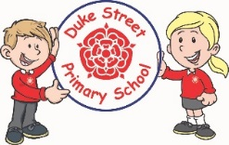

**Enrichment:**

* Outdoor Learning Day and further outdoor learning opportunities.

**School Expectations**

* We are kind and helpful
* We listen
* We are honest
* We work hard and take pride in our work
* We look after property

**British Values:**

Our work throughout the curriculum will promote the British Values of:

* Democracy
* Rule of Law
* Mutual Respect
* Individual Liberty
* Tolerance & harmony
* Responsibility/positive contribution
* Public Institution

**PSHE:**

**Core Values:** Resilience

Core Themes: Keeping myself safe

**Focus:**

Pupils will explore ways of being resilient in the face of difficulty or adversity in the wider world. They will consider how to keep themselves safe and have the inner strength to make positive choices.

**School Aims:**

Duke Street Primary School aims to:

* provide a secure, caring and stimulating learning environment,
* promote self-discipline, moral values and self-esteem,
* set challenging yet realistic goals in order to allow each child and member of staff to reach his or her potential
* encourage an enthusiastic attitude to learning through a well-balanced and varied curriculum.
* work in partnership with parents to provide the best for each child in order to get the best from each child
* offer colleagues an enjoyable, positive environment in which to work, fostering both team commitment and the well-being of everyone within our school.