icare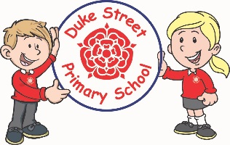

**Science:**

**Focused Investigation:**

Observing closely using simple equipment – What can I see in a microhabitat?

**Habitats:** The children will explore different habitats. They will learn about the plants and animals that live there and what they eat, including how a food chain works.

**Focused Investigation:**

Performing simple tests – Which material would make the best beach umbrella?

**Materials:** The children will be able to identify and describe a variety of materials including how the shape of some solid materials can be changed. They will examine materials of objects that can be taken to the beach.

**Geography:**

**Locational Knowledge:** The children will use maps of the UK to locate Chorley, Blackpool and the surrounding seas.

**Human and Physical Geography:** The children will look at the physical and human features of a coastal environment. They will use relevant geographical vocabulary to describe the features.

S**kills & Fieldwork:** The children will use compass directions and simple keys to create maps using basic symbols. They will examine aerial photographs and plan perspectives to identify landmarks.

**Computing:**

**Focus: Coding**

The children will be introduced to 2code.

The children will need to be able to drag and drop in order to move code blocks around.

They will learn how to write an algorithm and how to debug.

They will explain how to use the following terms in a computer program: Command, Repeat, Input, Output, Event, Collision Detection and Timer.

Children will be able to plan and use algorithms in programs successfully to achieve an end result.

Children will code a program using a variety of objects, actions, events, and outputs successfully.

**Mathematics:** Daily mathematics lesson

(Y1 & Y2 National Curriculum Objectives)

This term we will continue to follow the Lancashire Red Rose Scheme and cover: place value, data handling, multiplication and division, time, money and addition and subtraction. Year 2 children will also be preparing for SAT’s tests in May.

**Year 1 and 2 Curriculum Plans**

Summer 2022

Our Core Values

**English:** Daily English and phonics lesson

(Y1 & Y2 National Curriculum Objectives)

**Focused Text:** The Great Paper Caper

**Fiction:** We will be exploring the text and building up to writing a recount of the story using the story features we have learnt.

**Non- Fiction:** We will be looking at The Great Outdoors. We will be writing an information booklet all about outdoor activities, using verbs and adverbs.

**Poetry:** We shall be exploring nursery rhymes and creating our own

**Topic:** Seaside

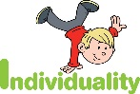  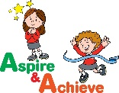 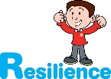

**Curriculum Drivers:**

* **Enterprise** – Develop collaborative learning within a group, class and whole school context.
* **Community** – Chorley Book Bench Project
* **Real Experiences** – Develop opportunities for outdoor learning.

**History: The Seaside**

The children will be learning about seaside holidays from the past. We will be looking at changes beyond living memory, as well as changes within living memory and making comparisons. We will focus on some seaside resorts that the children are familiar with, and see how they have changed since the Victorian era.

**Art:**

F**ocus**: Printing - The children will create their own prints based on the work of William Morris

**Artist:** William Morris

**DT: Freestanding Structures**

**Skills:** materials

**Finished Product:** Design, make and evaluate a model playground.

**PE:**

**Athletics:** During the term, PE lessons will focus on developing the children’s athletic skills.

**Net/Wall Games:** The children will learn to develop their catching, bouncing and kicking skills.

**Enrichment:**

* Trip to a beach
* Duke Street’s Got Talent
* Sports Day
* Outdoor Learning Opportunities
* Visit from Paul Cookson (Poet)
* Yoga Day

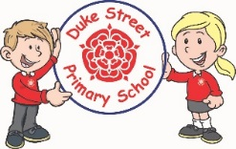

**Music:**

Redwood class will be learning how to play a recorder.

Spruce and Acer Class will be completing “Your Imagination” which focuses on learning and performing a song, understanding pitch and tempo.

**School Aims:**

Duke Street Primary School aims to:

* provide a secure, caring and stimulating learning environment,
* promote self-discipline, moral values and self-esteem,
* set challenging yet realistic goals in order to allow each child and member of staff to reach his or her potential
* encourage an enthusiastic attitude to learning through a well-balanced and varied curriculum.
* work in partnership with parents to provide the best for each child in order to get the best from each child
* offer colleagues an enjoyable, positive environment in which to work, fostering both team commitment and the well-being of everyone within our school.

**PSHE: Being my best and Growing and changing**

**Core Values:** Resilience and Aspire & Achieve

**Core Themes:** Relationship & Health and Wellbeing

**Focus:**

* Keeping healthy
* Growth mind-set
* Goal setting
* Achievement

**School Expectations**

* We are kind and helpful
* We listen
* We are honest
* We work hard and take pride in our work
* We look after property

**British Values:**

Our work throughout the curriculum will promote the British Values of:

* Democracy
* Rule of Law
* Mutual Respect
* Individual Liberty
* Tolerance & harmony
* Responsibility/positive contribution
* Public Institution

**RE:**

**Judaism:** What do people say about God?

**Christianity:** The Church – What do some people do because they believe in God?