icare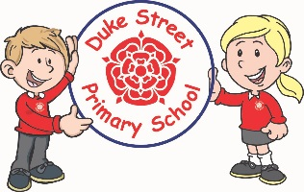

**Geography - Region in a European country – Paris (France)**

Focus: The children will look at human and physical features. They will make comparisons and explore maps and scales.

**History – Anglo Saxons**

Focus: the children will look at who the Anglo Saxons were and why they invaded Britain. We will also look at what Britain was like during that time.

**Science:**

**Focused Investigation:** Measuring plants

**Topic:** Animals including humans (health and Nutrition), and Forces and Magnets.

The children will look at a healthy diet and how to read food labels.

In forces and magnets, the children will explore and learn magnetism and how it affects some materials and not others.

**DT: 2D and 3D products**

**Skills**: Strengthen, stiffening and joining fabrics. The children will learn and practice these skills.

**Making: a shoulder bag.**

**Computing:**

**Focus**: Sequencing sounds

This unit explores the concept of sequencing in programming through Scratch. It begins with an introduction to the programming environment, which will be new to most learners. They will be introduced to a selection of motion, sound, and event blocks which they will use to create their own programs, featuring sequences. The final project is to make a representation of a piano. The unit is paced to focus on all aspects of sequences, and make sure that knowledge is built in a structured manner. Learners also apply stages of program design through this unit.

**Mathematics:** Daily mathematics lesson will cover:

All year 3 and year 4 children will follow the Lancashire Red Rose scheme looking at the 4 operations in number, place value, shape, space, time and measures.

**Cross-curricular mathematics:** Geography looking at maps and scales.

**English:** Daily English lesson (Y3 & Y4 National Curriculum Objectives)

**Focused Text:**

Greek Myths (Theseus and the Minotaur) The children will be writing a new myth based on Beowulf.

The children will be writing a setting description.

**Non- Fiction**: The children will create a travel brochure for Ancient Greece as a persuasive text.

**Year 3 and 4 Curriculum Plans**

Spring Term 2023

**Topic:** France and Anglo Saxons

Our Core Values

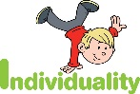  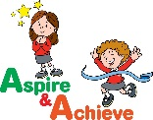 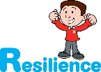 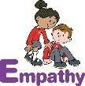

**PSHE: Appreciate (Happy Minds)**

**Core Value:** Appreciate

**Core Theme:** Being grateful

The Children will continue their journey looking at the brain through the lens of appreciating the world around them.

**Curriculum Drivers:**

* RE visit linked to Islam – Mosque.
* Rock Kids
* Runshaw College performance
* Half termly enrichment days

**Art: Textiles.**

**African inspired art.**

**Skills:** sewing, fabric dying and weaving. The children will create an African inspired piece of fabric artwork.

We will look at the artist - Esther Mahlangu.

**Music:** Enjoying and improvising and Composing using our imagination

The children will be looking at how music can make the world a better place. They will create their own music.

Children from Elder will be learning the ukulele.

**RE:** Christianity – Jesus

**Focus:**

Spring 1 **–** Following the example of Jesus. Discipleship. Helping others.

Spring 2 – Church – The Holy Spirit. Gifts of the spirit. Pentecost.



**Enrichment:**

* RE visit linked to Islam – Mosque.
* Rock Kids
* Runshaw College performance
* Enrichment day linked to Appreciate

**British Values:**

Our work throughout the curriculum will promote the British Values of:

* Democracy
* Rule of Law
* Mutual Respect
* Individual Liberty
* Tolerance & harmony
* Responsibility/positive contribution
* Public Institution

**School Aims:**

Duke Street Primary School aims to:

* provide a secure, caring and stimulating learning environment,
* promote self-discipline, moral values and self-esteem,
* set challenging yet realistic goals in order to allow each child and member of staff to reach his or her potential
* encourage an enthusiastic attitude to learning through a well-balanced and varied curriculum.
* work in partnership with parents to provide the best for each child in order to get the best from each child
* offer colleagues an enjoyable, positive environment in which to work, fostering both team commitment and the well-being of everyone within our school.

**School Expectations**

* We are kind and helpful
* We listen
* We are honest
* We work hard and take pride in our work
* We look after property

**PE: Gymnastics**

**Focus:**

The children will be looking at using symmetry and asymmetry with partners. They will also be looking at pushing and pulling.

