icare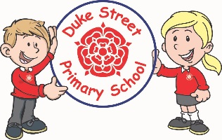

**Geography – Sustainability**

**Focus: The children will look at recycling and how we can create a more sustainable world.**

**History – Black History Unit**

Focus: A theme in British History beyond 1066 In this theme children learn about significant events in British History that will extend their chronological knowledge. beyond 1066 e.g. The Lancashire Cotton Industry and its links to the

Transatlantic Slave Trade. Alternatively children could study a theme such as medicine, homes, transport or

technology through time to develop their chronological understanding.

**DT: Simple Circuits and Switches**

**Skills**: Children will understand and use electrical systems in their products, such as series circuits incorporating switches, bulbs and buzzers.

**Making: A reading light or toy**

**Computing:**

**Focus: Data Logging**

Pupils will use technology to collect and store data. They will then turn this data into digital graphs and charts.

**Focus**: Stop Frame Animation

Pupils will use computers to create animation films using stop frame technology.

**Science:**

**Focused Investigation:** investigating plants

**Topic:** Plants and growth & Animals including humans

**The children will look at how plants grow and what a plant needs to survive.**

**The children will look at the skeletons of different animals and how this changes their movement.**

**Mathematics:** Daily mathematics lesson will cover:

All year 3 and year 4 children will follow the Lancashire Red Rose scheme looking at the 4 operations in number, place value, shape, space, time and measures.

**Cross-curricular mathematics:** Geography looking at maps and scales. Science looking at measuring.

**English:** Daily English lesson (Y3 & Y4 National Curriculum Objectives)

**Focused Text: Escape from Pompeii**

The children will create their own version of a story, escaping a disaster.

**Non- Fiction**: The children will create a travel brochure for Pompeii as a persuasive text.

**Year 3 and 4 Curriculum Plans**

Summer Term 2023

**Topic:** Sustainability and

Our Core Values

  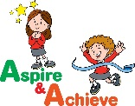 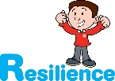 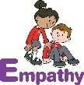

**PSHE: Appreciate (Happy Minds)**

**Core Value:** Relate

**Core Theme:** How we engage with the world around us

The Children will continue their journey looking at the brain through the lens of relating to the world around them.

**Curriculum Drivers:**

* Enrichment day linked to Relate

**Art: Creating art in the style of an artist.**

**Kandinsky**

**Skills:** Sketching, Painting, colouring blocking, use of textiles in art.

**Music:** Enjoying and improvising and Composing using our imagination

The children will be looking at how music can make the world a better place. They will create their own music.

**Children from Maple will be learning the Ukulele.**

**RE:**– Sikism & Hindu Dharma

Spring 1 **The 10 Gurus and how they guide a Sikh**

Spring 2 – Religious duty, Hindu scriptures (the Ramayana) and the festival of Raksha Bandhan.



**Enrichment:**

* Enrichment day linked to Relate

**British Values:**

Our work throughout the curriculum will promote the British Values of:

* Democracy
* Rule of Law
* Mutual Respect
* Individual Liberty
* Tolerance & harmony
* Responsibility/positive contribution
* Public Institution

**School Aims:**

Duke Street Primary School aims to:

* provide a secure, caring and stimulating learning environment,
* promote self-discipline, moral values and self-esteem,
* set challenging yet realistic goals in order to allow each child and member of staff to reach his or her potential
* encourage an enthusiastic attitude to learning through a well-balanced and varied curriculum.
* work in partnership with parents to provide the best for each child in order to get the best from each child
* offer colleagues an enjoyable, positive environment in which to work, fostering both team commitment and the well-being of everyone within our school.

**School Expectations**

* We are kind and helpful
* We listen
* We are honest
* We work hard and take pride in our work
* We look after property

**PE: Athletics**

**Focus:**

The children will be looking at running, jumping and hurdling and the skills required to take off successfully

