icare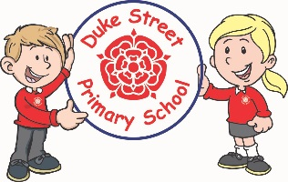

**Topic: History and Geography**

Focus: Romans for first part of the term – how did the Romans change Britain and the Roman invasion. The children will also look at Digimaps.

**The 2nd part of the term will focus on c**hanges in Britain from the Stone Age to the Iron Age including human geography and types of settlement and land use. The children will learn to ask questions including how, why as well as where and what.

**Science:**

Autumn 1 – Electricity – looking at appliances that use electricity and how to make a circuit.

**Autumn 2 - Rocks, Soils and Fossils**

* Compare and group together different kinds of rocks on the basis of their appearance and simple physical properties.
* Describe in simple terms how fossils are formed when things that have lived are trapped within rock.
* Recognise that soils are made from rocks and organic matter.

**Visit:** Walk to Astley Park investigating rocks in use in the buildings of Chorley.

**Computing:**

**Focus**: **Connecting computers**

Understand computer networks including the internet; how they can provide multiple services, such as the World Wide Web; and the opportunities they offer for communication and collaboration

**Desktop publishing** Select, use, and combine a variety of software (including internet services) on a range of digital devices to design and create a range of programs, systems, and content that accomplish given goals, including collecting, analysing, evaluating, and presenting data and information.

**Internet safety runs throughout all topics.**

**English:** Daily English lesson (Y3 & Y4 National Curriculum Objectives)

**Focused Text: The Loch Ness Monster (non-fiction newspaper report)**

**Stone Age Boy (Fiction)**

**Poetry: Remembrance**

**Mathematics:** Daily mathematics lesson

(Y3 & Y4 National Curriculum Objectives)

A1: Place Value including decimals. Written addition and subtraction including; inverse and problem solving,

A2: Mental multiplication, mental division, written multiplication and fractions.

**Topic:** Rock and Roll

**Year 3 and 4 Curriculum Plans**

Autumn Term 2020

Our Core Values

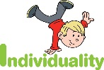  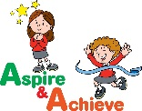 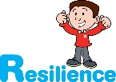 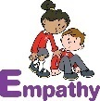

**DT:** The children will look at designing and creating a cold savoury meal in the first part of the term.

**PSHE:**

We will be following the SCARF programme. The children will look at relationships. Separate lessons will also look at worries, empathy and wellbeing.

**Art: Painting**

The children will be looking at texture and tone within painting, and mixing colours. They will try out a range of brushes to learn how to choose the best brush for a particular purpose.

The children will also look at printing and build up to making a Christmas product.

**Curriculum Drivers:**

**Trips relating to our topics.**

**Relationships with family and friends.**

**Christmas themed gift in Art.**



French: The children will be looking at French greetings and classroom commands through interactive games, singalongs, stories, and activities. They will practice speaking, listening, reading, and writing some basic vocabulary and phrases in French.

PE:

Year 3/4 Athletics

Years 3/4- Invasion Games

**Music:**

We shall be following the Charanga music programme. The unit for the Autumn term will be ‘Stop’ and will look at Grime, Classical, Bhangra, Tango, Latin Fusion. The children will explore composition with cross curricular links to bullying.

**RE:**

Autumn 1- Christianity (God) Prophet, service to God and inspirational people.

Autumn2 – Islam – Prophet Mohammad (PBUH).

We shall look for link between Christianity, Islam and Judaism (Abrahamic faiths)



**British Values:**

Our work throughout the curriculum will promote the British Values of:

* Democracy
* Rule of Law
* Mutual Respect
* Individual Liberty
* Tolerance & harmony
* Responsibility/positive contribution
* Public Institution

**School Expectations**

* We are kind and helpful
* We listen
* We are honest
* We work hard and take pride in our work
* We look after property

**School Aims:**

Duke Street Primary School aims to:

* provide a secure, caring and stimulating learning environment,
* promote self-discipline, moral values and self-esteem,
* set challenging yet realistic goals in order to allow each child and member of staff to reach his or her potential
* encourage an enthusiastic attitude to learning through a well-balanced and varied curriculum.
* work in partnership with parents to provide the best for each child in order to get the best from each child
* offer colleagues an enjoyable, positive environment in which to work, fostering both team commitment and the well-being of everyone within our school.

**Enrichment:**

* **Trips / Visitors**

Bring your wellies trip

RE: Stone Age (depending on restrictions)

Remembrance walk to Astley Park linked with science to investigate the use of different types of stone in Chorley.