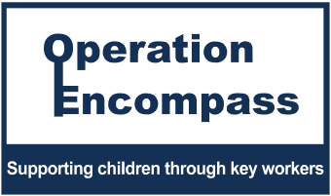

Operation Encompass Parents Awareness Letter

Dear Parent/Carer,
This letter is to remind you that our school is participating in Operation Encompass.
Operation Encompass is a unique Police and Education early intervention safeguarding partnership which ensures that a child's school is informed, prior to the start of the next school day, that there has been a domestic abuse, vulnerable child or missing incident to which the child or young person has been exposed, and which might then have an impact on them in school the following day.
Each school is informed of all such incidents, not just those where an offence can be identified or those which are graded as high risk. The partnership recognises that all domestic abuse, vulnerable child and missing incidents can be harmful to children and young people.
This information will be shared throughout the year, including holidays and weekends. Information will only be shared with the school/ college by the police where it is identified that a young person was present, witnessed or was involved.
A nominated member of staff, known as a Key Adult, has been trained to liaise with the police. At Duke Street Primary our Key Adults are Rachel Von-kaenel and Emma Robinson.
They will be able to use information that has been shared with them, in confidence, to ensure that the school makes provision for possible difficulties experienced by children or their families. The Key Adults will keep this information confidential and will only share it on a need-to-know basis, for instance, to teaching staff for the child or young person. It will not be shared with other school students.
This national initiative has been implemented across the whole of the Lancashire Police area. If you would like some more information about it, you can view it online at www.operationencompass.org.
We are keen to offer the best support possible for our pupils and a recent review of Operation Encompass showed that it is beneficial and supportive for all those involved.

Duke Street Safeguarding and Senior Leadership Team

