icare

**Computing:** The children will begin to understand what the term data means and how data can be collected in the form of a tally chart. They will learn the term ‘attribute’ and use this to help them organise data. They will then progress onto presenting data in the form of pictograms and finally block diagrams. Learners will use the data presented to answer questions.

**Mathematics:** Daily mathematics lesson

(Y1 & Y2 National Curriculum Objectives)

Red Rose maths

This term we will focus on place value, addition and subtraction, as well as shape, space and measure. The children will continue to use our maths characters to further develop their reasoning skills and engage in daily maths mastery sessions and early bird maths.

**Year 1 and 2 Curriculum Plans**

Summer 2024-2025

**English:** Daily English and phonics lesson

(Y1 & Y2 National Curriculum Objectives)

We will be focussing on writing perfect sentences, including capital letters, full stops and finger spaces. We will be coming up with interesting adjectives and using a range of conjunctions to add detail to our writing. Our Year 2 children will be learning to write with joined up writing, and our year 1 children will be perfecting their letter formation.

Art: In Art this term we will be looking at the work of Pablo Picasso. We will college to create faces in his style. We will be looking closely at ‘people’ and will be learning how to draw and mould realistic looking eyes.

**Science:**

**Summer 1 –**

Children will be looking at animals (including humans) and learning about how to Identify and name a variety of common animals including fish, amphibians, reptiles, birds and mammals. They will also learn about whether these animals are carnivores, herbivores or omnivores.

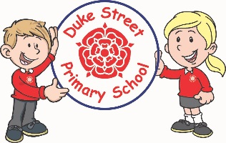

**History:**

**Learie Constantine**

The children will learn about the life of

Learie Constantine, a cricketing legend, political activist and our first black peer. We will learn about why his life and experience were significant and the impact he had on Britain.

Our Core Values

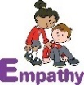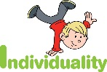  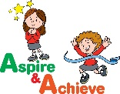 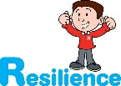

**Geography:**

In Geography we will be looking at Fieldwork and Mapping. The children will be using Google maps to discuss their journey to school. We will also be going on a journey to the library and creating a map of the route that we take.

**Curriculum Drivers:**

* **Enterprise** – Develop collaborative learning within a group, class and whole school context.
* **Resilience** – Develop resilience when tackling challenging tasks.
* **Aspiration** – Complete your best work at all time.
* **Real Experiences** – Develop opportunities for outdoor learning.

**Music:**

**Acer** Recorders

**Spruce and Redwood**

We will be learning to sing, play, improvise and compose with this song, children will listen to and appraise a variety of songs.

**RE:**

**Spring 1 – :** Hindu dharma. Children will learn about the Hindu belief in one God in many forms and how God is in all things. They will learn about how a Hindu might express ideas about God

**Spring 2-** : Christianity (Church) Children will learn about the Christian baptism and what belonging to a church means.

**PE:**

**Spring 1 – Athletics**

**Spring 2 – Health and Fitness**

**DT:**

Design Technology this half term will be different to usual. Key Stage 1 will be having a STEM (Science, Technology, Engineering and Maths) week! We will be using all of these skills to design and create a project.

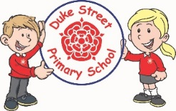

**PSHE: My Happy Mind**

Our module from My Happy Mind is ‘Engage’. We will be looking at how we engage with our lessons. We will also be looking at how our behaviour for learning helps us to engage with our learning and give our full attention and effort.

**School Expectations**

* We are kind and helpful
* We listen
* We are honest
* We work hard and take pride in our work
* We look after property

**Enrichment:**

* Enrichment day
* Sports day
* Class visit to a farm
* Compass Bloom workshops
* Visit from a member of a religious community.

**British Values:**

Our work throughout the curriculum will promote the British Values of:

* Democracy
* Rule of Law
* Mutual Respect
* Individual Liberty
* Tolerance & harmony
* Responsibility/positive contribution
* Public Institution

**School Aims:**

Duke Street Primary School aims to:

* provide a secure, caring and stimulating learning environment,
* promote self-discipline, moral values and self-esteem,
* set challenging yet realistic goals in order to allow each child and member of staff to reach his or her potential
* encourage an enthusiastic attitude to learning through a well-balanced and varied curriculum.
* work in partnership with parents to provide the best for each child in order to get the best from each child
* offer colleagues an enjoyable, positive environment in which to work, fostering both team commitment and the well-being of everyone within our school.