Welcome to Rowan Class- Spring 2021
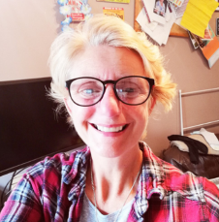
Our class is a year 4 class and is taught by Mrs Robinson.

Mr Allen and Miss Haddon cover PPA on either a Wednesday or a Thursday afternoon.
Miss Ford is our class teaching assistant whilst Miss Clitheroe is on maternity leave.
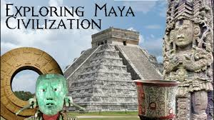
If you have any worries or concerns, please make an appointment to see us with Mrs. Nicholls at the front office or email – rowan@dukestreet-pri.lancs.sch.uk

History and Geography
Our topic for spring term 2021 is ‘The Maya Civilisation’.
We shall be exploring this fascinating civilisation. The children will begin by being immersed in a full day of activities about the Mayans. They will learn about Maya cities, their culture, buildings, religion and what happened to them. They will look at similarities and differences to other ancient civilisations we have explored, and how they all fit in with a timeline. In Geography, we shall be looking at the human and physical features of Mexico and our focus will be on mapping skills.
Science
The focus in Science for this term will be plants. We shall look at measuring growth over time and will be growing our own plants. Hopefully, dependent on COVID restriction, we will be walking to Astley Park to observe and measure different types of plants.
See term overview for more detail.

Times Table practise
In year 4, the recall of multiplication facts are very important. We encourage you to practise regularly with your child, from x2 up to x12 tables. Here are some websites you could use;
- https://www.topmarks.co.uk/maths-games/hit-the-button
- https://ttrockstars.com
It is a government expectation that all children, by the end of Year 4, know all of their times table facts, so it will give your children a great advantage if they can practise them as often as they can. The children will sit a computerised test towards the end of year 4.
Reading
We would like your children to read at least three times a week. Children will be rewarded weekly in class for this. At each stage 25, 50, 75 and 100 reads, the children will receive a small prize in class. This is in addition to the reading prizes from Miss Parkinson. A reading book will be issued on a Monday to be returned on a Thursday. The children will also have access to ‘Reading Eggspress’ and ‘Reading cloud’ in class. These can also be accessed at home to compliment your home reading book. All reading should be recorded on seesaw.
Homework
Weekly homework is not normally set apart from spelling (accessed from seesaw), TTRS practice and home reading. Instead, the children will be expected to complete pre-learning tasks ahead of a topic. This will give them an advantage, and enable them to progress more quickly, with a greater depth of understanding. More information on preview work was sent out at the end of the autumn term.
Weekly spellings will be introduced and sent out on a Monday. There will be a test on a Friday. These will be based on spelling patterns and common exception words.
P.E
Our P.E day will be on a Wednesday or Thursday (depending on PPA cover). Please make sure that your child comes to school in an outdoor PE kit, with trainers, on the designated days. Please also ensure that your child does not wear ear rings if they are unable to remove them themselves.
Medical
If your child requires medical attention in school please contact Mrs Nicholls and complete the relevant forms to keep school updated, and keep your child safe in school.
If you would like to email the class, you can at the following email address;
rowan@dukestreet-pri.lancs.sch.uk
Lockdown restrictions
In the event our class bubble needs to isolate, all home learning will be issued on seesaw. In the event of a whole school lockdown, the same will apply. If you will struggle to access online resources, please contact school as soon as possible. If your child shows any COVID symptoms, please isolate and contact school as soon as possible and advise of any test results. This will help us all to keep as safe as possible.

