icare

**Mathematics:** Daily mathematics lesson

(Y1 & Y2 National Curriculum Objectives)

*Red Rose Maths*

This term we will continue to build on number knowledge, as well as addition, subtraction, fractions and multiplication.. The children will continue to use our maths characters to further develop their reasoning skills and engage in daily maths mastery sessions and Early bird maths.

**Computing:**

Technology around us

We will be looking at technology around the classroom. We will use computers and develop our mouse and keyboard skills. We will learn about using a computer responsibly and safely.

Digital painting

We will learn about using computers to pain, by making lines and shapes. We will make careful choices and create our own digital artwork.

**English:** Daily English and phonics lesson

(Y1 & Y2 National Curriculum Objectives)

**Focused Text:** Dougal’s Deep Sea Dive

**Fiction:** We will be exploring the text and building up to retelling and adapting the story. We will focus on using capital letters, finger spaces and full stops.

**Poetry –** We will be reading a range of poems and then learning them. We will perform our poems in class to our friends.

**Art:**

We are focusing on Sculptures this half term. We will be looking at sculptures by Oldenburg.

The children will then be designing and making their own sculpture of a piece of food.

**Science:**

This half term we are looking at everyday materials and their properties.

We will be carrying out experiments to test for the best suitable material that will be waterproof.

We will be looking at new vocabulary to describe some materials.

We will also be comparing objects into material categories and discussing what they are best to be used for.

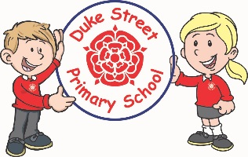

**History:**

We will be comparing Queen Elizabeth 1st and Queen Elizabeth 2nd. We will be focusing on similarities and differences between these significant individuals and the time periods that they lived in.

Our Core Values

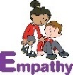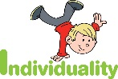  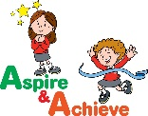 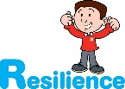

**Geography:**

*China*

The children will be learning about China and identifying some famous landmarks including the great wall of China.

They will be learning about Chinese New Year and how this is celebrated.

**Curriculum Drivers:**

* **Enterprise** – Develop collaborative learning within a group, class and whole school context.
* **Resilience** – Develop resilience when tackling challenging tasks.
* **Aspiration** – Complete your best work at all time.
* **Real Experiences** – Develop opportunities for outdoor learning.

**Music:**

**Redwood & Spruce** – Exploring simple patterns. We will be learning to sing, play, improvise and compose a song, children will listen to and appraise a variety of songs.

**Acer** - Recorders

**DT:**

**Skills:** We will be learning about sliders and leavers.

**Finished product:** Making a moving picture.

**PE:**

**Spruce and Acer – Great Fire of London Dance**

**Redwood – Fundamental movement skills**

**RE:**

We will be learning about Hindu Dharma.

We will learn about Hindu Dharma Gods and the different ways they are depicted. We will also look at how they worship.

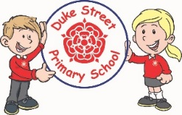

**School Aims:**

Duke Street Primary School aims to:

* provide a secure, caring and stimulating learning environment,
* promote self-discipline, moral values and self-esteem,
* set challenging yet realistic goals in order to allow each child and member of staff to reach his or her potential
* encourage an enthusiastic attitude to learning through a well-balanced and varied curriculum.
* work in partnership with parents to provide the best for each child in order to get the best from each child
* offer colleagues an enjoyable, positive environment in which to work, fostering both team commitment and the well-being of everyone within our school.

**PSHE: My Happy Mind**

**Autumn 1 – Appreciate**

We will learn about appreciating all of the amazing things about ourselves and the people around us!

**Autumn 2 - Celebrate**

We will celebrate the great things about ourselves and build up each other self esteems.

**Enrichment:**

* Science enrichment day
* World Book Day
* A visit from Kidz Rock

**School Expectations**

* We are kind and helpful
* We listen
* We are honest
* We work hard and take pride in our work
* We look after property

**British Values:**

Our work throughout the curriculum will promote the British Values of:

* Democracy
* Rule of Law
* Mutual Respect
* Individual Liberty
* Tolerance & harmony
* Responsibility/positive contribution
* Public Institution