icare

**Science:**

We will identify and name a variety of common animals including, fish, amphibians, reptiles, birds and mammals and describe and compare their structure.

We will identify and name a variety of common animals that are carnivores, herbivores and omnivores.

We will continue to observe changes across the seasons and focus on Summer. We will plant sunflowers and set up a diary.

**Art:**

We will be focusing on Van Gogh’s painting of sunflowers. We will be developing skills through painting, drawing, textiles, printing and making 3d sculptures.

**Mathematics:** Daily mathematics lesson

(Y1 & Y2 National Curriculum Objectives)

Red Rose maths

This term we will focus on place value, addition and subtraction, as well as shape, space and measure. The children will continue to use our maths characters to further develop their reasoning skills and engage in daily maths mastery sessions and early bird maths.

**Year 1 and 2 Curriculum Plans**

Autumn 2022-2023

**Computing:**

**Summer 1 – Digital pictograms**

Learners will begin to understand what the term data means and how data can be collected in the form of a tally chart. They will learn the term ‘attribute’ and use this to help them organise data. They will then progress onto presenting data in the form of pictograms and finally block diagrams.

**Summer 2 – Making music**

**English:** Daily English and phonics lesson

(Y1 & Y2 National Curriculum Objectives)

**Focused Text:** Nobot

**Fiction:** We will be exploring the text and building up to retelling and adapting the story. We will focus on writing in sentences with full stops, capital letters and finger spaces.

**Non- Fiction:** We will be doing lots of research about Wolves and other animals and creating a non-chronological report.

**History:**

The children will be learning about Learie Constantine, a significant individual. We will learn about what makes someone significant, and how Learie Constantine impacted the lives of people in Britain.

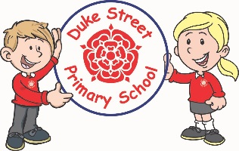

Our Core Values

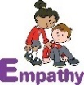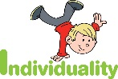  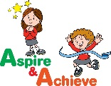 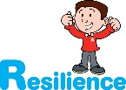

**Geography:**

The children will be learning about mapping skills. We will begin by exploring our playground and creating a sketch map of the area. We will sequence our journey and add pictures and objects from along the way. We will learn about human and physical features, and spot them on a trip to the library. We will create a map of the local area, and plot our route to the library.

**Curriculum Drivers:**

* **Enterprise** – Develop collaborative learning within a group, class and whole school context.
* **Resilience** – Develop resilience when tackling challenging tasks.
* **Aspiration** – Complete your best work at all time.
* **Real Experiences** – Develop opportunities for outdoor learning.

**Music:**

**Rewood** Recorders

**Spruce and Acer**

We will be learning to sing, play, improvise and compose with this song, children will listen to and appraise a variety of songs.

**PE:**

**Spring 1 –Fundamental Movement Skills**

Underarm throw, run, hop, jump, overarm throw, skip, bounding, rolling, kicking and catching.

**Spring 2 – Health and Fitness**

Warming up, healthy heart, strong muscles, simple circuits, large body movement and relaxation

**RE: Hindu Dharma**

We will explore the different roles that we have.

We will learn that Hindus believe in one God in different forms and that God is present in all living things. We will learn how Hindus use statues and images in their worship and reflect on how others see us and how we express ourselves.

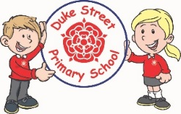

**PSHE: My Happy Mind**

**Engage**

Understanding how to set meaningful goals that matter and how to keep resilient in times of challenge. This module is all about building self-esteem and resilience too.

**Enrichment:**

* PSHE enrichment day
* Class visit to a church
* Year Group To Do list
* Year 1 Farm visit
* Library visit

**School Expectations**

* We are kind and helpful
* We listen
* We are honest
* We work hard and take pride in our work
* We look after property

**British Values:**

Our work throughout the curriculum will promote the British Values of:

* Democracy
* Rule of Law
* Mutual Respect
* Individual Liberty
* Tolerance & harmony
* Responsibility/positive contribution
* Public Institution

**School Aims:**

Duke Street Primary School aims to:

* provide a secure, caring and stimulating learning environment,
* promote self-discipline, moral values and self-esteem,
* set challenging yet realistic goals in order to allow each child and member of staff to reach his or her potential
* encourage an enthusiastic attitude to learning through a well-balanced and varied curriculum.
* work in partnership with parents to provide the best for each child in order to get the best from each child
* offer colleagues an enjoyable, positive environment in which to work, fostering both team commitment and the well-being of everyone within our school.