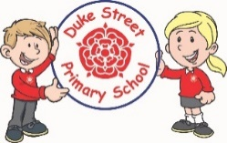

**Understanding the world**

The children will be learning about planting seeds and bulbs and how to take care of them. They will look at life cycles of a butterfly and even observe real caterpillars in class to see them grow and change. We will be exploring minibeasts in the outside areas and completing drawings of them.

**Mathematics:**

Daily mathematics lesson

The children will be consolidating their understanding of numbers to 10, adding one more/less, halving and completing problem solving activities for this real life problems. The children will also be looking at measures, length and weight.

**Physical development**

The children will be completing Forest school with Mrs Haddon and PE with Mr Allen on alternate weeks, please see the website for the dates.

The children will also be accessing our EYFS outdoor area on a daily basis.

**Literacy**

**Summer 1 and 2 Focused Texts:**

Jack and the Beanstalk, The Very Hungry Caterpillar, Handa’s Surprise, Tinga Tinga Tales – How the Elephant got its Trunk, We All Went on Safari and We’re Going on A Lion Hunt.

**Phonics:**

The children will have daily phonics sessions learning sounds from phase 3 and 4 following the Red Rose phonics scheme. We will consolidate our knowledge of tricky words and will continue to form the letter sounds and write captions independently using capital letters and full stops.

**Summer 1**

How do things grow? (Life cycles and growth)

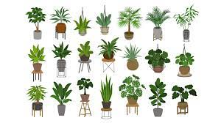

**Summer 2**

Ticket to ride …Hot places

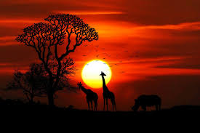

**EYFS**

Summer 2022-2023

**Communication and Language**

The children will be working in key worker groups to continue to develop their listening and attention skills for a longer period.

We also will be developing our vocabulary through the stories that we hear.

**Important dates:**

Parents evening: 18th April

Farm trip: 26th April

Photographer for class photos: 4th May

EYFS class assembly: 16th May

Sports day: 24th May

Enrichment day: 26th May

Half term: Mon 29th May to Wed 7th June 2023 (inclusive)

Summer fair: 13th July

Reception end of year assembly: 19th July

Finish for summer: 21st July

**Expressive arts and design**

The children will be exploring techniques within painting and drawing, and safely exploring a variety of materials, tools and techniques, experimenting with colour, design and texture by making Spring collages.

**Personal, social and emotional development**

We will continue following “My Happy Mind” to focus on expressing our feelings and emotions. We will be looking at our achievements and what we are good at.