UKS2 Preview Learning in preparation for Autumn 2020- Natural Disasters
In the Autumn term, year 5 and 6 will be learning all about survival in the context of natural disasters including volcanic eruptions, extreme weather, earthquakes etc. We will think about how people survive and overcome such incidents. We would like to kickstart our learning with preview work to be completed over the summer holiday. This will give your child a significant advantage in their learning. Preview learning can take any form and means exploring the areas of the topic which interests them. This then forms the foundation of our learning in class and allows the children to make more meaningful links in their understanding. Below are just some suggestions. It would be nice to complete the pre-learning task as a family and we ask that your child brings something in to show us at the start of Autumn term. From this, we will plan our future lessons based on the interests of the children. The children can either bring their work to school in September or photographs can be sent to class email accounts.
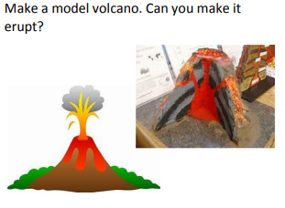 | 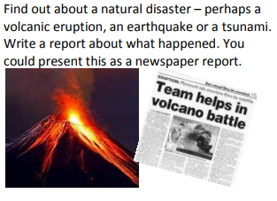 | 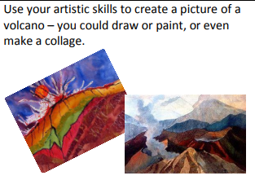 | 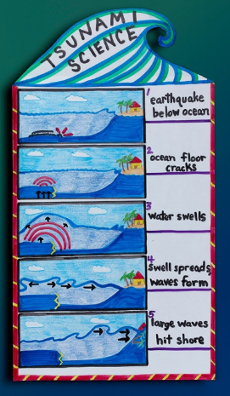
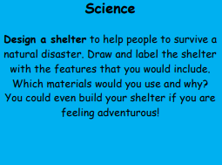 | 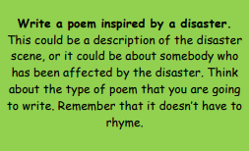 | 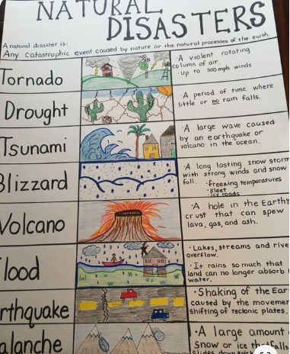 | 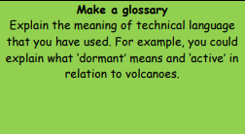
Thanks, from the UKS2 team, Mrs Worth, Miss Partington and Mr Stephens.
willow@dukestreet-pri.lancs.sch.uk poplar@dukestreet-pri.lancs.sch.uk sycamore@dukestreet-pri.lancs.sch.uk

